Town of Campton
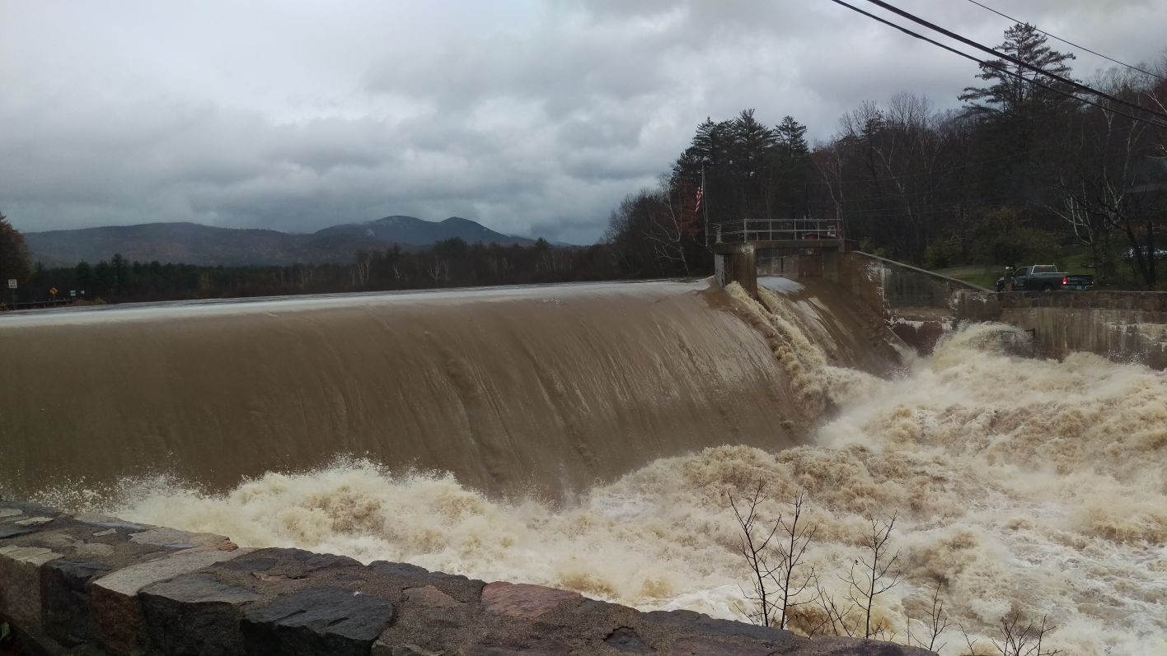
Climate Change Adaptation Report

November 17, 2020
Campton Climate Change Adaptation Committee
Rita Sebastian, Chair Nicholas Coates Ron Goggans
Sherrill Howard Sam Miller Mike Machanic
Susan Skinner Bill Sebastian

Executive Summary
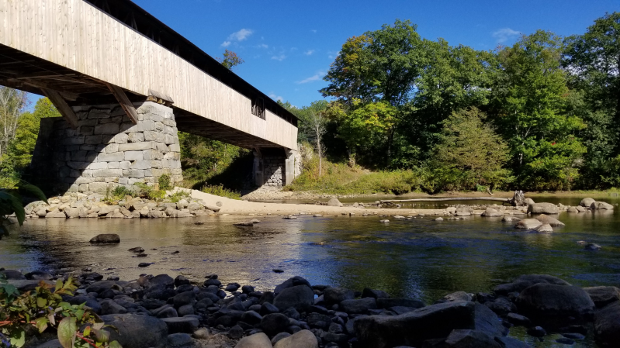
On March 11, 2020, the Town of Campton established an independent committee to produce a comprehensive report to identify the vulnerabilities that Campton will encounter over the next 20 years as a result of climate change and to recommend mitigation and adaptation strategies.
A committee of 8 people has been meeting weekly since that time, researching the vulnerabilities and exploring possible adaptation strategies that could be implemented by the town. This effort has been supported by the UNH Earth Systems Research Center, which has provided databases that have allowed the creation of localized projections of future climate for Campton and for the ski areas affecting the economy. The goal is to develop strategies that can achieve long-term cost savings for the town or provide health and other benefits to residents without incurring costs to the town.
Climate models are an intrinsic part of town operations. They are used when planners establish flood zones to prevent development in locations at risk from future storms, when the highway department designs it culverts or establishes seasonal load restrictions, and when the fire department plans its responses to emergencies. Using good models allows officials to save money and save lives. The models can also help planners anticipate future problems, such as how the regional ski industry might decline and affect Campton businesses.
The climate changes discussed in this report are not about theoretical events that might occur in the future, but rather about what has already happened and is continuing to occur. The ski season has shortened by 21 days over the past 100 years. More flooding disasters have occurred in NH in the past 17 years than in the 50 previous years. The number and intensity of droughts have steadily increased over the past 50 years. This report simply looks at how Campton will be affected when these trends continue.
This report is divided into four sections. The first provides background information on the preparation of the report along with some general information about climate change. The second section looks at issues affecting town infrastructure and operations. The third looks at the long term economic and growth outlook for Campton. The final section summarizes the recommendations and provides a convenient checklist. The main report is followed by an Appendix containing a three-part summary of the physical sciences affecting the climate projections for Campton and the surrounding areas. These reports were prepared for the committee by Dr. Sam Miller at Plymouth State University.
The report covers a wide range of issues, discussing the climate causes and the local impact and then making recommendations to the town. A sampling of these vulnerabilities and adaptation strategies includes:
- Early thaws are becoming more frequent, so that the fixed-date seasonal load restrictions may fail to protect the roads. Campton should use its authority under NH RSA 231:190 and 191 to adopt a dynamic system as done in Concord that uses the early warning service operated by the NH Municipal Association to control road restrictions.
- Droughts are becoming more frequent and severe, so that fire ponds and natural water sources are unreliable. The town should support the recommendation of the Fire Department in Article 25 of the 2014 Hazard Mitigation Plan to provide reliable water sources.
- Floods are becoming more frequent and severe, so that the old FEMA maps used by the town for zoning and disaster planning are inaccurate. The town should take advantage of the more up-to-date and accurate maps available from the First Street Foundation to implement flood plain policies as authorized under RSA 764:16 and 18.
- The length and quality of the winter sports season is declining, so that seasonal revenues for retail businesses and the market for second homes in Campton may decline. The town should create an economic planning committee to protect the interests of the retail, property maintenance, and construction industries in the town that depend on these revenues.
- A decline in winter sports in the region may result in 2nd homes being rented or sold to full-time residents, so that the town may see as much as a 65% increase in school enrollment without receiving additional tax revenues. A 2005 town report found that 39% of the homes in Campton are second homes, so that the owners are paying taxes but not sending children to local schools.
- Other areas of the country will suffer severe impacts of climate change such as heat waves, fires, droughts, storms, and sea-level rise, so that Campton is likely to experience substantial long-term population growth from domestic migration. The town should use its authority under NH RSA 674:35 and other statutes to create guidelines so that this growth is aligned with the long term vision for Campton established in the Master Plan.
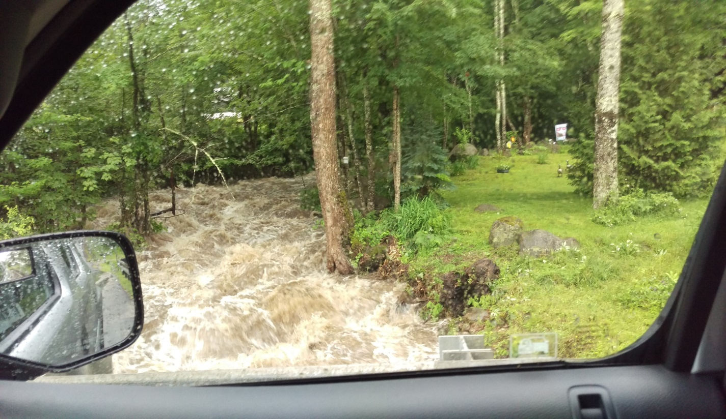
The following report provides details on these issues and covers many other topics. Ultimately the goal of this report is to assist the town to achieve the goals outlined in the Master Plan as the environment changes.
Avery Brook, July 2017
Contents
Executive Summary 2
1. Introduction 5
1.1 Purpose of this Climate Change Adaptation Plan 5
1.2 How Was This Plan Developed ? 5
1.3 Climate Change and Campton 6
2. Infrastructure, Property, Safety, And Public Health Vulnerabilities 7
2.1 Roads Vulnerable to Early Thaws and extreme precipitAtion 8
2.2 Property Vulnerable to Increasing Flood Risks 11
2.3 Ability to Fight Fires Vulnerable to Increasing Droughts 14
2.4 Public health Vulnerable to Warming Climate 16
2.5 Local Agriculture and Vulnerabity to Climate Change 18
3. Economic Planning for a Changing Climate 20
3.1 Winter Sports 20
3.2 Economic Diversification 25
3.3 The Campton Attraction 27
3.4 Building the future 28
4. Recommendations 30
4.1 Summary of Specific Recommendations 30
4.2 Next Steps 31
Appendices:
A. Physical Sciences Summary: Introduction......................................................................................................... A1
B. Physical Sciences Summary, Part 1 ................................................................................................................... A3
C. Physical Sciences Summary, Part 2 .................................................................................................................. A17
D. Technical Notes About Graphs In Main Report................................................................................................ A57

1. Introduction

1.1 Purpose of this Climate Change Adaptation Plan
The purpose of this plan is to identify vulnerabilities in Campton due to climate change and to propose strategies for reducing these risks. These steps can reduce the losses from hazard events as outlined in the Campton All-Hazard Mitigation Plan as well as to achieve long-term savings for the town by using the best possible data in its planning and operations.
Climate models are an intrinsic part of town operations. They are already used to determine the seasonal load restrictions protecting town roads, to define the flood zones affecting future development, and to guide many other building regulations and infrastructure design. The use of obsolete models costs the town money, such as to repair roads that were used by heavy trucks after a spring thaw or were damaged by inadequately sized culverts. The use of bad models can risk lives by failing to protect adequately against floods, forest fires, or other hazards. The climate continues to change in ways that affect how these risks need to be calculated, and a failure to use the best models can cost the town money and harm our citizens.
Climate models can also alert the town to emerging issues that require careful advance planning. For example, Campton's economic base is heavily dependent on the winter sports industry. This industry brings customers to local retail businesses and has attracted investments in second homes that boost the town tax base and generate revenues for construction and property maintenance businesses. A downturn in the winter sports industry would have a significant impact on Campton. The climate models can assist in quantifying the urgency and time frame associated with this risk. At the same time, the escalating problems in other regions of the US with extreme heat, forest fires, storm damage, water shortages, and sea-level rise may cause migration into Campton. This could potentially offset losses from winter sports industry, but without thoughtful planning, it could destroy the rural character and transform the town in ways that harm the rural nature and scenic beauty that are envisioned in the 2016 Campton Master Plan.
This climate adaptation plan is not intended to be an all-encompassing description of risks, but rather to identify a set of issues that will be affected by climate change and show how an understanding of these risks can save money and improve outcomes for the town.

1.2 How Was This Plan Developed ?
This plan was authorized as Article 21 in the Campton town meeting of March 11, 2020 to
"establish an independent committee consisting of 5-9 experts and citizens to produce a comprehensive report by January 8th, 2021. This report will:
- Identify the vulnerabilities that Campton, NH will encounter over the next 20 years as a result of climate change
- Recommend to the town mitigation and adaptation strategies to address these issues"
The committee was formed and met weekly since April 12 to discuss issues and to consult with experts in relevant areas. The approach in Campton was different from Dover, Keene, and other New Hampshire towns which have performed similar climate adaptation studies that were funded and assisted by regional and national organizations. In contrast, the Campton effort is completely locally staffed and has been done without any funding.
The committee received expert advice and technical review from:
Dr. Elizabeth Burakowski, University of NH, Earth Systems Research Center
Butch Leel, NH Local Technical Assistance Program, University of NH, Technology Transfer Center
Hi Fire ChiefDaniel Defosses, Campton-Thornton Fire Chief
Carina Park, Campton Town Administrator
Corey J. Davenport, Planning, Zoning, and Assessing Coordinator, Town of Campton
Sharon Davis, Town of Campton Select Board
Steve Doyon, Chief Dam Safety Engineer, NH Department of Environmental Services
Dr. Steve Whitman, Resilience Planning & Design, LLC
Stephanie Osborne, BSN, RN
Dr. Richard Osborne State Rep. Grafton 7, Campton, NH
The committee greatly appreciates their assistance and support of this project.

1.3 Climate Change and Campton
Climate change due to human activities is not something that might happen in the future, but rather is something that has already happened and is continuing to occur. Average global temperatures have been rising for the past 100 years and are expected to continue to rise at a rate that depends on global emissions of greenhouse gasses.
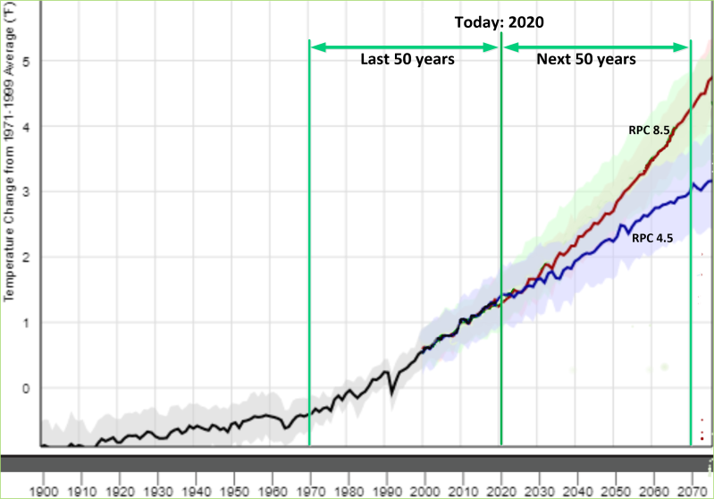
The black trace in the chart shows the rise in global temperatures that has already occurred. These changes have already affected Campton. For example, the average number of days with snow cover in the region has dropped by 21 days per year over the past 100 years. The projections for the future continue this trend, but depend on what steps are taken to reduce emissions. The RPC 4.5 line shows the expected increases in temperature even if aggressive steps are taken to reduce future emissions. The RPC 8.5 trace shows the greater temperature increases if emissions continue to increase at the current rate. Figure 1.1 Average Global Temperatures - 1900-2070
The warming temperatures affect precipitation patterns. In the Northeast US, the total amount of annual precipitation has been increasing slightly but the distribution is changing, with more precipitation in the winter and slightly less in the summer. The total amount of winter precipitation is expected to increase by 21-23% by 2041 while the summer amounts are estimated to decrease by 1.5-7.9%. In addition, the precipitation events are becoming more concentrated, with more falling in intense storms and increasing intervals of drought in between.
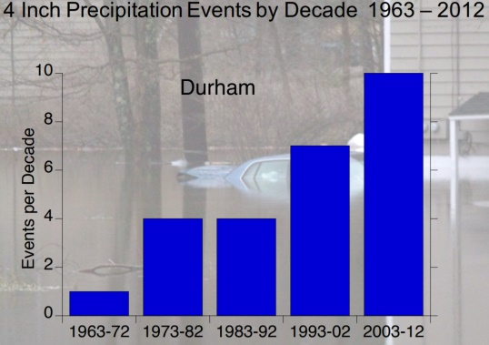
New Hampshire has already seen the increasing frequency of severe storms. In the 50 years from 1953-2002, New Hampshire experienced 12 federally declared disasters due to flooding. These events occurred 5 times more often over the next 17 years, when 21 flooding disasters occurred in NH. The 2006 Mother's Day floods were classified as a "once in 100 years" event. Eleven months later, a Patriot's Day nor'easter melted the snowpack and created even worse flooding. The chart on the right is from a 2014 UNH study that identified a 10-fold increase in 4" precipitation events in southern NH over the past 50 years. Figure 1.2 Historical 4" Rainfall Events in NH
In summary, climate change is not a theory about what might happen in the future, but rather is what New Hampshire has been experiencing over the past 100 years and what is expected to continue into the future. The increasing temperatures and more frequent severe storms are the reality which the Town of Campton must take into consideration in designing its infrastructure, managing its operations, and planning for its economic future.
Climate change is not just affecting Campton. It is already causing extreme heat in the Southwest, forest fires in the West, and increased hurricanes in the Southeast. These problems will intensify in the future. Climate change is also projected to cause water shortages in the Plains states and rising sea levels. These external factors may have local consequences for Campton, such as development pressures from people looking to relocate to a safer place. The Town of Campton needs to anticipate these changes so as to develop policies and plan for "smart growth" that will achieve the vision outlined in its Master Plan.

2. Infrastructure, Property, Safety, And Public Health Vulnerabilities
The Campton Climate Adaptation Committee identified several areas where climate change could have a direct impact on the operations of the Town of Campton. The committee then explored possible ways of reducing the costs to the town or the risks to the community. These adaptation strategies can serve as examples to town officials of how an understanding of climate change can help them to become more effective in their daily work.

2.1 Roads Vulnerable to Early Thaws and extreme precipitAtion
The warming climate is increasing the costs of maintaining roads in several ways:
- Spring thaws are occurring earlier and at more variable dates, so that they are more likely to occur before the dates protected by the current seasonal load restrictions (SLRs).
- Increases in thermal cycling due to winter rain and thaws are intensifying frost heaves.
- Increases in extreme precipitation events can damage roads and threaten public safety.
Understanding how the changing climate is impacting Campton's roads can allow the town to develop adaptation strategies that can improve the road quality and reduce the long term costs.
Climate Issues:
As the climate has been getting warmer, the arrival of the first thaw each year has been getting earlier. In the Campton area, the average date of the first thaw has advanced a week in the past 50 years, and that trend is expected to continue as the climate continues to warm. Climate models also suggest that the dates of the first thaw will also be increasingly variable, with thaws occasionally happening in January and February. The chart below shows the probability that the first thaw of a year will arrive on a particular day. Separate traces show the average over different decades, with the entries for both RPC 4.5 (low emission) and RPC 8.5 (high emission) shown for 2090.
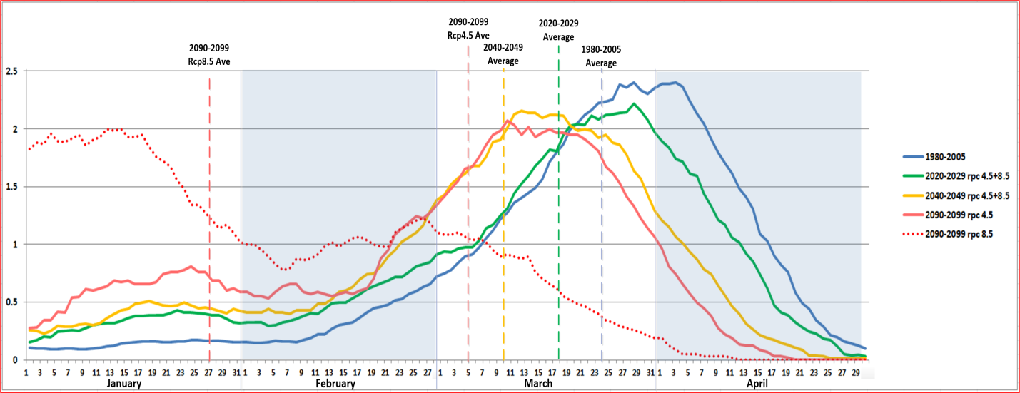 Figure 2.1 Date of First Thaw in Campton area
In the 1980-2005 reference interval, the most likely time for the first thaw was the beginning of April, and thaws in January or February were rare. In the next decade, the average date for the first thaw is in March, and the probability of getting an early thaw increases. By 2040-2049, a January thaw is three times more likely than in the reference years and a February thaw is twice as likely. If global greenhouse emissions are not decreased as shown on the RPC 8.5, the first thaws will be mostly occurring in January by the end of the century.
When thaws arrive early, they are likely to be followed by cold intervals, so that increases can be expected in the thermal cycling which causes frost heaves that the town must repair. As shown in section 2.2 below, extreme precipitation events are also likely to increase, which can damage roads.
Road Issue 1: Spring load restrictions [SLRs]:
Use of town managed roads by heavy vehicles after an early thaw damages the roads, increasing costs for the town and making travel difficult for residents. Violations of SLRs can cut the lifetime of asphalt roads in half. Gravel roads may become impassible to local residents after use by heavy trucks. However, the overall cost of load restrictions to businesses is often more than the costs to repair damages. The Campton Highway Department has to balance between flow of commerce and protecting town infrastructure.
Spring load restrictions are currently implemented by setting weight limits that are applied during fixed calendar dates posted on the signs placed on the roads. Even if those dates are moved earlier to compensate for the average shift, the increasing number of early thaws will leave the roads damaged and harm the residents. At the same time, moving the dates too early blocks the roads at times when they can be safely used by trucks.
The balance between flow of commerce and protecting town infrastructure may best be served by monitoring the conditions each year and setting the restricted dates according to the conditions each year. The NH Municipal Association provides an early warning service providing localized thaw warnings with 6 days advance notice. The town can use these warnings to set when the restricted period starts and to provide commercial operators with advance notice so they can adjust their schedules.
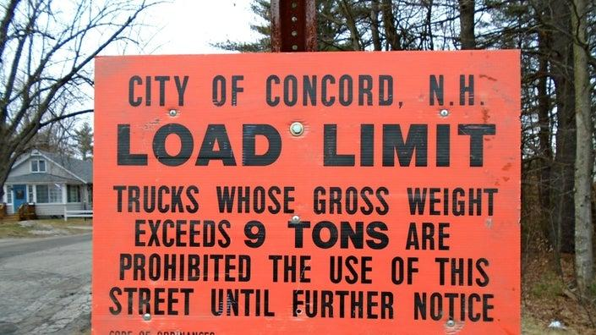
This approach is currently used in Concord can be implemented at low cost by Campton. Their road signs do not include dates, so they can post them when the spring thaw arrives each year rather than use a fixed calendar date. These towns provide a 6-day advance warning to commercial users by posting the dates and details on their web site as well as on Facebook. Residents or companies wishing to be proactively notified can be put on a list to receive emails as soon as the dates are set. Use of Undated Signs in Concord, Posted When Needed
Road Issue 2: Frost Heaves
Frost heaves are exacerbated by the cycling between the frozen and thawed states of the road sub-surface, and this will become worse due to the increasing frequency of winter thaws. The number and severity of frost heaves is thus expected to increase, degrading the road quality and inflating the amount that the town has to spend on repairs. They can also pose a safety hazard that can damage cars or cause injury.
Frost heaves tend to occur on roads where the material under the hard top is poor and the drainage is inadequate.
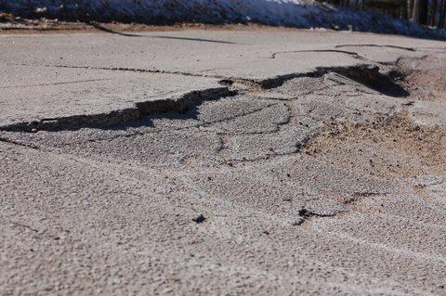
Most roads in Campton were not built to the specifications of modern highways, with a foundation of permeable gravel and good drainage to prevent underground moisture from accumulating and forming the ice lenses responsible for the frost heaves. Full replacement of the base may be prohibitively expensive, but adding sub-drains and insuring that the water has a place to run off can significantly reduce the problem. While the cost of correcting these underlying issues is greater than the cost of patching the surface, the long-term costs to the town can be lower as the annual maintenance costs would decrease and the risks of injury or vehicle damage can be reduced.
Road Issue 3: Upgrading Gravel Roads
Both heavy rainfalls and winter thaws are expected to become more frequent. Most of the gravel roads in Campton were not constructed using modern technology such as geogrids and geotextiles, so that they are subject to damage from these events. The town currently reduces this problem by imposing spring load restrictions that block heavy vehicle traffic during the season when the first spring thaws are expected. This provides no protection from extreme rainfall events during other times or when the first thaw occurs before the start of the restriction, and it does not reduce the damage caused from smaller vehicles.
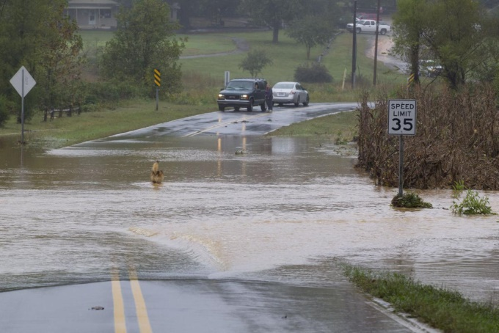
Adding sub-drains and installing a road base geogrid or geotextiles can prevent the roads from turning to mud and eroding away. The geotextiles allow surface water to flow through the gravel to the subgrade, restrict soil particles from migrating into the aggregate, prevent mud from pumping into the aggregate, and stop gravel from being pushed into the subgrade. This can create roads that are more resistant to degradation and may no longer require spring load restrictions. The cost of rebuilding the roads using these techniques is higher than regrading the surfaces after damage, but is offset in the long term by a reduction in maintenance costs, and residents will enjoy rut-free roads throughout the year.
Road Issue 4: Road Drainage
As discussed in section 2.2, heavy precipitation events are becoming more frequent and severe, which can damage roads and render them unsafe during these events. The rework needed to protect each road section can be different - such as increasing culvert sizes, creating retention basins, deepening ditches, or elevating road surfaces. The prioritization of which sections to repair can depend on the amount of usage of the road, the severity of the problem, and the costs of the required repairs. Public safety is also a concern both for the risks to motorists and for the need for emergency vehicle access.
The town has to balance these concerns with the need to minimize annual expenditures. Recommending specific repairs requires the expertise of the highway department and is outside the scope of this report. The key point here is that the weather patterns that cause the drainage problems are expected to increase and become more severe in the future, and the town should be making its infrastructure decisions based upon the need to handle these challenges.
Recommendations:
1. Set the dates for SLRs dynamically: The Town is allowed under RSA 231:190 and 191 to impose restrictions on the use of its roads to protect against damage, subject to some specific exemptions. Instead of using fixed calendar dates, the town should set the dates as needed to protect the roads, using the early warning service provided by the NH Municipal Association to provide notice to stakeholders.
2. Increase the use of sub-drains and other techniques to reduce the reoccurrence of frost heaves. The town should adjust its highway maintenance strategy to adapt to the impact of climate change. When deciding how to fix frost heaves, it faces a trade-off between lower cost short-term fixes and more extensive repairs. Knowing that this problem is becoming worse changes this calculation, so that it becomes more cost effective to invest in repair techniques that will reduce the chances of the frost heaves reoccurring.
3. Implement an incremental plan for rebuilding gravel roads: While the high costs make it impractical to rebuild most of Campton's gravel roads in the near term, the town should consider developing a target list prioritized according to the amount of use, susceptibility to damage, and cost of required repairs. Each year, one or more of the high-priority sections could be rebuilt as needed to protect it from future damage. The town should also investigate possible sources of federal or state funding to assist in these efforts, such as the USDA Community Facilities Grant Program.
4. Monitor drainage issues and create a prioritized repair list: One point that emerged in discussion with highway experts is the need to keep records of the performance of drainage systems so that the town has database to identify and issues and prioritize repairs.

2.2 Property Vulnerable to Increasing Flood Risks
The frequency and severity of floods are expected to increase, so that the town needs to adjust its zoning and disaster planning.
Climate Issues:
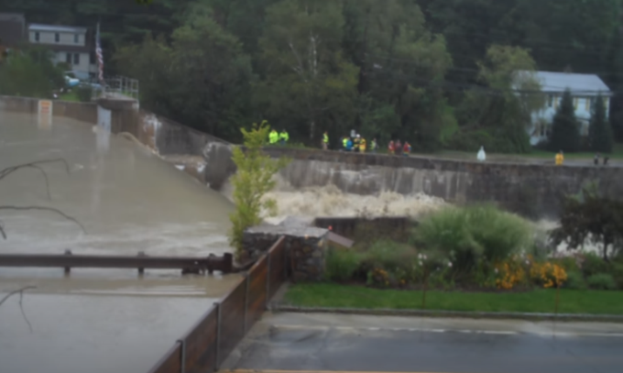
Climate change has increased the number of extreme precipitation events. The frequency of New Hampshire state disasters declared for flooding increased more than 5 times over the past 60 years, from 0.24/year in the interval 1953-2002 to 1.23/year over the interval 2003-2019. Extreme precipitation will continue to become
more common, both from more intense local storms as well as incursions from tropical storms like Bob and Irene.
The increase in winter rain due to global warming also increases the frequency of floods due to the breakup of ice jams. Irene floods Rte. 49 at Campton Dam. Sept 2, 2011
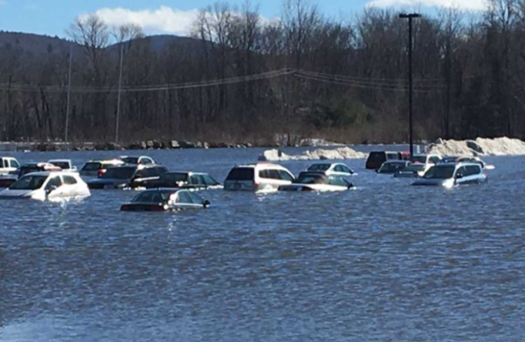
Impact on town:
An accurate understanding of these risks is needed to set up the zoning and building codes affecting future development in the town and to determine what flood control measures need to be deployed to protect homes and roads. The previous section 2.1 discussed the impact on town roads. One concern is that the FEMA flood maps flood zones and to plan disaster response may be outdated or inaccurate.

A second area of concern is the Campton Pond Dam. It is under federal jurisdiction because of its hydro-electric Flood on Rte. 175A due to break-up of ice jam Feb, 2017 generation and is inspected annually with state inspectors
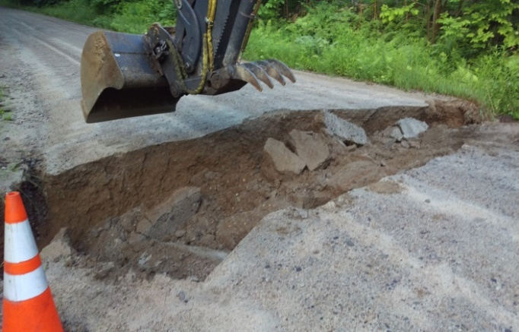
present. Because of the presence of developments such as Six Flags Park just downstream, the dam needs to be able to pass run-off that is 2.5 times the 100 year rainfall depth. While the inspections thus far have not identified a significant risk factor, these inspections have been assessed using an outdated model for the 100 year rainfall and may not adequately reflect the risk going forward.
Recommendations:
1. Use best available flood maps: When revising zoning maps, the town should use the most accurate and up-to-date maps that take climate change into their models. The drawings below compare the current FEMA maps used by Flood damage on Mason Rd, July,2017 the town with a more accurate map that incorporates recent and projected climate changes into its models:
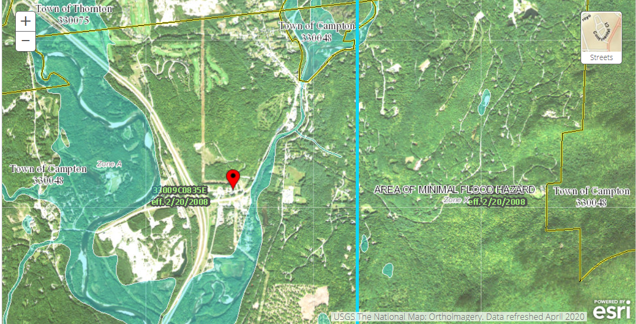
100 year Flood Risk Map from FEMA currently used by town

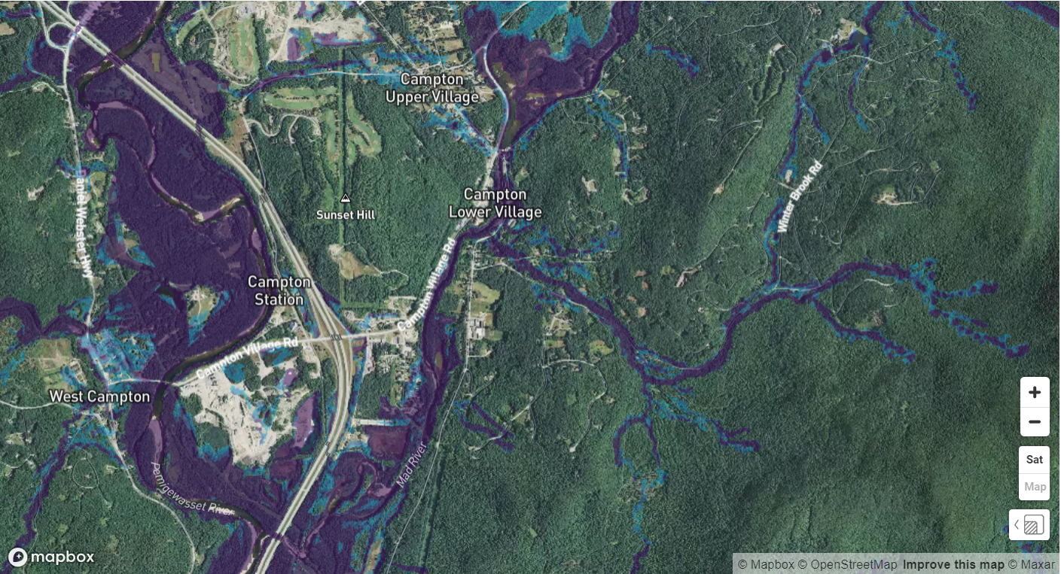
100-year Flood Risk Map from First Street Foundation
The more accurate map was developed by the First Street Foundation, a coalition of scientists from Harvard, MIT, and other universities and organizations. They provide an interactive online version that allows setting the risk factor (500-year floods, 100-year, etc.) and ability to zoom and see individual houses in high detail. The FEMA map misses many at-risk areas and its use can lead to developments in places where the homeowners are at risk and may be unable to get insurance in the future. The town should exercise its authority granted under RSA 764:16 and 18 to manage floodplains as well as use these maps in hazard planning.
2. Protect steep slopes and ridgelines: The town is authorized under NH RSA 675:21 to enact an ordinance protecting steep slopes and ridgelines, and 27 NH towns have already done so. The 2014 Campton Master Plan states that consideration should be given to the passage of an ordinance, but this has not yet occurred. Reducing development as a function of hillside slope can prevent erosion and drainage problems that contribute to flooding. These developments can also create unattractive slope scars and damage the aesthetics of the community.

2.3 Ability to Fight Fires Vulnerable to Increasing Droughts
Droughts like the recent one in 2020 will become more frequent and severe, which may make wildfires more dangerous as well as drying up fire ponds and other water sources used to fight fires.
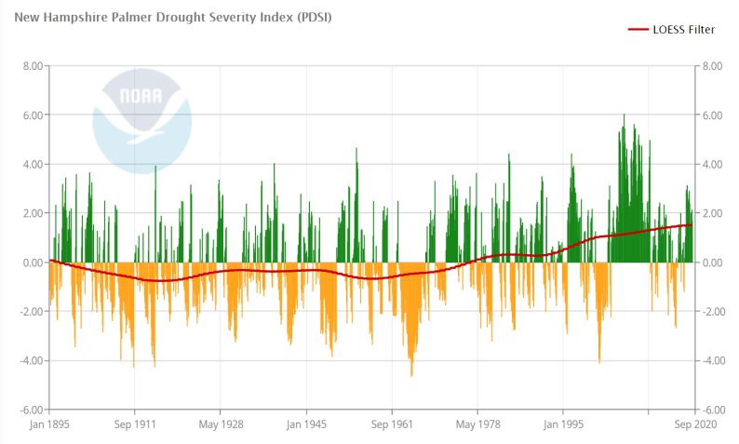
Climate Issues:
The warming climate has been changing the rainfall patterns, where more of the precipitation occurs in extreme events, leaving longer intervals of dry weather in between. The sporadic rains are often too much for the dry ground to absorb, causing run-off and floods rather than recharging the groundwater. The warmer temperatures also increase evaporation. These effects combine to increase the frequency and intensity of droughts even though the total annual rainfall has been increasing slightly. The chart shows this trend over the past 70 years, where the number and Figure 2.2 New Hampshire Droughts: 1895-2020
intensity of droughts has been steadily increasing since 1950. This upward trend is expected to continue, so that the drought this summer in Campton, which was the most severe in the past 20 years, is a warning of what to expect.

Impact on town:
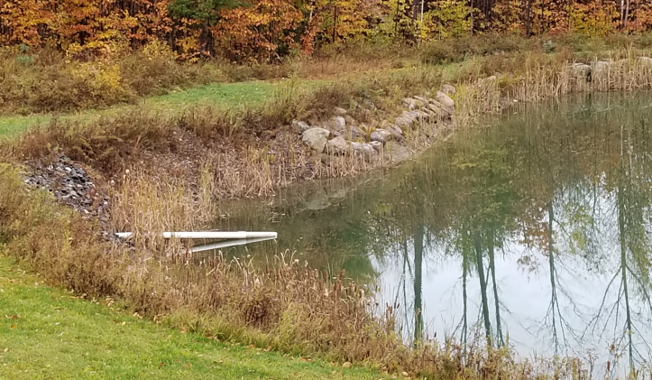
The droughts have had direct effects on the lives of Campton residents. Many dug wells dried up in the recent drought. Insufficient water in the Pemigewasset reduced revenues for local kayaking businesses. Farms and home gardens lost crops. The risk of forest fires will grow not just because of droughts, but also because of the increased amount of deadwood due to the arrival of pests due to the warming climate. Forests cover 84% of Campton and the town abuts the White Mountain National Forest.
The droughts impact the ability of the town to respond to fires. The droughts reduce the water levels in the fire ponds constructed by the town as well as in natural sources. In the recent drought, the water level in some of the fire ponds dropped below the intake pipes. Dysfunctional Fire Pond on Mason Rd 10/16/20
Recommendations:
The emergency planners for Campton need to consider the impact that droughts can have on the ability to prevent and fight fires. Several recommendations might help reduce this vulnerability:
1. Assess risks: The town should include a review of the drought susceptibility for the current fire ponds and other water sources on which the town depends for fire fighting.
2. Require new developments to install cisterns: In accordance with NFPA 1231 and NFPA 1141, the town should consider whether to require new developments to install cisterns of at least 10,000 gallons. The ordinance used in Pelham, NH, can serve as a model.
3. Investigate options for town installation of cisterns: The Fire Department recommended the installation of dedicated cisterns in the 2007 Campton Hazard Mitigation Plan as well as in the 2014 update. The town might look at available grant programs, such as the US DHS Assistance to Firefighters Grant program, which will cover up to 95% of the cost of these systems. If external funding is available, the Fire Department should identify the high-priority locations and techical requirements to begin the process.
4. Promote "firewise landscaping": As discussed in the 2014 hazard mitigation plan, the town should promote actions that individual home owners can take to reduce their risk.

2.4 Public health Vulnerable to Warming Climate
The warming climate can create public health risks by accelerating the spread of Lyme disease and increasing weather-related threats from storms and heat stress. In examining the climate adaptation strategies for public health, this report focuses on actions possible at the town level. The town's direct administrative responsibilities relative to public health are largely limited to emergency services and health related services performed within the school. The town contributes funds to Pemi-Baker Community Health and participates in regional organizations like the Central Region Public Health Network (CRPHN). The CPRHN states that:
It is the responsibility of local municipalities to promote health, prevent disease and injury, and provide protection from public health threats.
but no funding is provided to the town for these purposes other than for the emergency services. Consequently, the analyses and recommendations within this section will focus on the limited areas under direct administrative control of the town.
Climate Issues:
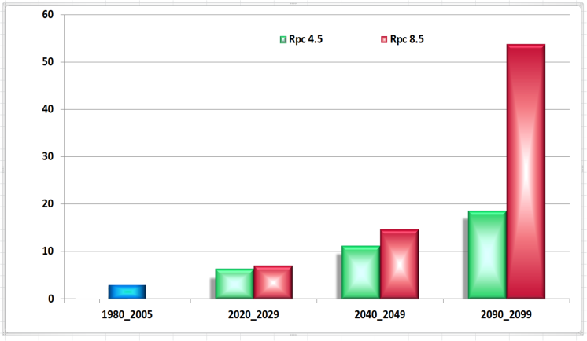
Changes in the climate can affect public health. Warming temperatures can impact health directly through the increasing occurrence of extreme heat events. These events are the most prominent cause of weather-related human mortality in the U.S., responsible for more deaths annually than hurricanes, lightning, tornadoes, floods, and earthquakes combined. This has not been an issue for Campton in the past - as the average number of 90⁰ days each year has been only 2.4. But by the 2040's, the average number is expected Figure 2.3 Number of days above 90⁰ annually in Campton
to increase substantially to 11-14. This is similar to what is currently experienced in Ohio - not the deadly events that affect the Southwest, but a sufficient risk to require planning. The situation by the end of the century could be far more dangerous in the high emission scenario, but this time frame is outside the scope of this report.
Warmer temperatures are making conditions in Campton more favorable to the spread of Lyme disease and other vector-borne diseases. Since 1991, New Hampshire and Delaware have had the highest increase in the prevalence of Lyme disease in the US. While the number of cases reported in Campton have been lower than in southern NH, Grafton County has had the largest rate of increase in the state over the period 2014-2018, as the warming Blacklegged tick at various life stages climate has expanded the range of the blacklegged tick. Similarly, the warming climate has increased the length of the mosquito season in NH from 56 days in 1980-1989 to 71 days since 2006. This increases the threat of diseases such as West Nile Virus and Eastern Equine Encephalitis.
Impact on town:
While most public health initiatives in NH are initiated by state and regional level agencies, the Town of Campton has several opportunities to intervene and improve outcomes for these climate-related issues:
- For Lyme and other vector-borne diseases, education about the issue is a key part of prevention and treatment. A systematic assessment of climate hazards in this region identified Lyme disease among youth as a priority issue. These risks can be mitigated by programs at Campton Elementary School.
- For heat stress and other weather-related dangers, the town is involved through both its fire and police departments. 2014 Campton Hazard Mitigation Plan lists steps the town can take toward the prevention of death and injury due to weather events, and opportunities exist for the town to take more proactive steps toward protecting the most vulnerable citizens in these emergencies.
Recommendations:
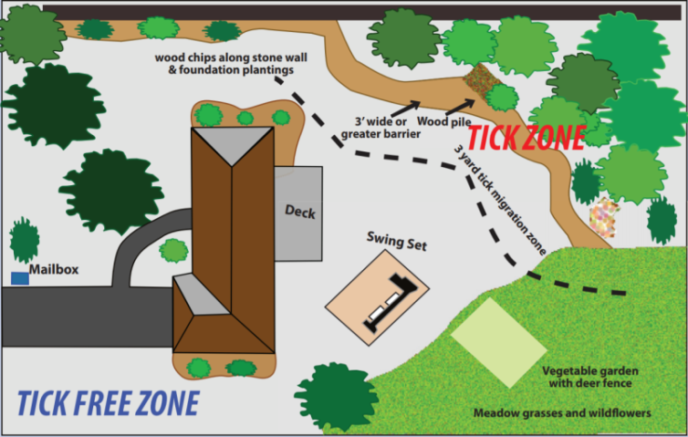
1. Provide Lyme disease education and support at the school: For protection against Lyme disease and other vector-borne illnesses, the Campton Elementary School should take advantage of free educational resources such as posters, training materials, and tick cards available from NH DHHS. The school should also be aware of programs that can assist families with treatment, such as the LymeAid 4Kids grants.
2. Identify vulnerable residents in need of special support during weather emergencies: The Town of Campton should work with regional health Educational Poster about Landscaping for Tick Prevention organizations and other social service groups to prepare a database identifying elderly and disabled residents who may need special assistance during weather related emergencies such as heat waves, floods, and severe storms. This should include residents who need electricity for critical home medical equipment for whom an electric outage can be a life-threatening event. The planning for disaster management should ensure that these vulnerable populations will be protected.

2.5 Local Agriculture and Vulnerabity to Climate Change
Local agriculture is included in this report not just because of the risks it faces from climate-related increases in droughts, floods, and invasive pests, but also because of its role in protecting Campton against other aspects of climate change.
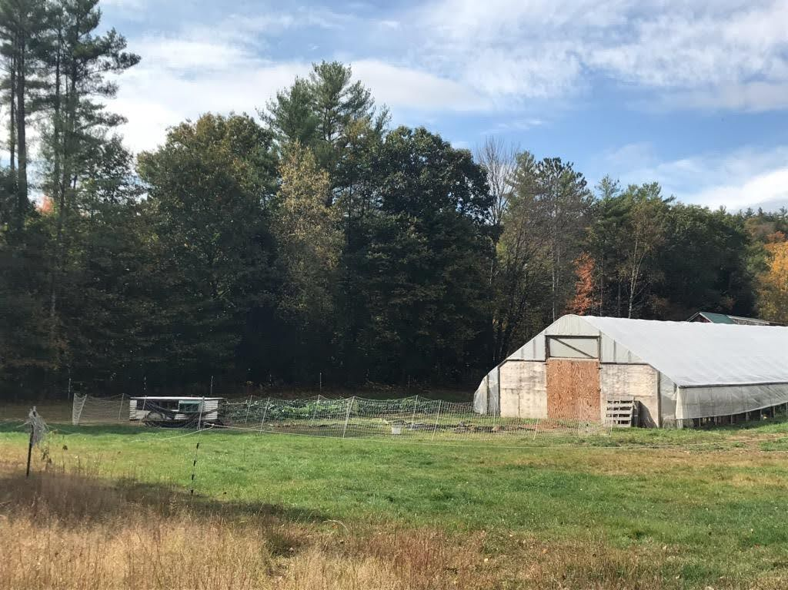
Local agriculture has been identified in the current Town of Campton Master Plan as essential for maintaining open spaces and the quality of life. While the early European settlers in this area subsisted on their local agriculture, this industry is no longer a major provider of employment in Campton, down to 0.3% as of 2016. Nevertheless, it is critical to evaluate the effects of climate change on our ability to produce food locally for two major reasons:
- The Campton Master Plan highlights the importance of open space to maintain the quality of life that has been identified by the community as essential. This involves identifying current farming activity and associated community benefits from agriculture and taking into consideration farming needs when making zoning changes. Increasing the opportunities for Serendipity Farm, Campton expanding the agricultural economy will provide access to jobs as well as fresh local food.
- The impacts of climate change on agriculture across the nation have the potential for threatening the food security of Campton residents. In many areas of the US, the rising temperatures will increase need for irrigation while current practices have been reducing available water, potentially causing dramatic changes in production. A food supply dependent on large scale production and irrigation, with long and complex food chains, reduces our food security. A local system of food production can provide resilience in the face of those changes.
Climate Issues:
As summer temperatures rise, the yield of many crops will be impacted. For instance, tomatoes and other traditional farmers market products, reduce fruit production when temperatures exceed 90⁰. Animals suffer as well, with reduced milk and meat production. Increased temperatures combined with frequent short-term drought will necessitate developing water management guidelines to include irrigation, water retention projects such as cisterns, ponds and swales, and evaluation of varieties of plants that are currently harder to grow in the north.
Dramatic increases in spring precipitation will delay large-scale planting by keeping machinery off fields, and damage plantings through flooding and other consequences of extreme weather events such as high winds or hail. Early warming and erratic early spring temperatures and late frosts pose risks to perennials and fruit production by damaging early buds and flowers.
While early warming and late frost onset have the potential to increase crop production, they also increase the northward expansion of agricultural pests and weeds. Ironically, the increasing CO2 levels will not improve all crop production. It leads to reduction in nutritional value of food plants and increases the growth rate of unwanted “weeds”.
Impact on town:
Taking actions to cultivate a healthy, expanding agricultural economy has the potential of preserving open spaces, providing employment opportunities, providing residents the ability to produce their own food at minimal cost and mitigating the CO2 levels creating this crisis. Campton can work in conjunction with the Campton Conservation Commission to protect the community's natural landscapes, clean water, forest and agricultural products for future residents and to create a vibrant, sustainable local food economy with minimal expense to the town.
Recommendations:
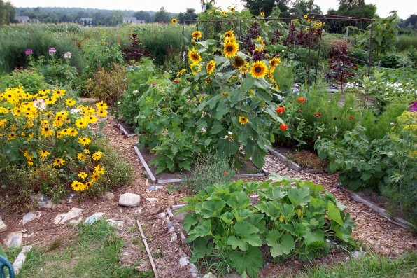
1. Create town Agricultural Sub-Committee: As Campton begins to work on its Open Spaces plan as recommended in the 2016 Master Plan, it should create an official committee to address the issues laid out there. Since agricultural development can play a significant role in addressing practices that will both mitigate climate change through reduction of CO2 emissions and adapt to the predicted changes, a subcommittee should be formed to identify current farming activity and associated community benefits and to identify ways that Campton can facilitate the growth of agriculture using the standards of “Climate Smart Agriculture” as set forth by the Food and Agriculture Organization of the United Nations. The three pillars of this movement are:
- Sustainably increase agricultural productivity and incomes (food security)
- Adapt and build resilience to climate change (adaptation) and
- Reduce and/or remove greenhouse gas emissions (mitigation) where possible.
The Global Alliance for Climate Smart Agriculture is providing education, research and resources for this work and the EPA and Department of Agriculture are providing research and information as well.
Even as work begins on the Open Space Plan, the town can take action by identifying town owned land near residential areas in Campton with access to water that would be suitable for community gardening or for a cooperative farming space to teach food production skills, to experiment with new methods that will sequester carbon, improve the soils, provide flood protection by creating a buffer zone, and engage community groups in making local food available to those who are food insecure. One possible location would be at Campton Elementary School, which would also provide enriching opportunities for the students.
2. Preserve and expand agricultural land: This committee should work with the Campton Conservation Commission to identify land that would be appropriate for agricultural conservation, to find funding sources to purchase and develop that land, and to establish guidelines for using it for agricultural production based on those CSA pillars.
3. Review zoning codes affecting agriculture: The agricultural subcommittee of the Open Space Plan committee would undertake a review of zoning codes and regulations that create roadblocks to food production and suggest steps to encourage individual and community gardening for food production as well as to provide opportunities to develop businesses to produce, process and market local food.
Campton is well-placed to use a growing agricultural sector to aid in adapting to the wide range of climate change risks that have been identified. Agricultural activities are being used to reduce flooding risk by using farm land as a buffer between rivers and residential and business areas. They are providing opportunities for renewable energy, providing space for solar and wind projects, and managing farm waste to produce biofuels. Local food production reduces the greenhouse gases required for long distance food supplies and provides opportunities to diversify local job opportunities by providing employment in food production, processing and marketing.

3. Economic Planning for a Changing Climate
An understanding of climate change is especially important for Campton's long-term planning. The actions of agencies like the Zoning Board or Planning Board affect how the town will grow and change in the future. Changes in the climate can transform the economic challenges facing the town, and the town planners need to base their plans around the best possible models of the future environment.

3.1 Winter Sports
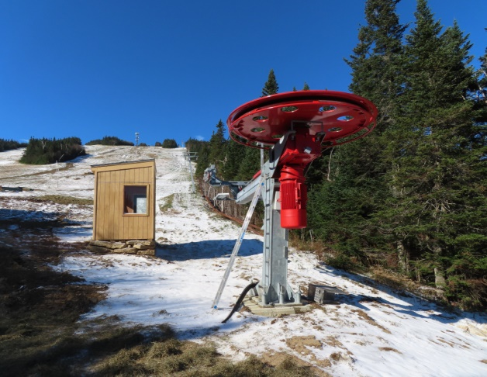
The economy of Campton is dependent on skiing, snowmobiling, ice fishing, and other winter sports. Local retail establishments suffer when the weather prevents these activities, as illustrated by the "Pray for Snow!" sign in front of Mad River Tavern during the snow drought of 2016. A greater economic impact on the town may come from the second homes purchased by people attracted to the area by winter sports, as these homes generate much of the income for local property maintenance and construction businesses. A decline in winter sports due to changes in the climate could reduce tax revenues for the town and affect the livelihoods of many residents. Understanding these risks can support long term planning that can reduce the town's economic dependency on these sports. Figure 3.1: Snow Shortage in Waterville
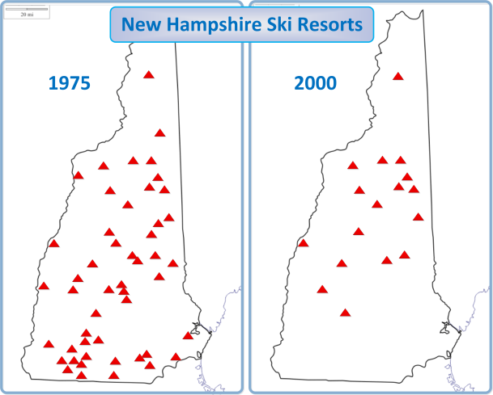
While various scientific studies have produced significantly different projections for the climate conditions affecting winter sports in our area, widespread agreement exists on many key points:
- The winter season has been decreasing: the average number of snow-covered days each year in New England has decreased by 21 days over the past 100 years.
- The loss of natural snowpack has reshaped the ski industry in New Hampshire: the number of resorts dropped from 47 in 1977 down to 17 currently. Resorts without artificial snowmaking have disappeared, and few resorts remain in the southern part of the state despite its higher population.
- Limits of snowmaking to prolong season have been reached: Figure 3.2: Loss of NH Ski Resorts
the slopes at the major ski resorts upon which Campton depends are fully covered (100% at Waterville, 99% at Loon, 90% at Cannon), so no tricks are available to prevent future reduction in the ski season due to a warming climate.
- The underlying atmospheric factors responsible for the shortened seasons are increasing: as discussed earlier, the rate of atmospheric warming is increasing, so the trends seen in the past will worsen.
The current dependence of the local economy on winter sports poses a risk that needs to be addressed by careful economic planning that takes advantage of the town's assets. With its cool climate and natural beauty, Campton is an attractive place for vacations, retirement, and residence as other sections of the country increasingly struggle with heat, drought, and sea-level rise.
Impact of climate change on winter sports using natural snowpack
While all the winter sports will be affected by rising temperatures, each is sensitive to different specific factors. While the major downhill ski resorts can deploy artificial snowmaking, sports like snowmobiling, cross-country skiing, and snowshoeing require natural snowpack. This graph averages the data from the different models in the UNH ESRC dataset as described in Appendix A to project snowpack levels at various times of the year:
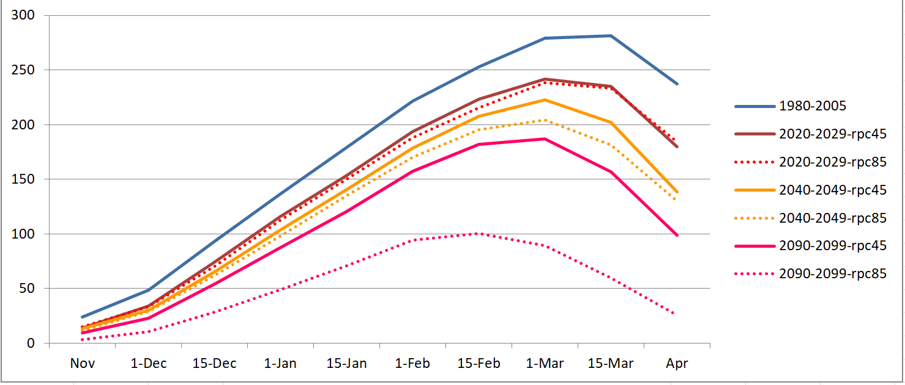
Figure 3.3. Waterville Valley average snowpack in mm of SWE
The chart shows the average natural snowpack for various times of the year for Waterville Valley. The snowpack is measured in millimeters of SWE (snow-water-equivalent) which is the amount of water that would be generated if the snow were melted. The actual thickness of the snowpack depends on the density, and the density required for various sports depends on factors such as the sport and the terrain. The graph has 7 traces:
- 1980-2005: This is the reference period for the UNH database, derived from actual measurements. It can be used to compare future levels to what is expected from past experiences.
- 2020-2029 @ RPC4.5 & 8.5: These show what to expect in the near future for two emissions scenarios. RPC 4.5 is the low emission scenario that can be achieved if aggressive steps are taken globally to reduce carbon emissions. RPC8.5 is the high emissions scenario which happens if business continues as usual. The differences between the two are small in the near-term, so the traces mostly overlap.
- 2040-2049 @ RPC4.5 & 8.5: These show what to expect at the end of the 20-year focus of this report.
- 2090-2099 @ RPC4.5 & 8.5: These are added as a reminder of what could happen by the end of the century, where snowpack would be 60% less than current levels under the high emission scenario.
The reduced snowpack levels would directly correlate with fewer visits and poorer experiences by cross country skiers and snowmobilers. Campton retail establishments would see fewer customers and out-of-towners would be less interested in second homes in the area.
Impact of climate change on downhill skiing
Campton sits at the center of the three most accessible major ski resorts in New England - Waterville Valley, Loon Mountain, and Cannon Mountain. One way to see the impact of climate change on the ski season is to look at the number of days each year when snowmaking is possible at these three sites. This graph averages the values from 29 separate models to estimate the number of days when the overnight low is less than -2⁰C, the maximum temperature at which snow can be made.
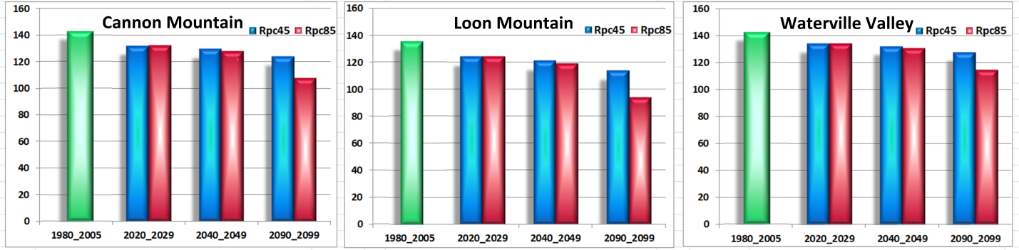
Figure 3.4. Number of days when overnight temperatures allow snowmaking
The values for Loon are smaller than for the other resorts because its elevation of 3,064 feet is lower than Cannon and Waterville, which both exceed 4,000 feet, and temperature decreases at higher elevations. If the minimum overnight temperatures were the only consideration, ski seasons of over 100 days would be anticipated through the end of the century except for the high emission scenario at Loon.
The ski season may also be adversely impacted by an increase in winter rain, which can result in poor snow conditions. Most climate models for this region project a substantial increase in the ratio of precipitation that falls as rain during the ski season, as shown in a graph showing the average results across the 29 models in the UNH database for Loon Mountain:
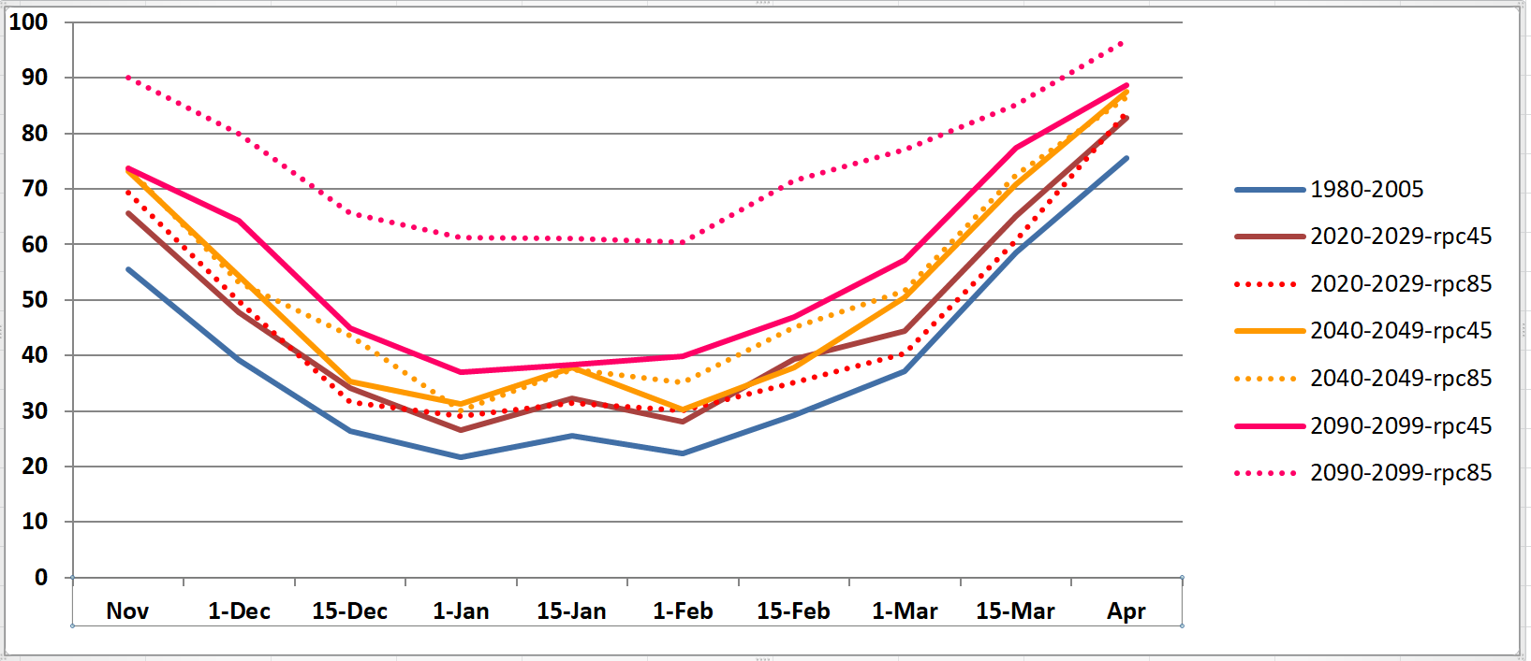
Figure 3.5: Percentage of winter precipitation falling as rain at Loon Mountain
As discussed in Appendix A, the results are similar for the two emission scenarios over the next few decades, but differ significantly by the end of century. These models indicate that winter rain is 63% more likely in the 2040-2049 interval than in the past, which could reduce the number of ski days as well as the quality of snow when skiing is possible.
The data for snowmaking days and winter rain capture only a small part of the complexity of conditions leading to successful ski seasons. These graphs show averages across multiple years and models, but each individual year will be unique and can vary significantly from the average. The timing of weather events such as warm spells or rain is critical, especially as to the relationship to the holiday season that is critical to resort revenues. The key point is that the number of ski visits to the area and the quality of the experience they obtain are both likely to decrease in the future, and this may have an economic impact on Campton.
Economic Impact
The climate impact on the ski industry will harm Campton retail businesses. Because of their larger size and higher elevation, the three local resorts have profited from the collapse of other New England resorts. This trend may continue as lower altitude resorts continue to close and send more customers to the three local resorts. These local resorts have also avoided the shrinkage of the ski season up to this point by installing advanced snow making equipment, but with almost 100% coverage already achieved, this will not prevent future climate-related shortening of the ski season. While the additional traffic from former customers of other resorts can partially balance out the reduced number of ski days, the concentration of retail activity into a smaller number of days also poses a challenge to local businesses.
The climate impact on the ski industry may affect other sectors of the Campton economy that are not normally considered as related to skiing. Approximately 40% of the homes in Campton are owned by people whose primary addresses are elsewhere, and interviews with Campton real estate brokers confirmed that the ski industry has been the key driver behind the second home market here. As both the opportunity to use the homes and the enjoyment of the experience decrease due to shortened seasons and poor snow quality, the market for second homes may lose its primary driver. This in turn can affect local businesses like property maintenance and construction that depend on these customers. A long term drop in the real estate market can also affect property values and the town tax base.
Adaptation Strategies for Campton
The key to protecting Campton from these adverse effects is the diversification of the economy, especially via activities that take place year-round or in other seasons. A steady year-round income stream would benefit both local businesses and the residents who work at these businesses.
The ski resorts themselves are attempting diversification, but these efforts are not going to compensate for the losses. Ski resorts across the country recognize the long-term problem and are attempting to build up summer businesses from activities like zip lining, mountain biking, concerts, and hosting conferences. However, so far these attractions have not provided the "magnet" that can draw a continuous stream of high-income visitors to the area as happens with skiing.
To facilitate this diversification, the Town of Campton should develop a comprehensive economic development plan that creates a vision for the future and identifies specific implementation steps.

3.2 Economic Diversification
The adverse impact of climate change on local winter sports reinforces the need to achieve Objective #2.2 in the Town of Campton Master Plan of 2016:
"Broaden the commercial and industrial base to prevent Campton from being overly [dependent on] any particular sector of the economy or business."
The Town of Campton should form a committee to draft an economic development plan that would explore what actions can be taken to diversify its economy and ensure that climate change does not adversely affect it. Drafting that plan is beyond the scope of this climate change adaptation study, but this section describes a few ideas that have been discussed at the committee meetings.
Teleworkers
The COVID-19 pandemic has accelerated the trend toward teleworking, and many companies are allowing employees to work full or part time from home. When daily commutes to the company office are no longer necessary, employees can choose where they want to live. Campton is an ideal place to relocate, because of its natural beauty and easy access to the Boston area. This trend is already evident during the 2020 pandemic, as many of the second homes in Campton have become full-time residences. Campton can benefit from having these teleworkers as new residents, as they tend have to high disposable incomes that can support local businesses. The town should try to provide the features that these people want.
Broadband internet access is a critical element for teleworkers. Telework requires video teleconferencing and other applications that need high bandwidth. While parts of Campton have access to Spectrum cable, many areas do not have access to anything better than DSL technology for internet access. Solving this problem may require combining multiple solutions. Many homes are too remote to run coaxial or fiber cable. Fixed wireless can help in those situations and be a lower cost solution, but requires line-of-sight to the transmitter. While the Town of Campton is not an internet service provider, municipalities can play a role in helping their citizens gain access to these services. The town can help see that its citizens benefit from state and federal programs like the $50M funding for the Connecting New Hampshire-Emergency Broadband Expansion Program. Towns can band together under House Bill 1111 to create communication districts with greater bargaining power with the serivice providers.
The school system is the highest priority for many families deciding where to relocate. The town needs to view its school system not just as a service needed by residents, but rather as a magnet that can attract new residents. Additional investments in the school can provide significant long-term benefits for all residents from the increase in the tax base and the revenues to local businesses. The school needs to be a high priority to all Campton residents - not just families with children. The school and the town should provide ways that the broader Campton community can contribute time and resources.
Retirees
As the climate changes, the cool temperatures and lush scenery make Campton more attractive than traditional retirement locations in Florida or the Southwest, which suffer from increasing extreme heat, destructive storms, and other problems. Attracting retirees to Campton can benefit the town as they bring accumulated financial resources and require fewer town services. They also are likely customers for property maintenance and construction businesses that might be suffering in the future from a decline in revenues from skier second homes.
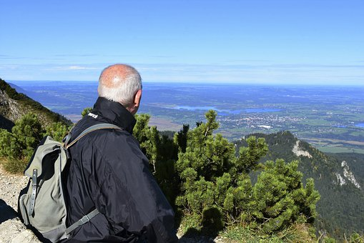
The town economic planning committee should explore ways to attract retirees into the community. Many of the issues that are important to retirees are outside the scope of town operations. For example, the state reliance on property taxes instead of income taxes shifts the tax burden disproportionately to retirees. The ideas in the section 3.3 for making Campton more attractive would be helpful with retirees. One issue that would be of particular interest to retirees is to improve transportation options, particularly to make Boston more accessible. Having easy access to the world's best medical facilities is a significant benefit for the elderly, as well as being able to enjoy the cultural institutions of a major city.
Effect of Shifting Residential Patterns on School Funding
Climate-driven changes to the residential patterns in Campton may increase the expenses to the town for education. The 2005 Brown University study reported that owners of 39% of the homes in Campton had a primary residence elsewhere. As discussed in Section 3.1, the purchase of these second homes was primarily motivated by winter sports, and the shortened season and decreasing snow quality is reducing this attraction. If teleworking increases the demand for full-time residences in Campton, many of the second homes will be sold or rented to families using them as their primary residence. If the new residents enroll children into the school system, the education expenses for the town will increase without a corresponding increase in the tax base.
This shift in housing patterns may have a significant impact on the Campton budget. The Dec. 31, 2019 Campton Annual Report listed 49% of the tax rate went to the elementary school and 21% to Plymouth Regional High School, so 70% of the tax revenues are currently spent on education. If all of the second homes became primary residences and the average number of children per household was the same as for the current residents, the number of students served by the town could increase by 40%. If the marginal cost per student remained constant, the increased in costs for education could raise the town tax rate from 23.21 to 38.68, which would be one of the highest rates in NH. While the marginal costs can be reduced by increasing class sizes, the conversion of a large number of second homes into primary residences would still have a substantial impact on the town budget.
One way for the town to avoid this shortfall would be by encouraging retirees to move to Campton, as they could rent or buy the properties currently used as second homes without adding to school enrollment. The implications for the school budget add to the importance of the recommendations for attracting retirees outlined in the previous section.

3.3 The Campton Attraction
Transforming Campton from a wayside into a destination is a key to inducing teleworkers, retirees, businesses and commuters to relocate to the town. Instead of offering services to travelers, Campton needs to become an attraction in itself. While this topic should also be explored by a town economic planning committee, the climate adaptation committee developed some ideas for achieving this goal.
Bike paths, sidewalks, and downtown placemaking
When the town offices and post office moved to their current locations, the original downtown lost its identity. Presently, there is no obvious answer to the question "where is Campton?". Placemaking at its basic level is creating a public space that capitalizes on a community’s assets where people can feel comfortable and can participate in the community. Placemaking incorporates existing aspects of the built environment and weaves it with the natural environment. A natural location to create a downtown is the intersection of NH Routes 49 and 175, including the stretches of road that go to the Campton Cupboard and to the dam. This place can be a place of civic pride where people can shop, see their neighbors, and enjoy the beauty of the dam and surrounding buildings
The key to placemaking is to design the space to a people scale, not a motorized vehicle scale. This is not to imply that motorized vehicle access needs to be eliminated. In fact, a location(s) where people can leave their cars and walk in the downtown is an important piece of the design. However, the redevelopment of the space needs to be a place where people can experience the outside world without being afraid of being hit by a speeding vehicle.
Placemaking is a multi-faceted approach using various techniques. These techniques include using the design elements noted above such as sidewalks to slow vehicles downtown to sharrows, which are shared lane markings used in situations where cyclists and drivers must coexist in the same lane. Placemaking is also drawn out through Town policies such as site plan and subdivision regulations. For example, the Planning Board could change its regulations to require parking to be on the side or behind businesses and reducing setback requirements so that buildings can be built closer to road and sidewalks would reduce vehicle and pedestrian/bicyclist conflicts.
A recommended first step is to take advantage of the Plan NH Charrette Program. Plan NH is a non-profit organization that has developed design plans for 70 New Hampshire communities. The process brings in architects and other planning professionals to visit the target area and meet with community members and leaders. Then they use their expertise in designing healthy and vibrant communities to develop designs based on what they have seen and heard. The cost is $6,500, but grants are available so the town may only need to contribute $1,500. The commercial cost for obtaining these same services would typically be in the range $25,000 - $80,000, so the program can provide a significant benefit to the town at a low cost.
Historic District
Another technique for creating a vibrant downtown Campton is to use zoning to establish a historic downtown area that provides more control to the Planning and Zoning Boards over development in that area. New Hampshire passed a law in 1983 giving towns the authority to establish these districts, and subsequent studies have confirmed that these districts have provided significant economic benefits to the towns. The statutes allow regulations about the size and appearance of buildings, so that new developments have to contribute to the community vision for the area. The codes would be worked out with the current property owners so that they see the effort as enhancing the value of their property rather than limiting their options.

3.4 Building the future
While the Campton Master Plan proposes a vision of the future that would protect its rural character and environmental beauty, a 2005 study commissioned by the town reported that development was largely unplanned and inconsistent with the community's vision for its future. Less than 9% of the land was protected from development, and if all land was developed under current zoning, there would be 23,000 homes - an increase of 12 times over current levels. This would destroy the rural character and pose difficult problems for transportation and infrastructure. While Campton has not recently been subject to extensive development, the town needs to plan for this possibility, as climate change is predicted to create substantial domestic migration into the region.
Climate Migration
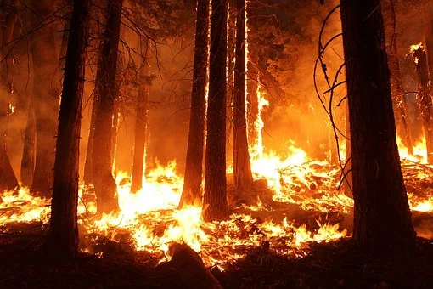
Migration into Campton is expected to increase because other regions of the country are experiencing far worse consequences of climate change. The Southwest faces extreme heat, as seen in the record-breaking 38 days above 110⁰ in Phoenix this summer. The long-term prognosis for that region is not just hotter temperatures, but also collapse of their water supply which is heavily dependent on diminishing sources like the Colorado River. As this report is being written, the far West is facing unprecedented wild fires which destroy the landscape and cause dangerous respiratory problems for people throughout the region, while a record number of simultaneous hurricanes are devastating the Southeast. One study suggested that by 2050, the US communities where 93 million people currently live will experience severe consequences, mostly from heat and compromised water supplies.
Models for the number of people who will migrate and where they will go are not well established, so the impact on Campton cannot be projected at this time. Studies of migrations after Katrina and other hurricanes found that most migration was to metropolitan areas, so Campton may not see a drastic population increase. Nevertheless, some influx is inevitable, and the town will need to manage this growth in a way that achieves the vision articulated in the Master Plan.
Regulation of Real Estate Development
The zoning and planning boards need to develop a comprehensive plan for managing new developments in the town. As noted in the 2005 study authorized by the town, allowing every large lot to be subdivided into the minimum lot sizes as defined in the zoning ordinances and allowing housing on every buildable lot would multiply the number of housing units in the town by 12 times. This level of development would largely erase the rural character and environmental beauty envisioned in the Master Plan.
A major opportunity to exert controls over development is in the authorization of subdivisions. The town currently has about 2,932 lots and 2,243 housing units, some of which involve multiple units on a single lot. If a single home was constructed on each vacant lot, approximately 1,000 additional units could be constructed. Most of these lots are large enough to be subdivided under current density guidelines. If all plots in Campton were subdivided into the maximum allowable number of units, an additional 20,000 units could be built. Thus the current zoning by-laws are in conflict with the vision for Campton outlined in the Master Plan.
The key to avoiding this uncontrolled expansion is provided by state RSA 674:35, which grants discretionary authority over approval of subdivision applications to the local planning board. Campton can utilize this authority to achieve community objectives such as preservation of the scenic beauty and rural character of the town. The 2005 study commissioned by the town discussed strategies for managing this process and prepared maps showing how to preserve scenic views, wildlife corridors, and other key objectives. It also developed a natural resource co-occurrence map that identified areas meriting special protection. By using and further developing these maps, the town can establish specific guidelines that can be used by the planning and zoning boards for approval of subdivisions and other development permits.
Energy
The primary focus of this report has been on climate adaptation - identifying areas where the town can save money or otherwise improve outcomes for its residents by anticipating the impacts of a changing climate. However, climate mitigation is also important - the town should do its part in reducing the greenhouse gas emissions responsible for this problem, even if it addresses only a small part of a global issue. One way to work toward this goal is to change how power is provided for town facilities. Preliminary analysis suggests that deploying solar voltaic systems at various town facilities can not only achieve this goal but also reduce the town's energy expenses. The town should work with the Plymouth Area Renewable Energy Initiative to develop a proposal that will quantify these savings and propose an implementation timetable.

4. Recommendations

4.1 Summary of Specific Recommendations
The following table summarizes the recommendations contained in the earlier sections and provides the section number where details about the recommendation can be found. A preliminary assessment of the Responsible Party is included to assist town officials in quickly seeing what issues might be most relevant to them. These assessments will be revised after future discussions with these parties.
Item | Recommendation | Responsible Party | Section
1 | Implement a dynamic method for managing seasonal road restrictions | Highway Dept | 2.1
2 | Increase the use of sub-drains and other techniques to reduce frost heaves | Highway Dept | 2.1
3 | Implement incremental plan for rebuilding gravel roads | Highway Dept | 2.1
4 | Monitor road drainage issues and create prioritized | Highway Dept | 2.1
5 | Use best available flood maps for setting up flood zones and disaster planning | Zoning Board, Hazard Mitigation Team | 2.2
6 | Enact a town ordinance regulating development of steep slopes and ridgelines | Town Meeting | 2.2
7 | Use best available flood maps for setting up flood zones and disaster planning | Zoning Board, Hazard Mitigation Team | 2.2
8 | Assess risks due to impact of drought on fire ponds | Campton-Thornton Fire Dept | 2.2
9 | Require new developments to install cisterns | Planning board | 2.2
10 | Promote firewise landscaping | Campton-Thornton Fire Dept | 2.2
11 | Incorporate education and other support for Lyme Disease into school | School Board & Staff | 2.4
12 | Identify elderly and disabled needing special support during weather crises | Campton-Thronton Fire Dept; CRPHN | 2.4
13 | Develop basic plan for extreme heat events | Hazard Mitigation Team | 2.4
14 | Create agricultural sub-committee under the Campton Open Spaces Plan | -tbd- | 2.5
15 | Identify and acquire land suitable for agricultural conservation | Conservation Commission | 2.5
16 | Review zoning codes affecting agriculture | Agricultural sub-commitee | 2.5
17 | Establish town economic planning committee | Planning Board, Town Meeting | 3.2
18 | Set up zoning and other incentives to encourage businesses that attract visitors | Planning Board, Town Meeting | 3.2
19 | Enhance access to broadband Internet | Town Administration | 3.2
20 | Provide ways for community to contribute time & resources to school | School Board & Staff | 3.2
21 | Submit a grant to the Plan NH Charrette program for downtown design support | Town Meeting | 3.3
22 | Create committee to enhance town center such as by designating historic district | Planning Board | 3.3
23 | Create framework under for approving sub-divisions based on long term vision | Planning Board, Town Meeting | 3.4
24 | Deploy solar power at town facilities where economically advantageous | Town Administration, Town Meeting | 3.4

4.2 Next Steps
The goal of the climate adaptation report is to integrate these recommendations into the Campton Master Plan, the Hazard Mitigation Plan, zoning regulations, and other areas of town operations. In addition to developing and implementing these specific recommendations, the report hopes to encourage all town agencies to consider what the environment is going to be like in the future when developing plans, establishing regulations, and implementing programs and to encourage citizens to consider what they want Campton to be like over the coming decades.
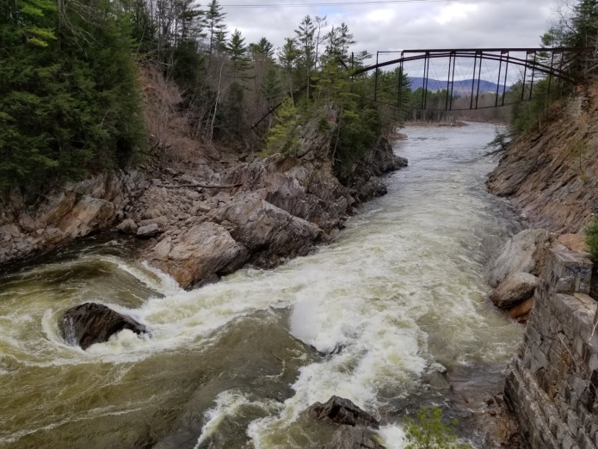

Livermore Falls

Photo by Sherrill Howard
"Confronting Our Changing Winters", Hubbard Brook Research Foundation, Science Links 2019 https://hubbardbrook.org/sites/default/files/documents/HBRF/reports/ConfrontingOurChangingWinters.pdf
"Global Climate Dashboard", US NOAA. https://www.climate.gov/maps-data
see Table 9 and analysis in Appendix A - Miller, Physical Sciences Report, Part 1.
"New Hampshire Disaster Declarations: 1953-Present", Homeland Security Emergency Management, New Hampshire Department of Safety, https://www.nh.gov/safety/divisions/hsem/disaster/documents/NHDisasterInfo.pdf
Adam Sexton, "10 years ago, NH dealt with its second 100-year flood within 11 months", WMUR.com, April 16,2017, https://www.wmur.com/article/10-years-ago-nh-dealt-with-its-second-100-year-flood-within-11-months/9277435
Cameron Wake, et. al, "Past Present, and Potential Future 100-year floods in the Lamphrey River Watershed", University of New Hampshire Scholar's Repository, January 9, 2014, https://scholars.unh.edu/cgi/viewcontent.cgi?article=1054&context=stormwater
"Climate Change to Make Hot Droughts Hotter in the US Southern Plains", Cooperative Institute for Research in Environmental Sciences at the University of Colorado at Boulder. https://cires.colorado.edu/news/climate-change-make-hot-droughts-hotter-us-southern-plains
Jo Daniel et al., "Climate change: potential impacts on frost-thaw conditions and seasonal load restriction timing for low-volume roadways", Road Materials and Design, 2017. https://par.nsf.gov/servlets/purl/10039935
"Cost/Benefit Study: Spring Load Restrictions", Minnesota Dept. of Transportation, 2015. https://www.lrrb.org/media/reports/200515.pdf
Justine Paradis, "You Asked, We Answered: What Are Frost Heaves? Are They Unique to N.H.?", NHPR, Jan 26, 2018. https://www.nhpr.org/post/you-asked-we-answered-what-are-frost-heaves-are-they-unique-nh#stream/0
Lori Schaus and Mark Popik, "Frost Heaves: A Problem That Continues To Swell", Transportation Association of Canada, TAC Conference 2011. http://conf.tac-atc.ca/english/annualconference/tac2011/docs/sm1/popik.pdf
"Its Mud Season: Weight Restrictions on Local Roads", NH Municipal Association, March 2008. https://www.nhmunicipal.org/town-city-article/it%E2%80%99s-mud-season-weight-restrictions-local-roads-0
"New Hampshire Disaster Declarations: 1953-Present", Homeland Security Emergency Management, NH Department of Public Safety. https://www.nh.gov/safety/divisions/hsem/disaster/documents/NHDisasterInfo.pdf
"Four People and Dog Rescued from Floods in Campton", photo by WMUR, July 2, 2017
Joel Scata, "FEMA's Outdated and Backward-Looking Flood Maps", National Resources Defense Council, Oct 12, 2017. https://www.nrdc.org/experts/joel-scata/femas-outdated-and-backward-looking-flood-maps#:~:text=However%2C%20a%20recent%20investigation%20by,maps%20put%20communities%20at%20risk.
"Ice Jam on Pemigewasset River Breaks Free", photo by WMUR, Feb 28,2017. https://www.wmur.com/article/ice-jam-on-pemigewasset-river-breaks-free/8990777
"The First Street Foundation Mission", The First Street Foundation. https://firststreet.org/mission/
"Steep Slope and Ridgeline Protection", NH DES, chapter 2.2. https://www.des.nh.gov/repp/documents/ilupt_chpt_2.2.pdf
"Climate at a Glance", National Oceanic and Atmospheric Administration. https://www.ncdc.noaa.gov/cag/statewide/time-series/27/pdsi/all/1/1895-2020?filter=true&filterType=loess
"Drought in New Hampshire", The National Integrated Drought Information Center, 2020 https://www.drought.gov/drought/states/new-hampshire#:~:text=The%20U.S.%20Drought%20Monitor%20started,21.99%25%20of%20New%20Hampshire%20land.
Annie Ropeik, "As Climate Change Drives Droughts, Water Conservation & Infrastructure Become Key", NHPR, Oct 4, 2020. https://www.nhpr.org/post/climate-change-drives-droughts-water-conservation-infrastructure-become-key#stream/0
Photo by Sherrill Howard
"Fire Cistern Regulations", Pelham Fire Department, https://www.pelhamweb.com/sites/g/files/vyhlif4856/f/file/file/cisternregs_copy.pdf
"Notice of Funding Opportunity (NOFO), Fiscal Year 2019 Assistance to Firefighters Grant Program (AFG)", The Department of Homeland Security. https://www.fema.gov/sites/default/files/2020-07/FY19AFGNOFINAL.pdf
"Mission & Overview", Central New Hampshire Health Partnership. https://www.cnhhp.org/about-cnhhp/
Jeffrey Berko et al., "Deaths Attributed to Heat, Cold, and Other Weather Events in the US", National Health Statistics Reports, July 30, 2014. https://www.cdc.gov/nchs/data/nhsr/nhsr076.pdf
"Climate Change Indicators: Lyme Disease", US EPA. https://www.epa.gov/climate-indicators/climate-change-indicators-lyme-disease
"Reported Cases of Lyme Disease in New Hampshire, 2014-2018", NH Division of Public Health Services. https://www.dhhs.nh.gov/dphs/cdcs/lyme/documents/county2018.pdf
"Mosquito Season Getting Longer", Climate Central, July, 2015. https://www.climatecentral.org/gallery/graphics/mosquito-season-getting-longer
"Mosquito -borne Diseases", NH Dept. of Health and Human Services. https://www.dhhs.nh.gov/dphs/cdcs/arboviral/index.htm
"Health and Climate Change" in New Hampshire's Lakes Region: An Action Plan", Lakes Region Partnership for Public Health, Feb. 2016. https://www.dhhs.nh.gov/dphs/climate/documents/climate-plan-lakes.pdf
"Publications and Data for Lyme and Other Tickborne Diseases", New Hampshire Dept. of Health and Human Services. https://www.dhhs.nh.gov/dphs/cdcs/lyme/publications.htm
"LymeAid for Kids Provided $383,000 in Grants Since 2004", Lyme Disease Association, Inc. https://lymediseaseassociation.org/grants/lymeaid-4-kids/about-lyme-aid-4-kids/
Photo by Sherrill Howard
"Confronting Our Changing Winters", Hubbard Brook Research Foundation, Science Links 2019 https://hubbardbrook.org/sites/default/files/documents/HBRF/reports/ConfrontingOurChangingWinters.pdf
Lawrence Hamilton, et al., "Warming Winters and New Hampshire's Lost Ski Areas: An Integrated Case Study", International Journal of Sociology and Social Policy, Vol 3, No 10, 2003 https://www.researchgate.net/publication/235264127_Warming_Winters_and_New_Hampshire's_Lost_Ski_Areas_An_Integrated_Case_Study
from resort web sites: https://www.waterville.com/blog/tag/Snowmaking, https://www.loonmtn.com/mountain-stats, https://www.snow-forecast.com/resorts/Cannon-Mountain
Alexandra R. Contosta et al., "Northern forest winters have lost cold, snowy conditions that are important for ecosystems and human communities", Ecological Applications, July 2019 https://esajournals.onlinelibrary.wiley.com/doi/full/10.1002/eap.1974
Stephie Elson, "Campton's Past, Present and Future", Brown University, Feb, 2005. http://www.camptonnh.org/nh/wp-content/uploads/2016/04/NRI-2005.pdf
Ralf Garrison, Rick Kahl, "Measuring the Summer Market", Ski Area Management, January, 2017 https://www.saminfo.com/component/k2/item/121-measuring-the-summer-market
"Before the coronavirus, telework was an optional benefit, mostly for the affluent few", FactTank, Pew Research, March, 2020. https://www.pewresearch.org/fact-tank/2020/03/20/before-the-coronavirus-telework-was-an-optional-benefit-mostly-for-the-affluent-few/
Stephie Elson, "Campton's Past, Present and Future", Brown University, Feb, 2005. http://www.camptonnh.org/nh/wp-content/uploads/2016/04/NRI-2005.pdf
Julia Ferrari, et al, "Local Historic Districts of New Hampshire With Their Historic District Commissions and Heritage Commissions", Plymouth State University, Sept. 2012 https://www.nh.gov/nhdhr/publications/documents/lhd_surveyreport2012.pdf
Stephie Elson, "Campton's Past, Present and Future", Brown University, Feb, 2005. http://www.camptonnh.org/nh/wp-content/uploads/2016/04/NRI-2005.pdf
"117⁰ Record", Arizona Weather Authority, Aug 14, 2020. https://www.azfamily.com/weather/extreme_heat/crazy-heat-phoenix-hits-high-temp-of-117-degrees-tying-record/article_0487221c-ddb2-11ea-8a99-77bedba8557f.html#:~:text=By%20late%20afternoon%2C%20we%20hit,2020%20is%20now%20at%208.
Abrahm Lustgarten, "How climate migration will reshape America: Millions will be displaced. Where will they go?", NYTimes Sept 15, 2020. https://www.nytimes.com/interactive/2020/09/15/magazine/climate-crisis-migration-america.html
ibid.
Elson, ob. cit.
Photo by Sherrill Howard

