Town of Campton
Climate Change Adaptation Report
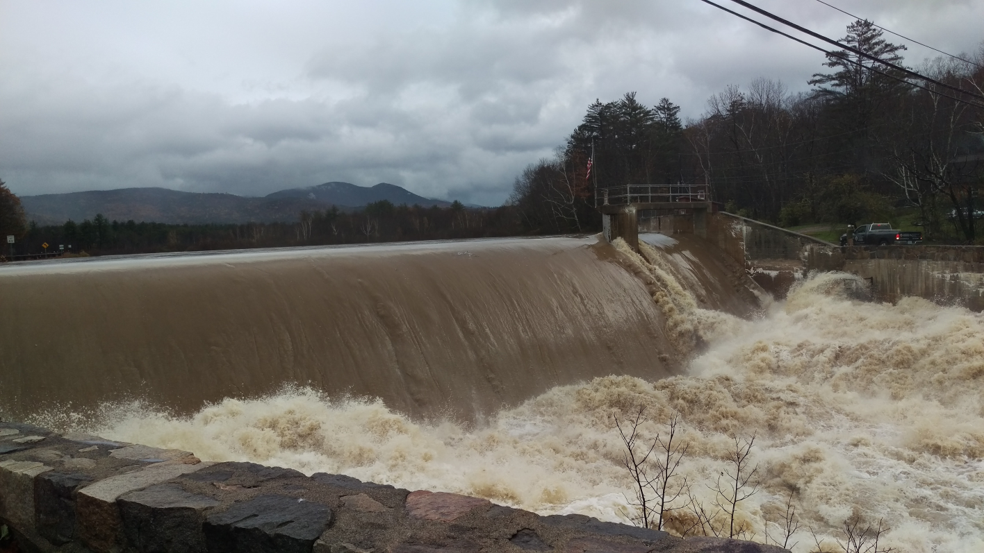
Executive Summary

November 17, 2020
Campton Climate Change Adaptation Committee
Rita Sebastian, Chair Nicholas Coates Ron Goggans
Sherrill Howard Sam Miller Mike Machanic
Susan Skinner Bill Sebastian

Executive Summary
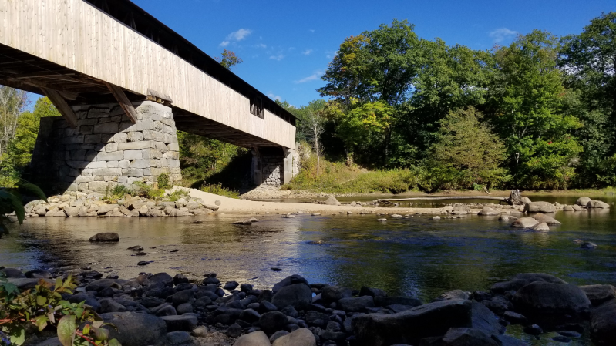
On March 11, 2020, the Town of Campton established an independent committee to produce a comprehensive report to identify the vulnerabilities that Campton will encounter over the next 20 years as a result of climate change and to recommend mitigation and adaptation strategies.
A committee of 8 people has been meeting weekly since that time, researching the vulnerabilities and exploring possible adaptation strategies that could be implemented by the town. This effort has been supported by the UNH Earth Systems Research Center, which has provided databases that have allowed the creation of localized projections of future climate for Campton and for the ski areas affecting the economy. The goal is to develop strategies that can achieve long-term cost savings for the town or provide health and other benefits to residents without incurring costs to the town.
Climate models are an intrinsic part of town operations. They are used when planners establish flood zones to prevent development in locations at risk from future storms, when the highway department designs it culverts or establishes seasonal load restrictions, and when the fire department plans its responses to emergencies. Using good models allows officials to save money and save lives. The models can also help planners anticipate future problems, such as how the regional ski industry might decline and affect Campton businesses.
The climate changes discussed in this report are not about theoretical events that might occur in the future, but rather about what has already happened and is continuing to occur. The ski season has shortened by 21 days over the past 100 years. More flooding disasters have occurred in NH in the past 17 years than in the 50 previous years. The number and intensity of droughts have steadily increased over the past 50 years. This report simply looks at how Campton will be affected when these trends continue.
This report is divided into four sections. The first provides background information on the preparation of the report along with some general information about climate change. The second section looks at issues affecting town infrastructure and operations. The third looks at the long term economic and growth outlook for Campton. The final section summarizes the recommendations and provides a convenient checklist. The main report is followed by an Appendix containing a three-part summary of the physical sciences affecting the climate projections for Campton and the surrounding areas. These reports were prepared for the committee by Dr. Sam Miller at Plymouth State University.
The report covers a wide range of issues, discussing the climate causes and the local impact and then making recommendations to the town. A sampling of these vulnerabilities and adaptation strategies includes:
- Early thaws are becoming more frequent, so that the fixed-date seasonal load restrictions may fail to protect the roads. Campton should use its authority under NH RSA 231:190 and 191 to adopt a dynamic system as done in Concord that uses the early warning service operated by the NH Municipal Association to control road restrictions.
- Droughts are becoming more frequent and severe, so that fire ponds and natural water sources are unreliable. The town should support the recommendation of the Fire Department in Article 25 of the 2014 Hazard Mitigation Plan to provide reliable water sources.
- Floods are becoming more frequent and severe, so that the old FEMA maps used by the town for zoning and disaster planning are inaccurate. The town should take advantage of the more up-to-date and accurate maps available from the First Street Foundation to implement flood plain policies as authorized under RSA 764:16 and 18.
- The length and quality of the winter sports season is declining, so that seasonal revenues for retail businesses and the market for second homes in Campton may decline. The town should create an economic planning committee to protect the interests of the retail, property maintenance, and construction industries in the town that depend on these revenues.
- A decline in winter sports in the region may result in 2nd homes being rented or sold to full-time residents, so that the town may see as much as a 65% increase in school enrollment without receiving additional tax revenues. A 2005 town report found that 39% of the homes in Campton are second homes, so that the owners are paying taxes but not sending children to local schools.
- Other areas of the country will suffer severe impacts of climate change such as heat waves, fires, droughts, storms, and sea-level rise, so that Campton is likely to experience substantial long-term population growth from domestic migration. The town should use its authority under NH RSA 674:35 and other statutes to create guidelines so that this growth is aligned with the long term vision for Campton established in the Master Plan.
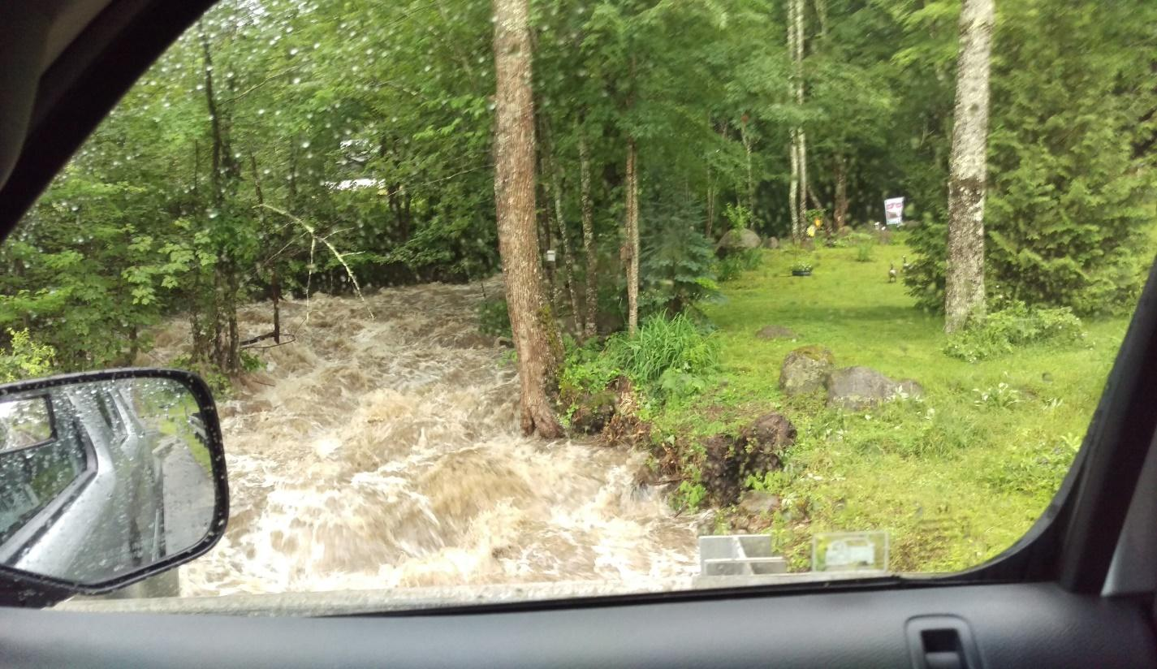
The following report provides details on these issues and covers many other topics. Ultimately the goal of this report is to assist the town to achieve the goals outlined in the Master Plan as the environment changes. Avery Brook, July 2017

Photo by Sherrill Howard

