Appendix A: Physical Sciences Report: Introduction

Over the last three million years, the global climate system has been forced by astronomical cycles with periods varying between 26 thousand and one hundred thousand years, causing it to oscillate between ice ages (which last more than 100,000 years) and interglacials (which are about ten times shorter). A third quasi-stable state is also known from evidence of an event that occurred more than 50 million years ago: A global hot house. Human industrial and agricultural activities have added a new forcing signal to the Earth’s inherently unstable climate system, by adding additional greenhouse gases (GHGs) to the atmosphere, and removing natural mechanisms that remove some of these gases. The result is a strong warming trend, beginning in the second half of the 19th Century, that cannot be explained by appealing to natural causes.

Internal feedbacks, such as the outgassing of methane and nitrous oxide from the sub-Arctic permafrost and Arctic Ocean floor, are now taking over, enhancing the artificially induced warming (e.g. Gray 2018, Science Daily 2019). The initiation of these positive feedbacks means that, even if human society were to completely halt the emission of excess GHGs today, warming, and all of its accompanying ills, could continue to worsen for several hundred more years. And our entire economic and political system, including the production of food and energy, is premised on Holocene (the present interglacial era, which began about 12,000 years ago) climate remaining in effect.

Steffen et al. (2018) illustrate the results of internal feedbacks with the image shown in Figure 1 (below). They explain that “there is a planetary threshold that, if crossed, could prevent stabilization of the climate at intermediate temperature rises and cause continued warming on a ‘Hothouse Earth’,” even with substantially reduced anthropogenic GHG emissions. They further state that the exact temperature increase at which this threshold exists is uncertain, but it could be quite close to the 1.5 – 2.0°C mark, which is well within the target set by the Paris Accord (Steffen et al. 2018). They further state that we may already had added enough addition GHGs to the atmosphere to carry the world right over that threshold.

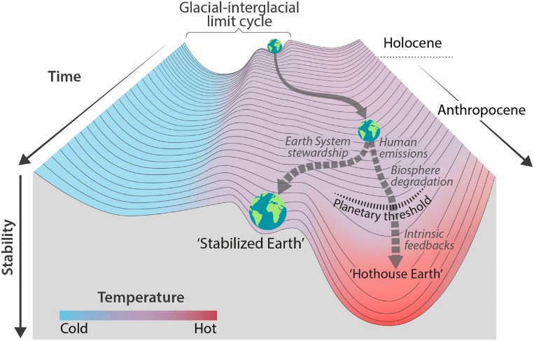
Fig. 1: Schematic illustrating past and near-future trajectories of the Earth system (Steffen et al. 2018). Possible future pathways, and the possible location of the threshold for a runaway greenhouse.

The new geologic period, in which human influence on Earth’s climate becomes the dominant effect, has been named the Anthropocene, and is distinct from the Holocene (e.g. Stromberg 2013). The Anthropocene is (or will soon be) characterized by a long list of consequences that threaten to overwhelm our ability to cope (e.g. IPCC 2014; Reidmiller et al. 2018; Stern 2007). Because of the positive feedbacks now operating in the climate system, of which induced methane emissions are only one, and the global failure to address the growing problem over the last 30 years, the onset of these consequences has either already begun, or is almost certain at some point in the next few decades. Among them are:

- Increasingly severe and frequent tropical storms
- Sea-level rise
- Extreme drought and extreme (acute) precipitation events
- Levels of heat that tax human endurance beyond the breaking point
- Shifting climatic zones and consequent ecosystem collapse
- Invasions of tropical diseases and insects into the middle latitudes
- Failing agricultural systems
- Economic depression
- Heightened international tension and open conflict
- Hundreds of millions of environmental refugees

References:

Gray, E., 2018: Unexpected future boost of methane possible from Arctic permafrost, NASA's Earth Science News Team, accessed July, 2019. [Available on-line at https://climate.nasa.gov/news/2785/unexpected-future-boost-of-methane-possible-from-arctic-permafrost/]

IPCC, 2014: AR5 Synthesis Report, Climate Change 2014, accessed July, 2019. [Available on-line at https://www.ipcc.ch/report/ar5/syr/]

Reidmiller, D., and Coauthors, 2018: Fourth National Climate Assessment, U.S. Global Change Research Program, Washington, D.C., accessed July, 2019. [Available on-line at https://nca2018.globalchange.gov]

Science Daily, 2019: Warming Arctic permafrost releasing large amounts of potent greenhouse gas, Harvard University, accessed July 2019. [Available on-line at https://www.sciencedaily.com/releases/2019/04/190415090848.htm]

Steffen, W., J. Rockström, K. Richardson, T. Lenton, C. Folke, D. Liverman, C. Summerhayes, A. Barnosky, S. Cornell, M. Crucifix, J. Donges, I. Fetzer, S. Lade, M. Scheffer, R. Winkelmann, and H. Schellnhuber, 2018: Trajectories of the Earth System in the Anthropocene, Proceedings of the National Academy of Sciences, 115 (33), 8252–8259, doi:10.1073/pnas.1810141115

Stern, N., 2007: The Economics of Climate Change: The Stern Review, Cambridge University Press,
doi:10.1017/CBO9780511817434

Stromberg, J., 2013: What Is the Anthropocene and Are We in It?, Smithsonian Magazine, accessed July 2019. [Available on-line at https://www.smithsonianmag.com/science-nature/what-is-the-anthropocene-and-are-we-in-it-164801414]

Appendix B: Physical Sciences Report, Part 1

Physical Sciences Report, Part 1:
21st Century Climate Projections for Campton and Surrounding Area.
S. Miller
23 May 2020

Background

The Fourth National Climate Assessment (Reidmiller et al. 2018) includes a chapter on expected climate change in the Northeast United States for the duration of the 21st Century. This report states that “[b]y 2035, and under both lower and higher scenarios (RCP4.5 and RCP8.5), the Northeast is projected to be more than 3.6° F (2 °C) warmer on average than during the preindustrial era. This would be the largest increase in the contiguous United States and would occur as much as two decades before global average temperatures reach a similar milestone.” Reidmiller et al. (2018) also state that the instrumental record over the past several decades indicates that “more intense precipitation events have [already] increased the risk of some types of inland floods, particularly in valleys, where people, infrastructure, and agriculture tend to be concentrated. With little redundancy in their infrastructure and, therefore, limited economic resilience, many rural communities have limited ability to cope with climate-related changes.”
In addition to economic challenges, the changes in regional climate already observed and the projected changes in climate over the next 80 years increases stresses on human health and well-being. Reidmiller et al. (2018) state that “[t]he changing climate of the Northeast…lead[s] to health-related impacts and costs, including additional deaths, emergency room visits and hospitalizations, higher risk of infectious diseases, lower quality of life, and increased costs associated with healthcare utilization. Health impacts of climate change vary across people and communities of the Northeast and depend on social, socioeconomic, demographic, and societal factors; community adaptation efforts; and underlying individual vulnerability.”
While some individuals and organized groups have tried to claim that the climatic changes observed over the past century are entirely natural, this assertion is not supported by direct and rigorous scientific investigation. The Intergovernmental Panel on Climate Change Fifth Assessment (2014) states plainly that “[h]uman influence on the climate system is clear, and recent anthropogenic emissions of greenhouse gases are the highest in history. Recent climate changes have had widespread impacts on human and natural systems” (IPCC 2014).
Several professional organizations, representing the community of climate scientists across the globe, have also made their positions on climate change quite clear. For example, the U.S. National Academies of Sciences states that “[s]cientists have known for some time, from multiple lines of evidence, that humans are changing Earth’s climate, primarily through greenhouse gas emissions… The evidence is clear and compelling. Earth’s atmosphere and oceans are warming, the magnitude and frequency of extreme climate and weather events are increasing, and sea level is rising along our coasts. Climate change is [already] having significant effects on infrastructure, agriculture, fisheries, public health, and the ecosystems that support society. It is also changing the environment in ways that affect the distribution, diversity, and long-term survival of species of plants, animals, and other forms of life on Earth” (NAS 2020). Another example is the American Geophysical Union, which states that this warrants “immediate and coordinated actions to limit and adapt to human-caused climate change…to protect human and ecological health, economic well-being, and global security” (AGU 2019). Thus, climate change represents not only the primary effects of increasing mean temperatures and changes in precipitation patterns (detailed below), but also creates a plethora of secondary effects involving the health and well-being of humans, their communities, and wildlife.
Waiting for regional climate change to reach crisis levels before taking adaptation measures is not a cost-effective strategy. This is akin to waiting for a building to catch fire before purchasing an insurance policy or hiring a fire department. To this end, Vogel et al. (2016) detail climate change adaptation efforts already underway in 17 different communities across the United States (ranging in size from small towns to large cities, such as Boston). One such community is Dover, New Hampshire, which has adopted a highly-detailed and proactive adaptation plan as part of the city’s 2018 master plan (Peterman and Coauthors 2018). Vogel et al. (2016) includes the following summary recommendations for community-level adaptation, based on an integration of the best practices already in use.

Communities should:

- Start getting ready now.
- Look for co-benefits, cross-sector leveraging, and opportunities to “piggyback” climate adaptation onto other relevant community issues.
- Employ commonly used policy tools to mainstream adaptation.
- Build flexibility into policies, projects, and programs.
- Consider both the needs and capabilities of more vulnerable populations.
- Creative outreach and community engagement efforts build community support.
- Take prudent risks and adjust over time.
- Consider the local (cultural) context.
- Provide leadership.
- Work with partners.

For a detailed review of Vogel et al. (2016), including further discussion of the underlying climate science and the implications for community development objectives, see Miller (2019).
While it is not the purpose of this report to repeat the extensive content of the Reidmiller et al. (2018), the many peer-reviewed scientific publications referenced by their report, or the other documents referenced here, this section will attempt to summarize the expected climatic changes relative to Campton, located in central New Hampshire, for the period beginning in 2020 and ending in approximately 2040. Later sections of this report will address several secondary effects of the expected changes in temperature and precipitation during this period.

Insensitivity to emissions scenario. Bryan et al. (2015), in their literature review, state that warming of the climate will continue through the 21st Century, even if all anthropogenic greenhouse gas (GHG) emissions were to cease immediately. This is the result of the long residence time of carbon dioxide in Earth’s atmosphere, which is on the order of 1000 years.
With continuing emissions, the amount of warming beyond mid-century is dependent on the emissions scenario (Nakicenovic et al. 2000), but prior to that, particularly in the period from 2020 through 2040, the differences between the amount of warming under different emissions scenarios is small. Figure 1 (below), reproduced from Bryan et al. (2015), shows the expected mean temperature in Maine through the 21st Century for the winter and summer seasons. (Their research domain included a large portion of the northeastern United States, and they use Maine to demonstrate the expected warming in New England.) The figure clearly shows that the differences in warming associated with different GHG emission scenarios do not become important until the very end of this report’s period of interest. Bryan et al. (2015) report similar results for precipitation: Changes in regional precipitation totals, in inches of liquid equivalent per day, are relatively insensitive to assumptions about emissions until after the end of our period of interest.

Fig. 1: Average seasonal temperatures in the Northeast United States, under different emission scenarios. Red and blue lines represent high and low emission scenarios, respectively, from a 33-member ensemble of global climate models, downscaled to 800-meter horizontal resolution. Black line corresponds to historical (observed) data. Upper panel: Meteorological Winter (DJF); Lower panel: Meteorological Summer (JJA). Period of interest in this report (2020 - 2040) is indicated by the yellow boxes. (Reproduced from Bryan et al. 2015.)

Expected changes in temperature. Bryan et al. (2015) state that (based on historical information) annual temperatures in the Northeast have increased by an average of 0.16 °F (0.09 °C) per decade from 1895 through 2011, and that warming has been more pronounced during the winter (0.24 °F/0.13 °C per decade) than the rest of the year during this period. Thibeault and Seth (2014) further state that the historical record indicates that minimum temperatures in the Northeast are warming more rapidly than maximum temperatures, consistent with observed changes seen around the world.
Scherer and Diffenbaugh (2014) utilized a multi-member ensemble of global climate models to evaluate the changes in temperature in different regions of the United States expected with climate change. They computed Baseline (BL) median temperatures at each gridpoint, along with the distribution of daily median temperature values about the average daily median temperature. This was accomplished for both annual and seasonal values, based on the historical observations of temperature for the 30-yr period beginning in 1980 and ending in 2009. Next, they define two metrics (both of which are illustrated in Figure 2):

- Permanent Exceedance (PE): The minimum value of the new daily median temperature distribution in a region is equal to the average daily median value of the old BL temperature distribution. In a warming climate, this benchmark would occur first.

- New Normal (NN): The average value of the new daily median temperature distribution in a region is equal to the maximum daily median value of the old BL temperature distribution. In a warming climate, this benchmark would occur after PE.

Fig. 2: Increases in median temperature, and distribution about the median. BL = Baseline (median and distribution; 1980 – 2009). Thin dashed line = Permanent Exceedance (PE). Heavy dashed line = New Normal (NN). (Adapted from Scherer and Diffenbaugh 2014.)

Scherer and Diffenbaugh (2014) report the following relevant findings for the Northeast:

- For maximum daily temperatures, PE is expected by 2030. This means that the new lowest daily maximum temperature will be equal to the median daily maximum temperature in the historical BL period by then.

- They also expect NN for daily maximum temperatures by 2040, the end of our period of interest. This means that the new median daily maximum temperature will be equal to the maximum daily maximum in the historical BL period of 1980 - 2009.

Both of these benchmarks indicate a significant upward daily shift in daily high temperatures, and both fall within the high-confidence, emissions-independent period discussed in Bryan et al. (2015). This means that both PE by 2030 and NN by 2040 can be taken with high confidence, and that we can expect an increase in the incidence of heat waves and the resulting toll on human health in Campton within 20 years.
Karmalkar and Bradley (2017) also used downscaled global model simulations to estimate regional warming in the United States. Their work utilized a threshold-based approach, producing the amount of warming (in degrees Celsius) by period. They find that, while all regions of the contiguous United States are warming faster than the global rate, the Northeast region is warming the fastest. Relevant to this report’s period of interest, Karmalkar and Bradley (2017) report that the Northeast will warm by 5.4 °F (3 °C) by 2039, relative to pre-industrial times, while the rest of the world warms by an average of 3.6 °F (2 °C). This is somewhat higher than the Northeast warming estimate reported in Bryan et al. (2015), which is 3.6° F (2 °C) by 2035.
Fan et al. (2015) used an ensemble of regional climate models, forced by global climate models, as part of the North American Regional Climate Change Assessment Program (NARCCAP), to develop projections of future temperature and precipitation changes in the Northeast United States. They based their work on a baseline period of historical observations spanning the years 1961 – 1990, and report that, by the period beginning in 2041 (the end of this report’s period of interest) and ending in 2070:

- Ensemble-average temperature increases in winter in the Northeast will be 5.8 °F (3.2 °C).

- Ensemble-average temperature increases in summer in the Northeast will be 4.5 °F (2.5 °C), with increased variability.

In both cases, the projected increases in temperature far exceed the estimated natural variability in the region. Thibeault and Seth (2014) also reported that Northeast winters will become milder (warmer), and summers hotter, displaying statistically significant shifts outside their current ranges. This echoes the findings of Scherer and Diffenbaugh (2014) for the period 2020 – 2039. Thibeault and Seth (2014), looking further out to the period between 2041 and 2070, found that the resulting warm summer extremes are “likely to impact human populations vulnerable to extreme heat, e.g. young children, the elderly, and people with respiratory illnesses…”

Identifying the historical warming trend. Fryeburg, Maine (ICAO identifier KIZG) has an airport weather station, called an AWOS, that records surface weather conditions as often as once every 20 minutes. KIZG is located at 43.99 °N, 70.95°W, at an elevation of 135 meters above sea level (mASL). Plymouth, New Hampshire (K1P1) is located at 43.78 °N, 71.75 °W, at an elevation of 157 mASL. The great-circle distance between these two stations is 68.12 kilometers (42.35 statute miles). Given the short distance between these two stations, their similarity in elevation and other physical geographic factors, and the fact that both stations are in the same U.S. Department of Agriculture Plant Hardiness/Climate zone (5a), we assumed that KIZG is a reasonable proxy for K1P1.
While K1P1 is relatively close to Campton, it only became operational as recently in 2007. The data from KIZG go back considerably further, and are easily obtainable via the Plymouth State Weather Center database. Given the readily available data for KIZG, and its climatological similarity to K1P1, the following historical statistics (Table 1) are presented for the former to represent the range of temperature conditions in Campton. The period represented by these statistics begins on 01 January 1999 0000 EST, and ends on 31 December 2019 2300 EST, a period of approximately 21 years (184,080 hours).

Table 1: Bulk temperature statistics for Fryeburg, Maine (KIZG), for 21-yr record of hourly temperatures. Values shown are in degrees Fahrenheit (degrees Celsius in parenthesis). Average range is defined as average daily maximum – average daily minimum.
 | Average Daily  Minimum | Average Daily  Median | Average Daily  Maximum | Average Range
Annual | 33.71 (0.95) | 45.64 (7.58) | 56.30 (13.50) | 22.59 (12.55)
Winter | 11.36 (-11.41) | 23.50 (-4.72) | 32.50 (0.28) | 21.14 (11.69)
Summer | 54.97 (12.76) | 67.01 (19.45) | 78.67 (25.93) | 23.70 (13.17)

The 21-yr time series of temperature at KIZG was divided into two periods. The first 11 years selected for comparison with Scherer and Diffenbaugh (2014), discussed below; and the second half for comparison to the first.

- The first period spans the period beginning on 01 January 1999 0000 UTC, and ending on 31 December 2009 2300 EST, and includes hourly observations of temperature for 96,432 hours (11 years). Bulk statistics for this period are shown in Table 2.

- The second period spans the period beginning on 01 January 2010 0000 UTC, and ending on 31 December 2019 EST UTC, and includes hourly observations of temperature for 87,648 hours (10 years). Bulk statistics for this period are shown in Table 3.

Table 2: Bulk temperature statistics for Fryeburg, Maine (KIZG), for 11-yr period ending December, 2009. Values shown are in degrees Fahrenheit (degrees Celsius in parenthesis). Average range is defined as average daily maximum – average daily minimum.
 | Average Daily  Minimum | Average Daily  Median | Average Daily  Maximum | Average Range
Annual | 33.21 (0.67) | 45.14 (7.30) | 55.92 (13.29) | 22.71 (12.62)
Winter | 10.49 (-11.95) | 22.68 (-5.18) | 32.05 (0.03) | 21.56 (11.98)
Summer | 54.84 (12.69) | 66.54 (19.19) | 78.21 (25.67) | 23.37 (12.98)

Table 3: Bulk temperature statistics for Fryeburg, Maine (KIZG), for 10-yr period ending December, 2019. Values shown are in degrees Fahrenheit (degrees Celsius in parenthesis). Average range is defined as average daily maximum – average daily minimum.
 | Average Daily  Minimum | Average Daily  Median | Average Daily  Maximum | Average Range
Annual | 34.29 (1.27) | 46.99 (8.33) | 56.73 (13.74) | 22.44 (12.47)
Winter | 12.54 (-10.81) | 24.42 (-4.21) | 33.01 (0.56) | 20.47 (11.37)
Summer | 55.13 (12.85) | 67.53 (19.74) | 79.20 (26.22) | 24.07 (13.37)

Comparing the results shown in Table 3 to those shown in Table 2, it is clear that, by every measure, the climate in Fryeburg warmed. Table 4 summarizes the differences between the values in Tables 2 and 3, with positive numbers indicating that the values in Table 3 are greater than the values in Table 2. Table 4 indicates average winter minimum temperatures have increased by about twice as much average annual minimum temperatures, and about six times as much as average summer minimum temperatures, which is agreement with Fan et al.’s (2015) projections that winter is warming at a greater rate than summer. The increase in the average range in the summer also increased (while the annual and winter ranges decreased), which is also in good agreement with Fan et al. (2015).

Table 4: Differences between bulk temperature statistics for Fryeburg, Maine (KIZG), for the two periods shown in Tables 2 and 3. Positive numbers indicate that the values in Table 3 are greater than those in Table 2. Values shown are in degrees Fahrenheit (degrees Celsius in parenthesis).
 | Average Daily  Minimum Change | Average Daily  Median Change | Average Daily  Maximum Change | Average Range Change
Annual | 1.08 (0.60) | 1.85 (1.03) | 0.81 (0.45) | -0.27 (-0.15)
Winter | 2.05 (1.14) | 1.74 (0.97) | 0.96 (0.53) | -1.09 (-0.61)
Summer | 0.29 (0.16) | 0.99 (0.55) | 0.99 (0.55) | 0.70 (0.39)

Estimating warming through 2040. Three methods were used to estimate temperature changes during the period of interest. The first used linear projections based on the baseline temperatures summarized in Table 3, and the 10-yr changes summarized in Table 4. Using this method, we find the following for our benchmark years:

- By 2030, annually-averaged daily median temperatures should increase by another 1.85 °F, to 48.84 °F. Average winter daily median temperatures should increase by another 1.74 °F, to 26.16 °F. Average summer daily median temperatures should increase by another 0.99 °F, to 68.52 °F.

- By 2040, annually-averaged daily median temperatures should increase to 50.69 °F. Winter daily median temperatures should increase to 27.90 °F, and summer daily median temperatures should increase to 69.51 °F.

Since the Fryeburg temperatures used as a baseline in this method cover a period of only 11 years, rather than the usual 30 (e.g. Scherer and Diffenbaugh 2014), and because the records are from the most recent (and therefore warmer) period, there is probably a warm bias in these projections, with a maximum magnitude on the order of about 1 °F.
The second method used Scherer and Diffenbaugh (2014)’s findings about PE and NN for daily maximum temperatures in the Northeast. Table 5 shows bulk statistics for daily maximum temperatures during the period beginning on 01 January 1999 0000 EST, and ending on 31 December 2009 2300 EST (96,432 hours), which we used as our baseline period. Note that this is the same period used to compute the contents of Table 2.

Table 5: Range of daily maximum temperatures for Fryeburg (KIZG) for the 11-yr period ending in December, 2009. Values shown are in degrees Fahrenheit (degrees Celsius in parenthesis).
 | Minimum Daily  Maximum | Median Daily  Maximum | Maximum Daily  Maximum | Range
Annual | -2.99 (-19.44) | 55.99 (13.33) | 99.00 (37.22) | 101.99 (56.66)
Winter | -2.99 (-19.44) | 32.00 (0.00) | 69.01 (20.56) | 72.00 (40.00)
Summer | 48.99 (9.44) | 79.00 (26.11) | 99.00 (37.22) | 50.01 (27.78)

Combining the results shown in Table 5 with Scherer and Diffenbaugh (2014), the following estimates were made for changes in daily maximum temperatures in 2030 and 2040:

- 2030: PE for daily maximum temperatures, meaning the new lowest daily maximum temperature will be equal to the median daily maximum temperature in the historical BL period. For winter, this means the new lowest daily maximum temperature will be 32 °F, and for summer, 79 °F.

- 2040: NN for daily maximum temperatures, meaning the new median daily maximum temperature will be equal to the maximum daily maximum in the historical BL period. For winter, this means the new median daily maximum temperature will be 69 °F, and for summer, 99 °F.

For the same reasons noted in the previous method, there is probably a warm bias in these projections, on the order of about 1 °F.
The third method was based Fan et al. (2015)’s ensemble-average model projections that winter temperatures in the Northeast will increase by 5.8 °F (3.2 °C) by the 2041-2070 timeframe, and that summer temperatures will increase by 4.5 °F (2.5 °C), with respect to the 1961-1990 baseline period. To complete this calculation, a record of temperatures recorded in Concord, New Hampshire (KCON) was obtained from Climatologist Barry Keim and his graduate student (Keim and Thompson 2020), and subjected to standard quality-control techniques. This record begins on 01 January 1961 at 0000 EST, end on 31 December 1990 at 1800 EST, representing a period of 262,968 hours. There is a three-year long period of missing data beginning in 1970 and ending in 1972. Records are hourly from 1961-1990, once every three hours from 1965-1969, and hourly again beginning in 1973. Concord was deemed a suitable proxy for Plymouth and Campton, because (a) it is 67.99 kilometers (42.15 statute miles) from Plymouth (about the same distance as Fryeburg from Plymouth), and (b) like Fryeburg, it is in the same U.S. Department of Agriculture Plant Hardiness/Climate zone as Plymouth and Campton (5a).
Unlike Fryeburg, however, Concord is at a slightly lower latitude than Plymouth. This results in slightly warmer median and mean temperatures than Plymouth. Comparing more recent records for Plymouth (K1P1) to Concord (KCON) (for the period between 2007 and 2020), there appears to be a difference in summer median temperature between KCON and K1P1 of about 1.98 °F, and a winter median difference of about 3.99 °F. In both cases, Concord was the warmer station. A similar comparison of mean temperatures indicates that KCON is about 2.54 °F warmer than K1P1 in summer, and 1.78 °F warmer in winter. Table 6 shows the median and mean seasonal temperatures derived from the 1961-1990 Concord record, and Table 7 shows estimated median and mean seasonal temperatures for Plymouth, based on the KCON-K1P1 warm biases noted.

Table 6: Seasonal median and median temperatures for Concord, New Hampshire, for the period 1961-1990. Values shown are in degrees Fahrenheit (degrees Celsius in parenthesis).
 | Median Temperature | Mean Temperature
Winter | 24.00 (-4.44) | 22.67 (-5.81)
Summer | 68.00 (20.00) | 67.71 (19.84)

Table 7: Estimated seasonal median and median temperatures for Plymouth, New Hampshire, for the period 1961-1990, using bias-adjusted data from Concord. Values shown are in degrees Fahrenheit (degrees Celsius in parenthesis).
 | Median Temperature | Mean Temperature
Winter | 20.01 (-6.66) | 20.89 (-6.17)
Summer | 66.02 (18.90) | 65.17 (18.43)

Combining the results shown in Table 7 with Fan et al. (2015), the following estimates were made for changes in seasonal median and mean temperatures in the period 2041-2070:

- Winter: Median seasonal temperature will increase to 25.81 °F; Mean seasonal temperature will increase to 26.69 °F.

- Summer: Median seasonal temperature will increase to 70.52 °F; Mean seasonal temperature will increase to 69.67 °F.

Expected changes in precipitation. Thibeault and Seth (2014) report that the Northeast has already become wetter, with more frequent extreme precipitation events, than during earlier periods in history. Using a 23-model ensemble, they found that this trend will continue through the 21st Century, with increases in precipitation due to more frequent, intense extreme precipitation events.
Thibeault and Seth (2014) focused their work on the end of our period of interest, with the same temporal window of 2041 – 2070. Compared to their baseline period of 1981 – 2010, they found that increases in total annual precipitation in the Northeast are strongly influenced by increases in winter wet extremes. “Projected increases in winter wet extremes are larger than for summer, [and] consistent with projected increases in mean winter precipitation are triple those of summer” [emphasis added].
Fan et al. (2015) also focused their work on the end of our period of interest, but used a baseline period of hourly precipitation beginning in 1961 and ending in 1990. Further, their results provide specific numbers we can work with to estimate seasonal precipitation amounts for the 30-year period beginning in 2041. Their results indicate a 21 – 23 percent increase in winter precipitation, and (unlike Thibeault and Seth (2014)) a 1.5 to 7.9 percent decrease in summer precipitation over the baseline period by 2041. Further, their results indicate an increase in the variability of winter precipitation totals of about 1.6 percent.
To apply these results, a database of hourly precipitation amounts in Concord, New Hampshire (KCON), beginning in 1960 and ending in 1999, was obtained from Keim and Thompson (2020). (Once again, we used Concord as a proxy for Plymouth and Campton because of the relatively short distance between them, because they are in the same USDA climate zone, and because a long record of hourly observations at Concord was easily available.) After merging the four separate 10-yr files, removing the extraneous data from both before and after the baseline period, and applying quality control procedures, winter and summer seasonal precipitation totals were computed for each year beginning in 1961 and ending in 1990, by summing the hourly amounts. Some interpolation was necessary to account for missing data, but was limited to 6-hr gaps (which were rare). The same three years were missing in this dataset as were missing in the parallel hourly temperature dataset used above (1970 – 1972). Note that, for much of the winter precipitation, the relevant numbers are for the liquid equivalent (or Snow Water Equivalent; SWE), obtained when snow is melted. Table 8 shows the yearly results. The winter total for 1980 is suspiciously low and may be the result of degraded data. The rest of the seasonal totals shown seem reasonable, and correspond well with the usual annual total in Concord of about 40 inches liquid equivalent (USA Climate 2020). Bulk statistics computed from the seasonal precipitation totals in Table 8 are shown in Table 9.

Table 8: Seasonal precipitation totals for Concord, New Hampshire, for the period 1961-1990. Values shown are in inches SWE. Winter = DJF; Summer = JJA.
Year | Winter Total | Summer Total
1961 | 6.28 | 8.83
1962 | 8.40 | 8.89
1963 | 5.99 | 6.90
1964 | 8.64 | 6.92
1965 | 5.40 | 7.62
1966 | 7.47 | 9.81
1967 | 8.38 | 10.68
1968 | 8.81 | 10.71
1969 | 11.31 | 13.83
1970 | ND | ND
1971 | ND | ND
1972 | ND | ND
1973 | 11.94 | 12.82
1974 | 9.10 | 5.47
1975 | 9.62 | 11.49
1976 | 8.13 | 6.45
1977 | 8.49 | 6.93
1978 | 9.87 | 7.36
1979 | 12.46 | 7.65
1980 | 2.06 | 8.61
1981 | 12.41 | 11.79
1982 | 7.68 | 13.12
1983 | 11.46 | 6.54
1984 | 9.72 | 8.24
1985 | 4.59 | 8.39
1986 | 11.52 | 13.51
1987 | 4.57 | 12.37
1988 | 5.26 | 12.77
1989 | 3.72 | 11.43
1990 | 9.52 | 11.51

Table 9: Bulk statistics of annual seasonal precipitation totals in Concord, New Hampshire during the period 1961-1990. Values shown are in inches SWE.
Statistic | Winter | Summer
Max | 12.46 | 13.83
Min | 2.06 | 5.46
Mean | 8.25 | 9.65
Median | 8.49 | 8.89
Standard Deviation | 2.78 | 2.54

Combining the results shown in Table 9 with those of Fan et al. (2015), we find that:

- Winter: Seasonal totals are expected to increase by 21 to 23 percent by 2041. This corresponds to maximum values of 15.08 to 15.32 inches, mean values of 9.98 to 10.15 inches, and median values of 10.27 to 10.44 inches. Variability in these totals, expressed in Table 9 as standard deviation, will increase by 1.6 percent to 2.82 inches.

- Summer: Seasonal totals are expected to decrease by 1.5 to 7.9 percent by 2041. This corresponds to maximum values between 12.74 and 13.62 inches, minimum values between 5.03 and 5.38 inches, mean values between 8.89 and 9.51 inches, and median values between 8.19 and 8.76 inches.

References

American Geophysical Union (AGU), 2019: Position Statement on Climate Change. [Available on-line at https://www.agu.org/Share-and-Advocate/Share/Policymakers/Position-Statements/Position_Climate]

Bryan, A., A. Karmalkar, E. Coffel, L. Ning, R. Horton, E. Demaria, F. Fan, R. Bradley, and R. Palmer, 2015: Chapter 1: Climate Change in the Northeast and Midwest United States, in Integrating Climate Change into Northeast and Midwest State Wildlife Action Plans, Northeast Climate Science Center, Amherst, Massachusetts, 201 pp. [Available on-line at http://necsc.umass.edu/biblio/integrating-climate-change-northeast-and-midwest-state-wildlife-action-plans]

Fan, F., R. Bradley, and M. Rawlins, 2015: Climate change in the Northeast United States: An analysis of the NARCCAP multimodel simulations, Journal of Geophysical Research: Atmospheres, 120, 10,569 – 10,592, DOI: 10.1002/2015JD023073.

Intergovernmental Panel on Climate Change (IPCC), 2014: AR5 Synthesis Report, Observed Changes and Their Causes. [Available on-line at https://www.ipcc.ch/report/ar5/syr/]
Karmalkar, A., and R. Bradley, 2017: Consequences of global warming of 1.5 ̊C and 2 ̊C for regional temperature and precipitation changes in the Contiguous United States. PLoS ONE 12 (1): e0168697. DOI:10.1371/journal. pone.0168697.
Keim, B., and D. Thompson, 2020: Personal communications. Dr. Keim is a professor of geography at Louisiana State University in Baton Rouge, and the Louisiana State Climatologist. Mr. Thompson is his graduate student. Dr. Keim was the author’s Ph.D. advisor at the University of New Hampshire, from 1999 through 2003, as well as the former New Hampshire State Climatologist.
Miller, S., 2019: Community development in a time of climate crisis, graduate student paper, Carsey School of Public Policy, University of New Hampshire, 34 pp. [Available on-line at https://vortex.plymouth.edu/~stmiller/stmiller_content/Publications/CommunityDevlpment_2019.pdf]

National Academy of Sciences (NAS), 2020: Climate at the National Academies. [Available on-line at https://sites.nationalacademies.org/sites/climate/index.htm]

Peterman, J., and Coauthors, 2018: City of Dover, New Hampshire Master Plan: Chapter 18 Climate Adaptation Chapter, Department of Planning and Community Development, City of Dover, 66 pp. [Available on-line at https://www.dover.nh.gov/Assets/government/city-operations/2document/planning/master-plan/Climate/Climate_Adaptation_Chapter_Certified.pdf]

Reidmiller, D., and Coauthors, 2018: Fourth National Climate Assessment, Chapter 18: Northeast, U.S. Global Change Research Program (USGCRP). [Available on-line at https://nca2018.globalchange.gov/chapter/18/]

Scherer, M., and N. Diffenbaugh, 2014: Transient twenty-first century changes in daily-scale temperature extremes in the United States, Climate Dynamics, 42, 1383 – 1404, DOI: 10.1007/s00382-013-1829-2.

Thibeault, J., and A. Seth, 2014: Changing climate extremes in the Northeast United States: Observations and projections from CMIP5, Climatic Change, 127, 273 – 287, DOI: 10.1007/s10584-014-1257-2.

University Corporation for Atmospheric Research (UCAR), 2020: The A2 Emissions Scenario, North American Regional Climate Change Assessment Program, available on-line at https://www.narccap.ucar.edu/about/emissions.html; referenced to Nakicenovic et al., 2000. Special Report on Emissions Scenarios. A Special Report of Working Group III of the Intergovernmental Panel on Climate Change, Cambridge University Press, 599 pp.

USA Climate Data, simple climatology for Concord, New Hampshire, accessed May, 2020. [Available on-line at https://www.usclimatedata.com/climate/concord/new-hampshire/united-states/usnh0045]

Vogel, J., K. Carney, J. Smith, C. Herrick, M. Stults, M. O’Grady, A. St. Juliana, H. Hosterman, and L. Giangola, 2016: Climate Adaptation – The State of Practice in U.S. Communities, The Kresge Foundation. [Available on-line at https://www.georgetownclimate.org/files/report/climate-adaptation-the-state-of-practice-in-us-communities-full-report.pdf]

Appendix C: Physical Sciences Report, Part 2

Physical Sciences Report, Part 2:
21st Century Climate Projections for Campton and Surrounding Area.

S. Miller
August, 2020

Background. Climate conditions for the region in around Campton, New Hampshire were estimated using model data provided by the Earth Systems Research Center (ESRC) at the University of New Hampshire’s Institute for the Study of Earth, Oceans, and Space. This work was done to evaluate the vulnerability of Campton’s local economy to stresses on the local ski industry and local agriculture, as well as the vulnerability of the town’s public health brought about by anthropogenic climate change over the course of the 21st Century. The primary objective was to evaluate changes to the climate during the period beginning in 2020 and ending in 2040, which corresponds to the main focus of our report on climate change adaptation and mitigation strategies, commissioned during the 2020 Town Meeting. The secondary objective of this work was to evaluate climatic changes over the remainder of the 21st Century.

ESRC used an ensemble of 29 Global Climate Models (GCMs) to project daily values of total precipitation [mm], maximum and minimum temperature [°C], and snowpack [mm SWE]. A smaller ensemble of 14 GCMs was used to project daily values of snowfall [mm SWE]. In all cases, the base GCMs were used to compute mean climatic conditions, and a “weather generator” was used to compute random variations about the mean conditions projected for a given day. Data were then downscaled to local conditions via the method described in Pierce et al. (2014) and Grogan et al. (2020). Locally-downscaled conditions were computed to a resolution of 1/16 of a degree of latitude, corresponding to a linear distance of 6.9 kilometers, or about 47.8 km². Time series of all five daily parameters for the gridpoints corresponding to four ski resorts within about 25 miles of Campton (Table 1) were extracted from each ensemble member by Burakowski (2020), and made available via electronic bulletin board. Miller downloaded the files and used a Matlab-based suite of data analysis procedures, called AirSea, to compute ensemble means and associated statistics (Miller 2020). Additional parameters were computed using AirSea from the five original parameters as described below (see Data and Methods).

Table 1: Ski resorts corresponding to gridpoints used in this study.
Name of Resort | Latitude [DMS N] | Longitude [DMS W] | Distance from Campton [km] (miles)
Cannon Mountain | 44° 10’ 37” | 71° 42’ 06” | 36.61 (22.75)
Loon Mountain | 44° 03’ 23” | 71° 38’ 00” | 22.99 (14.29)
Tenney Mountain | 43° 44’ 49” | 71° 45’ 55” | 14.78 (9.18)
Waterville Valley | 43° 57’ 06” | 71° 30’ 18” | 16.12 (10.02)

All models in the ensemble were forced using two different greenhouse concentration scenarios, known as “Representative Concentration Pathways” (RCPs; Grogan et al. 2020). These are not emissions scenarios, but models of greenhouse gas concentrations levels that result in different levels of radiative forcing, and were adopted for use with GCMs by scientists contributing to the work of the Intergovernmental Panel on Climate Change (IPCC). While there are many RCPs, only four were used in the IPCC’s Fifth Assessment, published in 2014: RCP2.6, RCP4.5, RCP6.0, and RCP 8.5. Figure 1 (below) shows all four RCPs and their corresponding greenhouse concentration levels for the period beginning in 2000 CE and ending in 2100 CE. For more detail, the reader is referred to the IPCC’s Data Distribution Center (2019), and the RCP Database (2009). For the relationship between RCPs and socioeconomic conditions, please see Hausfather (2018).

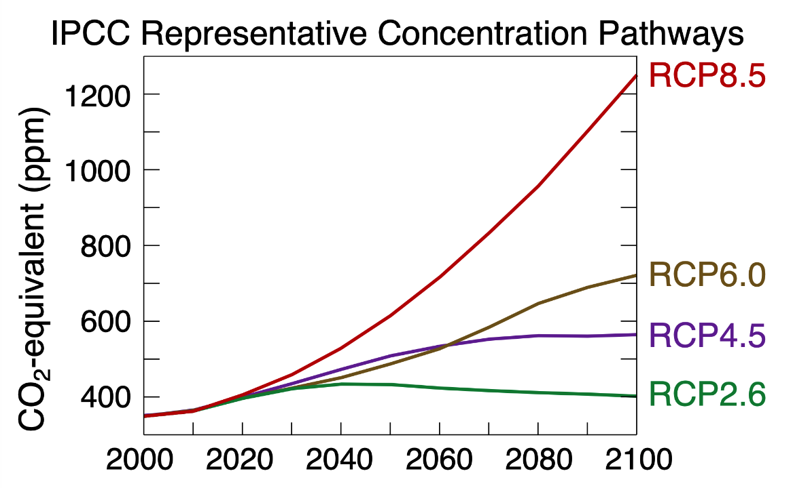
Fig. 1: IPCC Representative Concentration Pathways (Creative Commons License 4.0)

The two RCPS used with the model ensemble in this work are further defined by the National Oceanic and Atmospheric Administration (NOAA(a), n.d.; NOAA(b), n.d.) as follows:

- RCP4.5 is “a stabilization scenario, which means the radiative forcing level stabilizes at 4.5 Wm⁻² before 2100 by [the] employment of a range of technologies and strategies for reducing greenhouse gas emissions.” This can be thought of as a scenario in which very aggressive actions are taken at all levels of society, worldwide, to reduce anthropogenic greenhouse gas emissions and stabilize the climate in Holocene-like conditions.

- RCP8.5 is a “scenario [in which] the radiative forcing reaches 8.5 Wm⁻² characterized by increased greenhouse gas emissions over time [and is] representative for scenarios in the literature leading to high greenhouse [gas] concentration levels.” This has been described as a “business as usual” scenario, in which anthropogenic greenhouse gas emissions continue to grow as a result of increasing industrialization, large-scale agriculture, population growth, and rising standards of living in the developing world. There is some debate about this characterization, with some preferring to describe RCP8.5 as “worst case scenario.” It seems possible that both of these descriptions are accurate. The reader is referred to ClimateNexus (n.d.) for further discussion of this point.

The answers to two general categories of questions were explored using the datafiles provided by UNH. These included questions about (1) how the cold-season would evolve in the Campton area over the 21st Century, and how these changes might affect recreational skiing, which is a major factor in the economy of the town; and (2) how the warm-season would evolve during the same period of time, and how these changes might impact public health, agriculture, and infrastructure. The ski season in New Hampshire usually begins in mid-November, and ends in mid-April, and so we defined the cold-season as the six-month period including November, December, January, February, March, and April. The warm-season was then defined as the other six-month period, beginning in May and ending in October.

Data and Methods. Burakowski (2020) provided time series of daily maximum and minimum temperature [°C], precipitation [mm], snowfall [mm SWE], and snowpack [mm SWE]. These files contained a date-time group [YYYYMMDD] in column 1, and an additional column with the parameter in question. Metadata at the top of each file listed the applicable units. The data begin on 01 January 1980, and end on 31 December 2099. Entries are on a daily basis. The entries for the first 25 years represent observations during the “spin up” time for the ensemble’s member models, and the remainder of the data are the generated by the GCMs in question (Burakowski 2020).

Individual results were computed at five-year intervals from the base model data as follows:

- Mean daily minimum temperatures by month for the cold-season were computed by (1) stepping through each ensemble member and identifying all entries for that month; (2) taking the model’s mean value for the minimum temperature during that month; (3) repeating for all ensemble members; and (4) taking the ensemble-mean of all mean monthly minimum temperatures.

- Daily maximum temperature datafiles were used to compute the number of warm-season days with high temperatures ≥ 90 °F (32.2 °C), defined at this level because it is associated with a marked increase in heat-related illness. This was accomplished by (1) stepping through each model identifying all warm-season daily high temperatures during the year in question; (2) counting the number of days during the warm-season when the high temperature met or exceeded the threshold; (3) repeating for all ensemble members; and (4) taking the ensemble-mean of all members during the warm-season for that year.

- The mean number of days per month when artificial snowmaking is possible during the cold-season were computed using the assumption that “snow guns” can be used when the minimum temperature of the day is ≤ 28 °F (-2 °C) (Wilson et al. 2018; Grogan et al. 2020). Note that this criteria does not determine how many hours during a given day snowmaking will be possible, but only that snowmaking will be possible for at least one hour during a given day. Days during a given month with minimum temperature ≤ -2 °C were totaled up for each model, then averaged across all ensemble members for that month.

- Mean monthly precipitation totals during the cold-season were computed by (1) stepping through each ensemble member and totaling up all precipitation values for that month; (2) repeating for all ensemble members; and (3) taking the ensemble-mean of all monthly precipitation totals.

- Mean monthly snowfall totals were computed by similar means.

- Mean monthly snowfall-to-precipitation ratio was computed by combining the results of steps 4 and 5 (described above), and applying the results to:

$$Ratio= 100 \% x \left(\frac{Monthly Snowfall Total}{Monthly Precipitation Total}\right)$$ | (1)

- Mean monthly snowpack during the cold-season was computed by (1) stepping through each ensemble member and identifying all entries for that month; (2) taking the model’s mean value for the daily snowpack during that month; (3) repeating for all ensemble members; and (4) taking the ensemble-mean of all mean monthly snowpack values.

- Mean “drought lengths” were computed for the warm-season by (1) identifying stretches of days in each ensemble member with zero precipitation for 3, 5, 7…. 15 days; (2) counting them up; and (3) averaging the results for each category across all ensemble members. For example, a stretch of days with no precipitation for five days would contain three 3-day stretches, two 4-day stretches, and one 5-day stretch.

- Warm-season heavy precipitation days were computed in “buckets,” by (1) searching each ensemble-member for days with precipitation totals in certain categories (defined below); and (2) averaging the category totals across all members of the ensemble.

Cold-Season Results. In all cases, two separate sets of results are shown, corresponding to the RCP4.5 and RCP8.5 emissions scenarios. These are presented here graphically. Interpretation of these results is in the next section.

- Average minimum daily temperature:

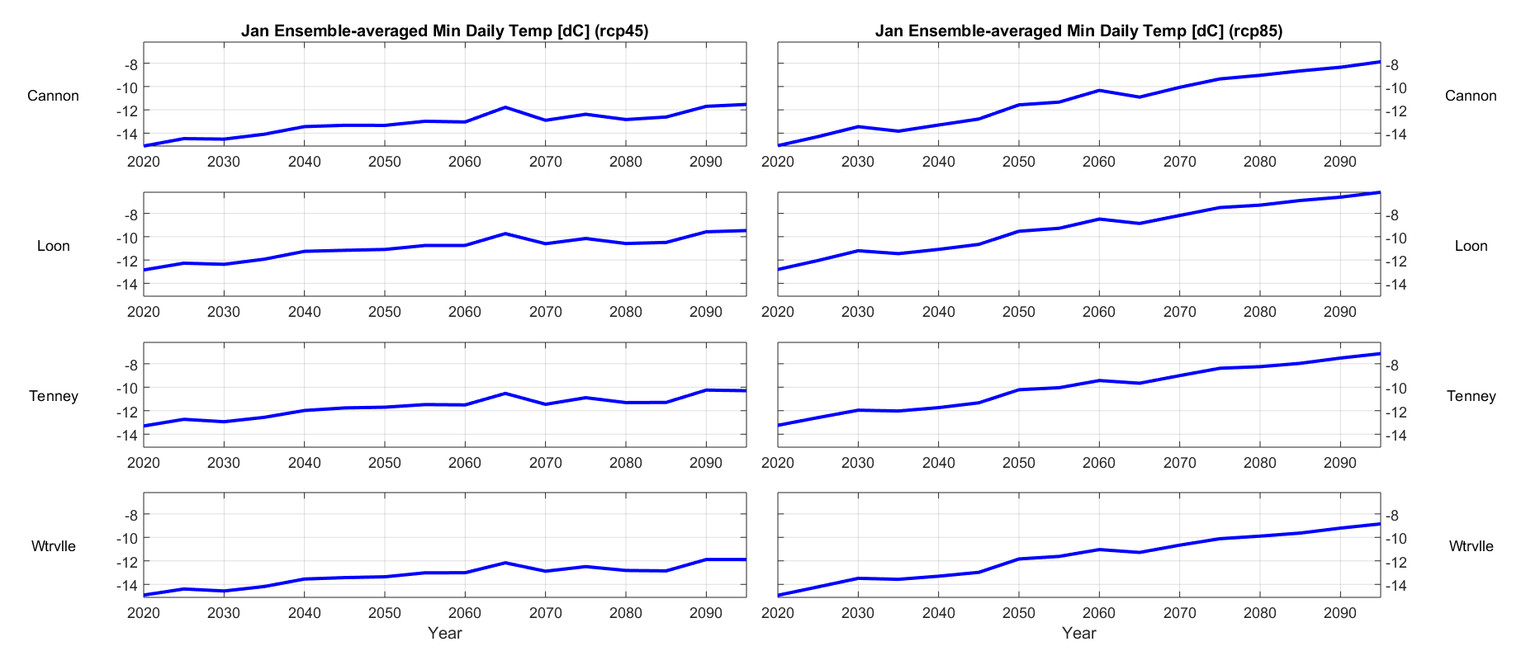
Fig. 2.1.1.: January ensemble-averaged minimum daily temperature, 2020 – 2095.
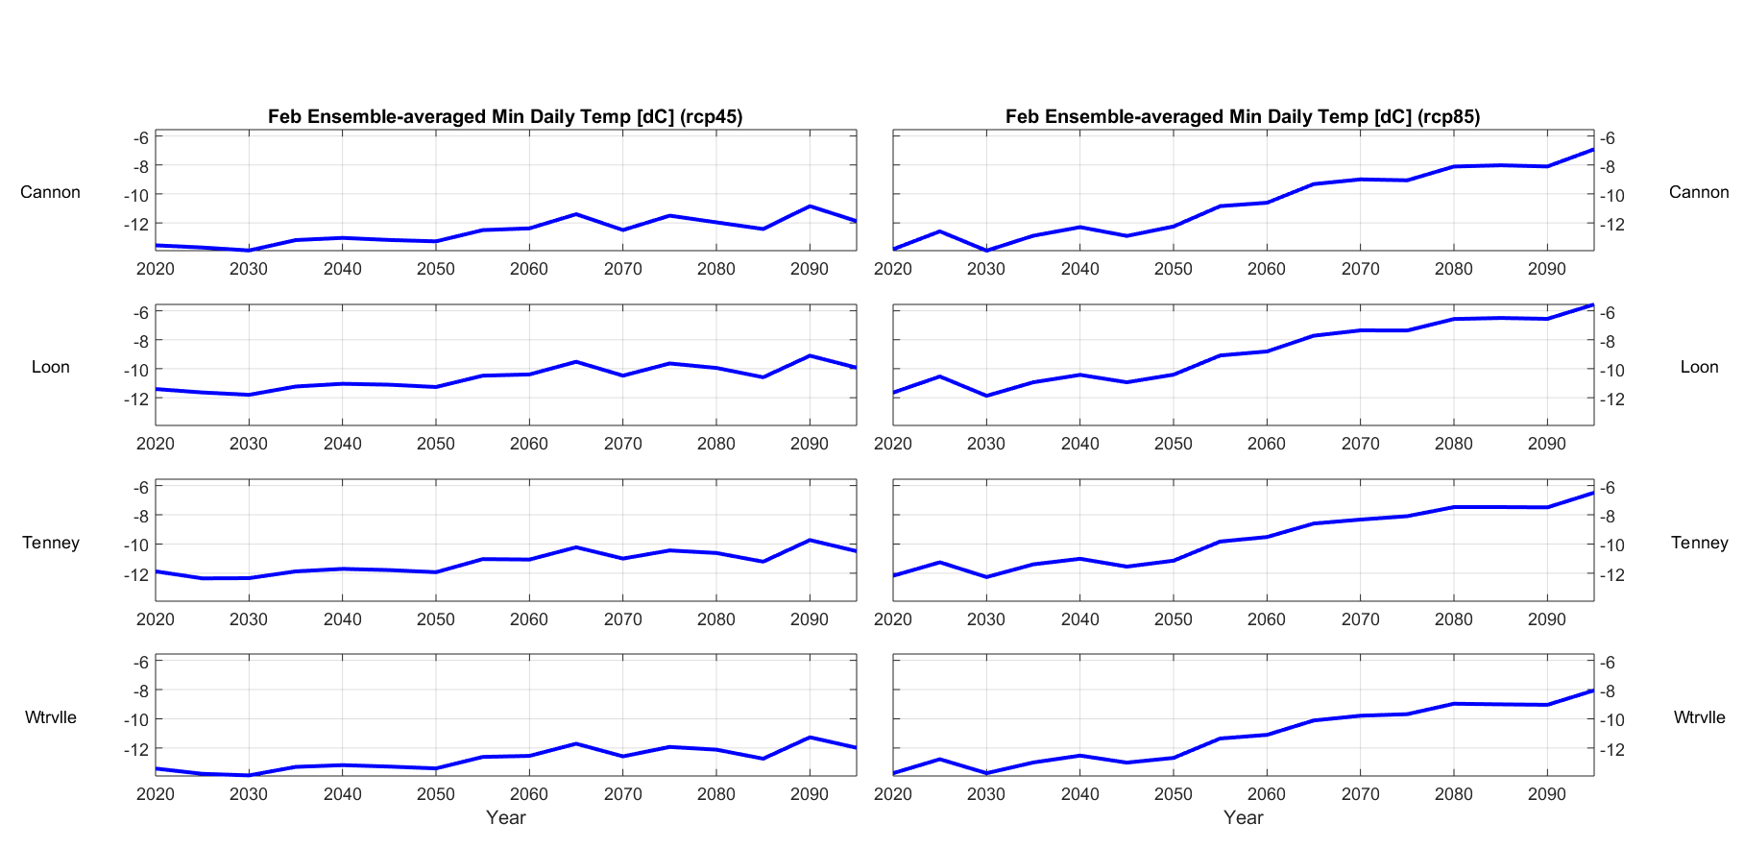
Fig. 2.1.2.: February ensemble-averaged minimum daily temperature, 2020 – 2095.

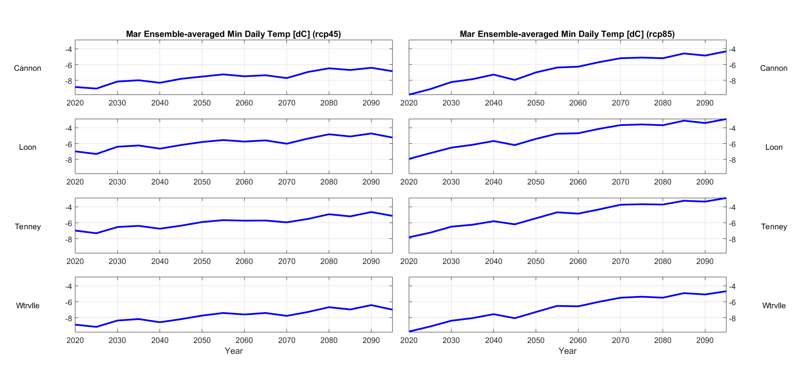
Fig. 2.1.3.: March ensemble-averaged minimum daily temperature, 2020 – 2095.

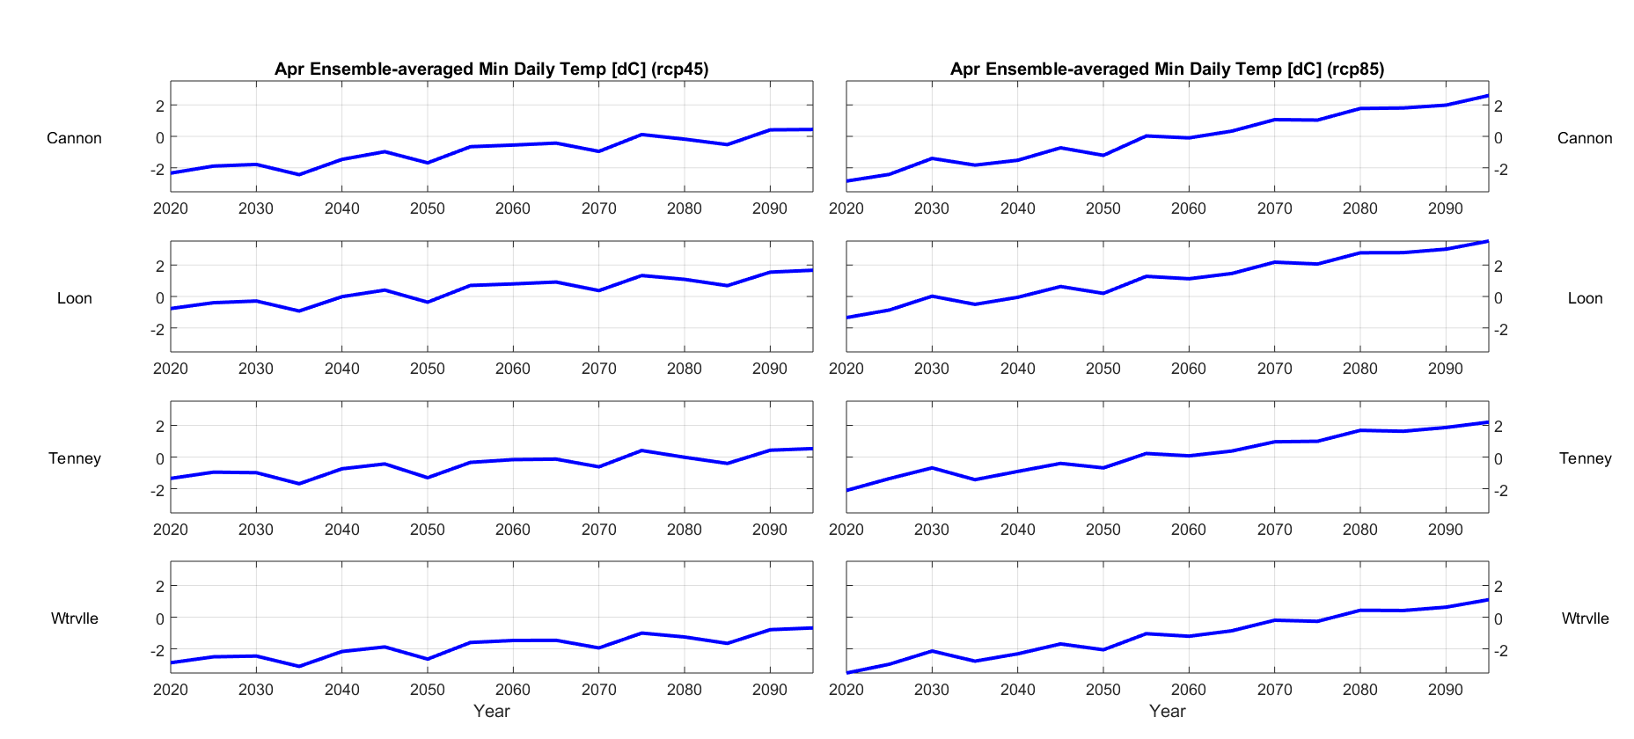
Fig. 2.1.4.: April ensemble-averaged minimum daily temperature, 2020 – 2095.

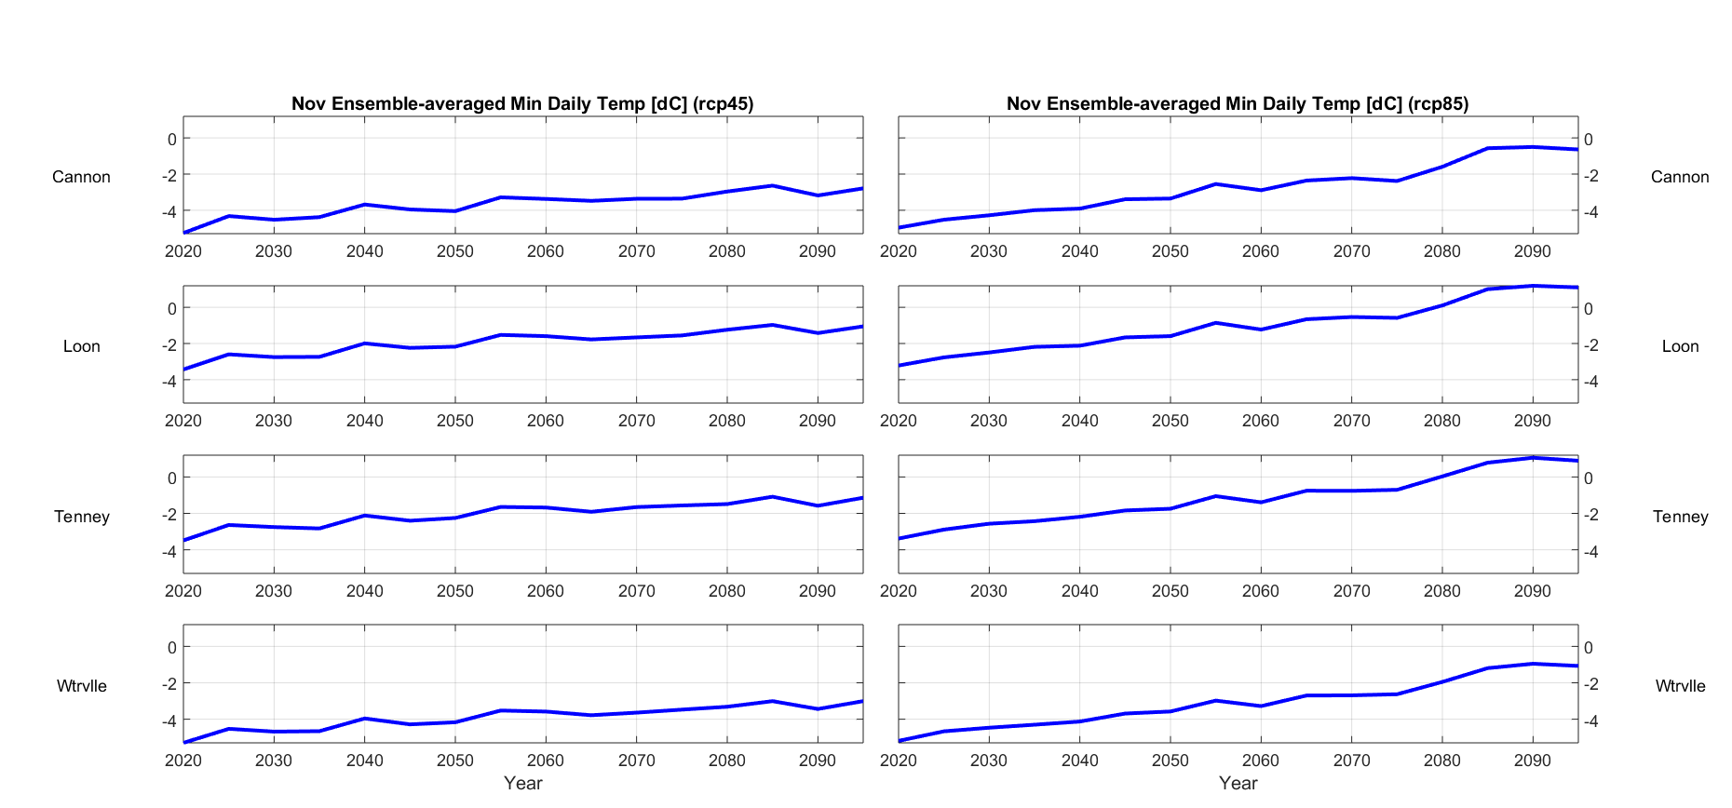
Fig. 2.1.5.: November ensemble-averaged minimum daily temperature, 2020 – 2095.

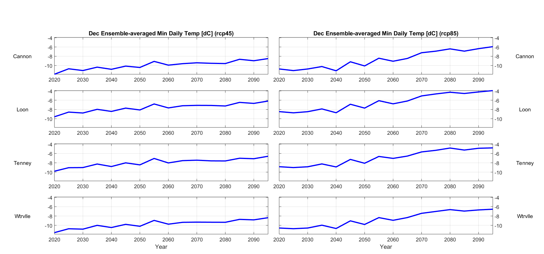
Fig. 2.1.6.: December ensemble-averaged minimum daily temperature, 2020 – 2095.

- Average number of days when snowmaking is possible (minimum temperature ≤ 28 °F, or ≤ -2 °C):
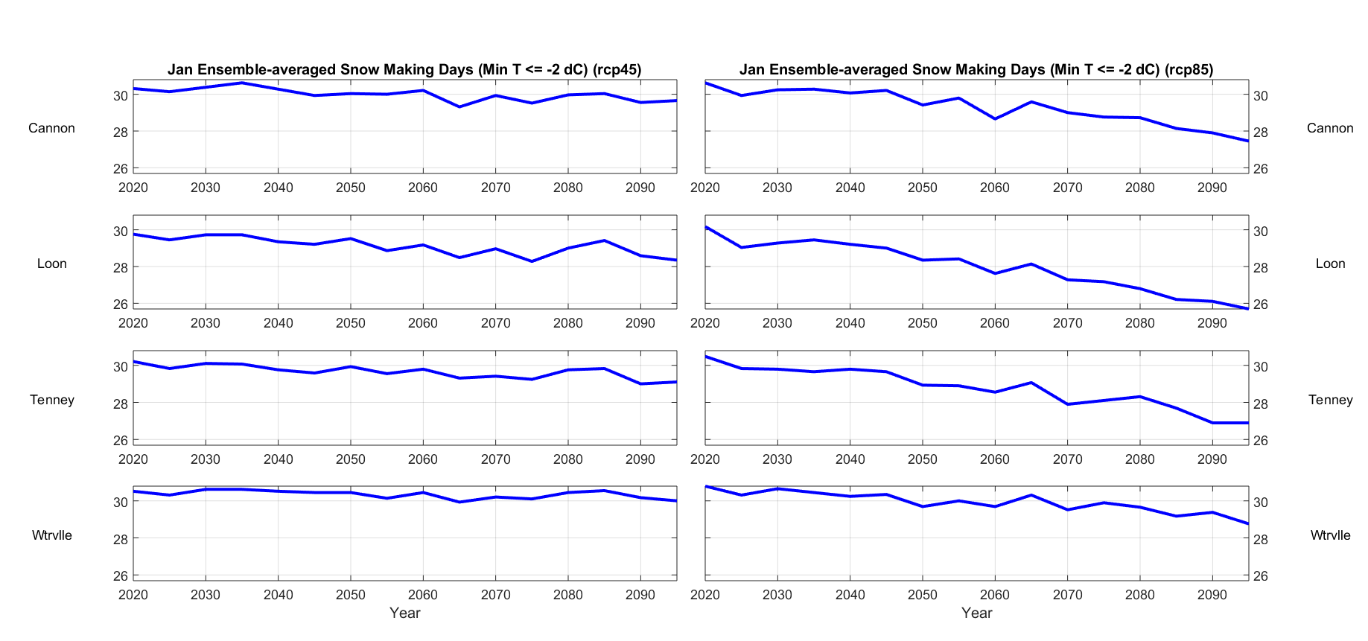
Fig. 2.2.1.: January ensemble-averaged number of days when snowmaking is possible, 2020 – 2095.

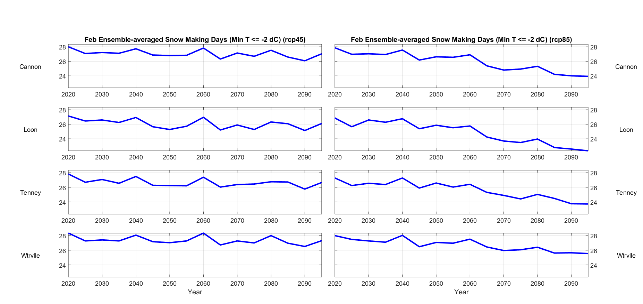
Fig. 2.2.2.: February ensemble-averaged number of days when snowmaking is possible, 2020 – 2095.

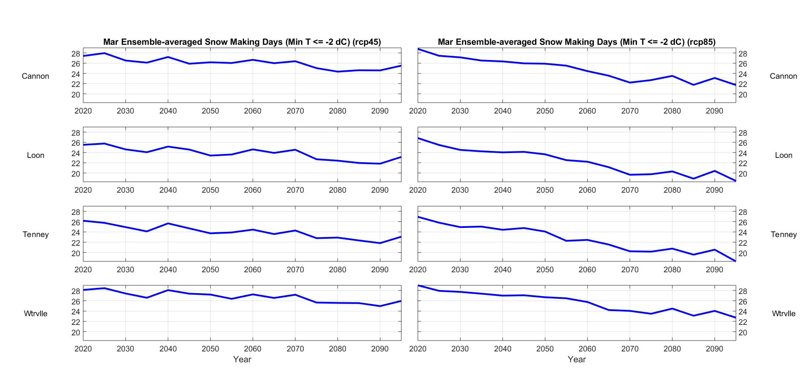
Fig. 2.2.3.: March ensemble-averaged number of days when snowmaking is possible, 2020 – 2095.

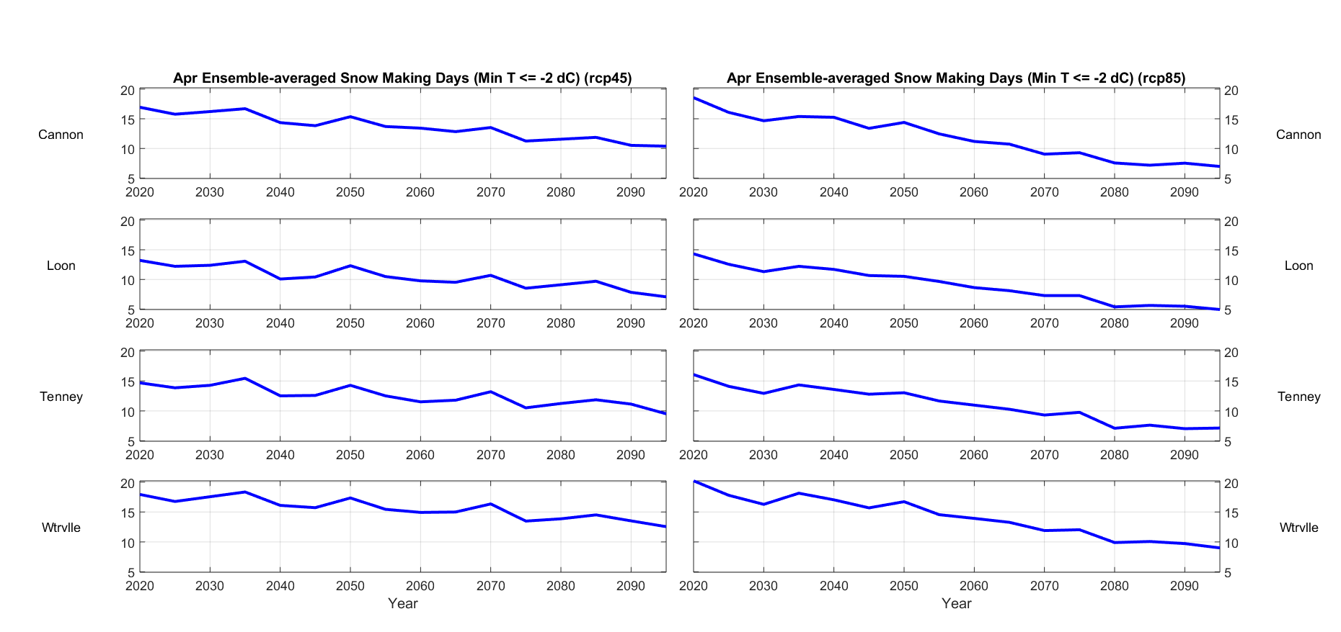
Fig. 2.2.4.: April ensemble-averaged number of days when snowmaking is possible, 2020 – 2095.

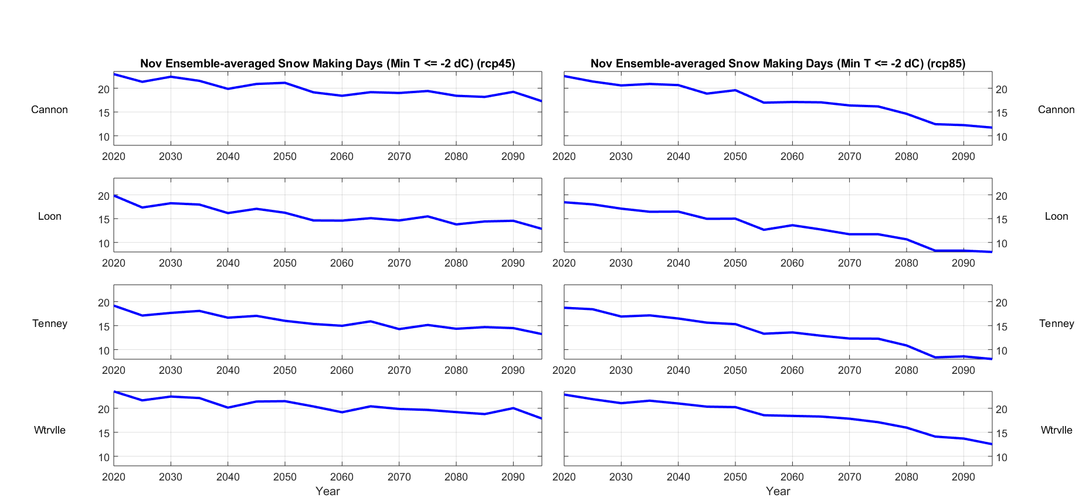
Fig. 2.2.5.: November ensemble-averaged number of days when snowmaking is possible, 2020 – 2095.

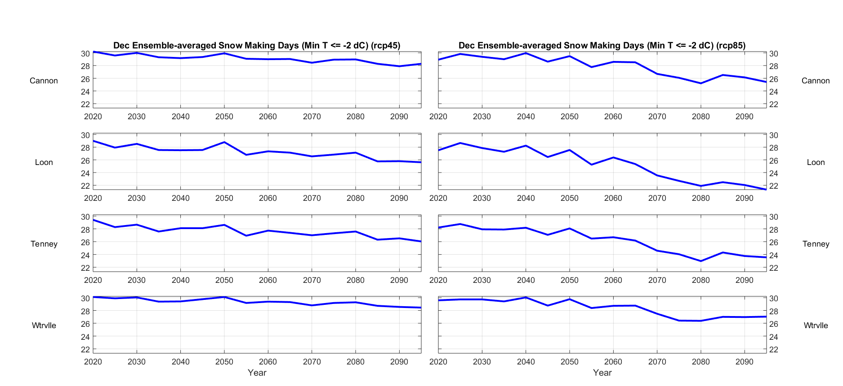
Fig. 2.2.6.: December ensemble-averaged number of days when snowmaking is possible, 2020 – 2095.

- Total monthly snowfall:
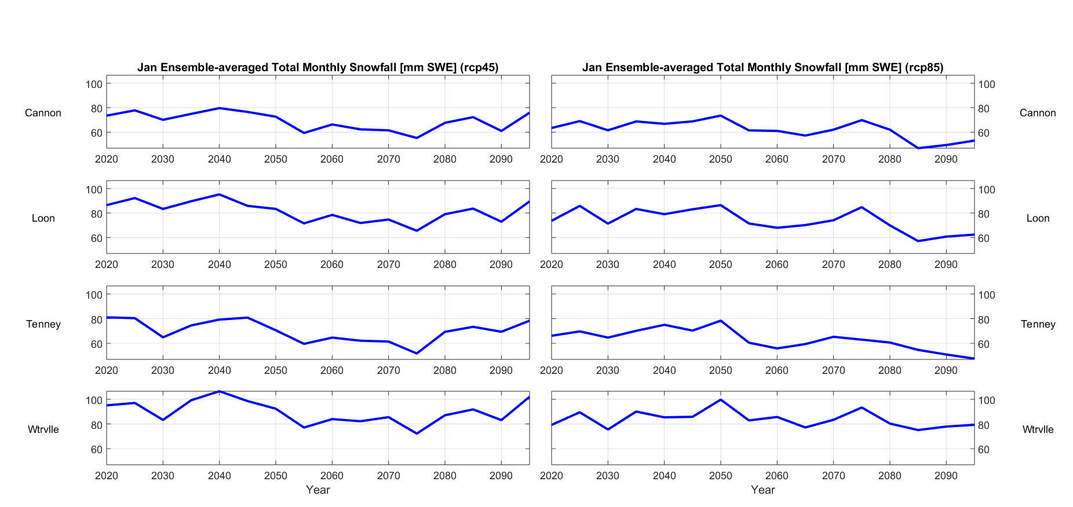
Fig. 2.3.1.: January ensemble-averaged total monthly snowfall, 2020 – 2095.

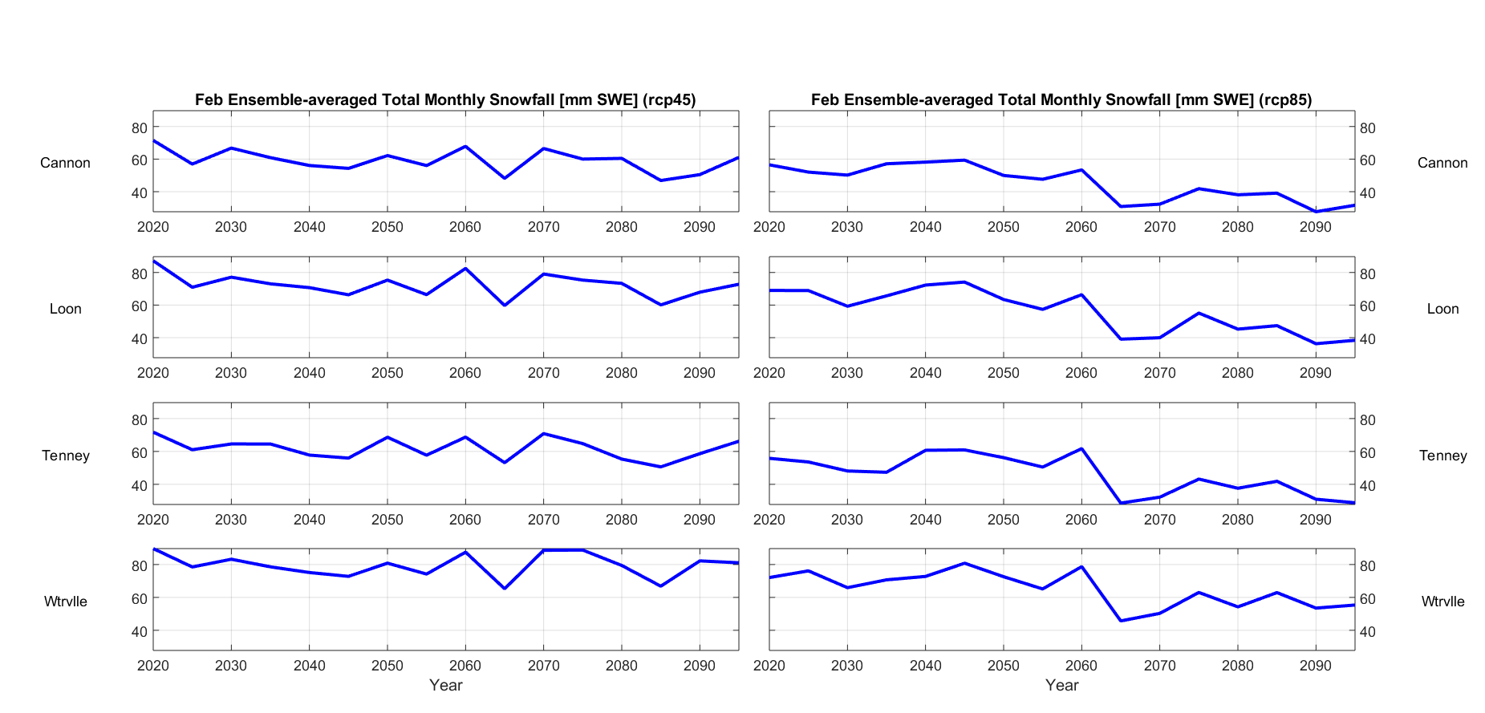
Fig. 2.3.2.: February ensemble-averaged total monthly snowfall, 2020 – 2095.

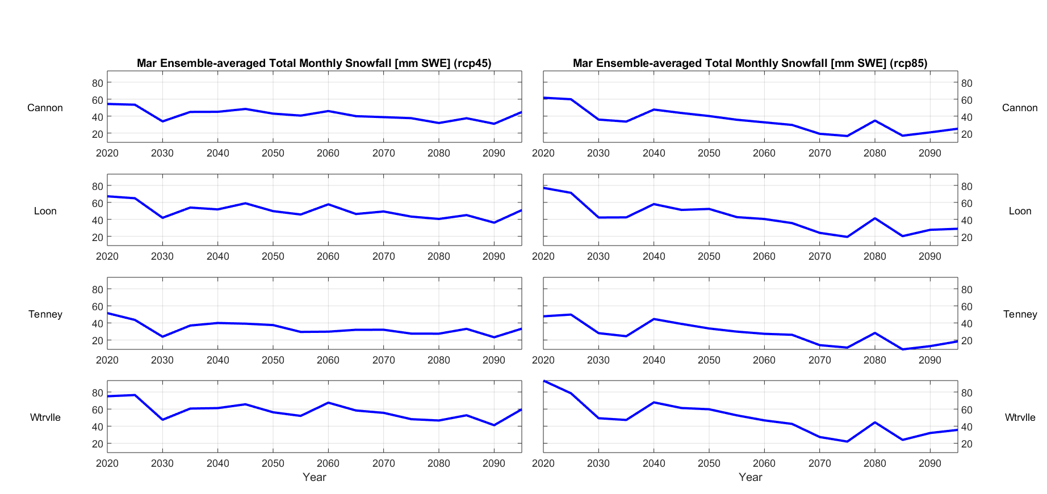
Fig. 2.3.3.: March ensemble-averaged total monthly snowfall, 2020 – 2095.

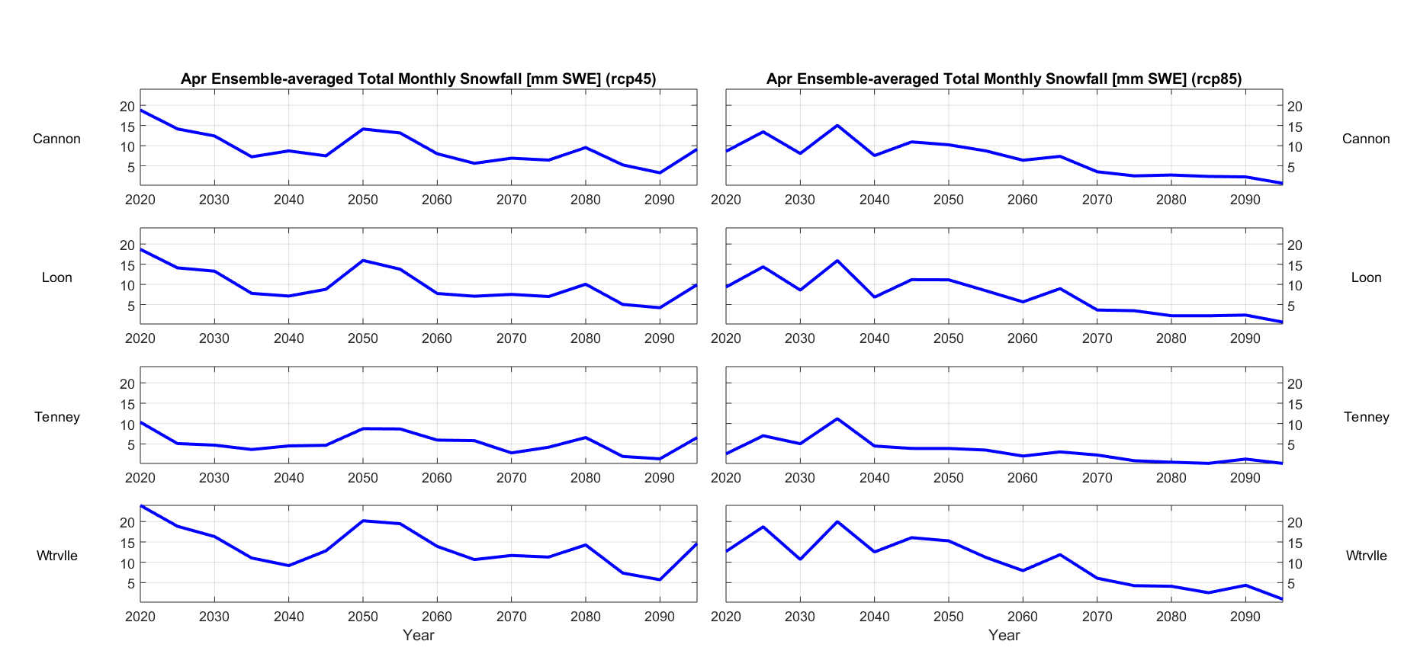
Fig. 2.3.4.: April ensemble-averaged total monthly snowfall, 2020 – 2095.

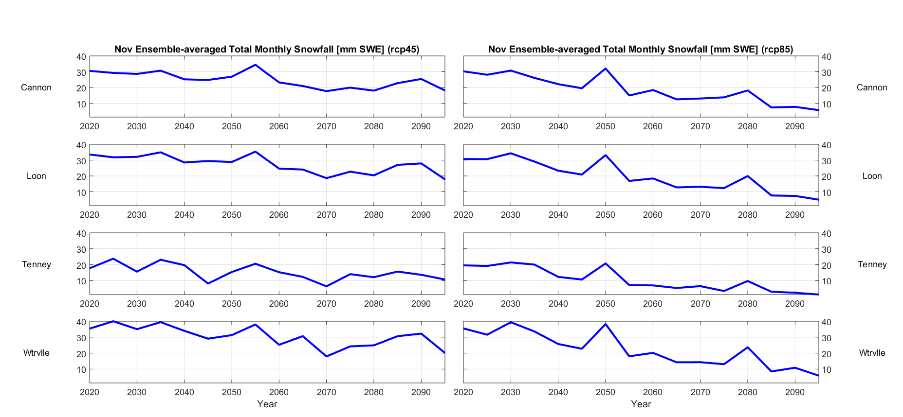
Fig. 2.3.5.: November ensemble-averaged total monthly snowfall, 2020 – 2095.

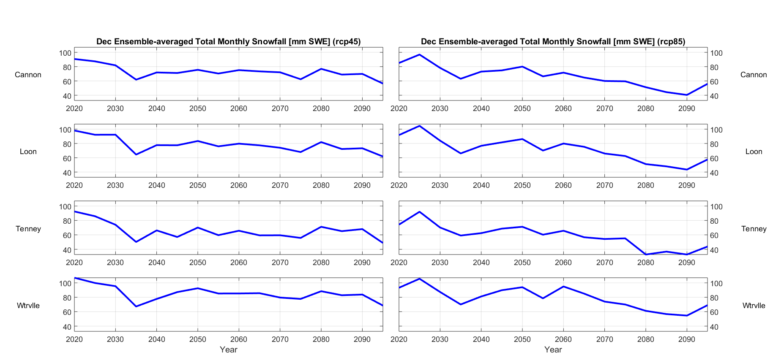
Fig. 2.3.6.: December ensemble-averaged total monthly snowfall, 2020 – 2095.

- Average snowfall-to-total precipitation ratio:
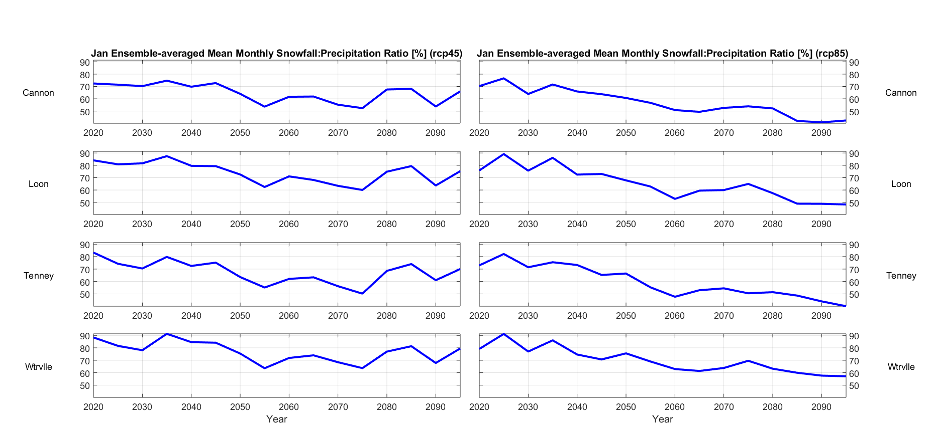
Fig. 2.4.1.: January ensemble-averaged snowfall-to-total precipitation ratio, 2020 – 2095.

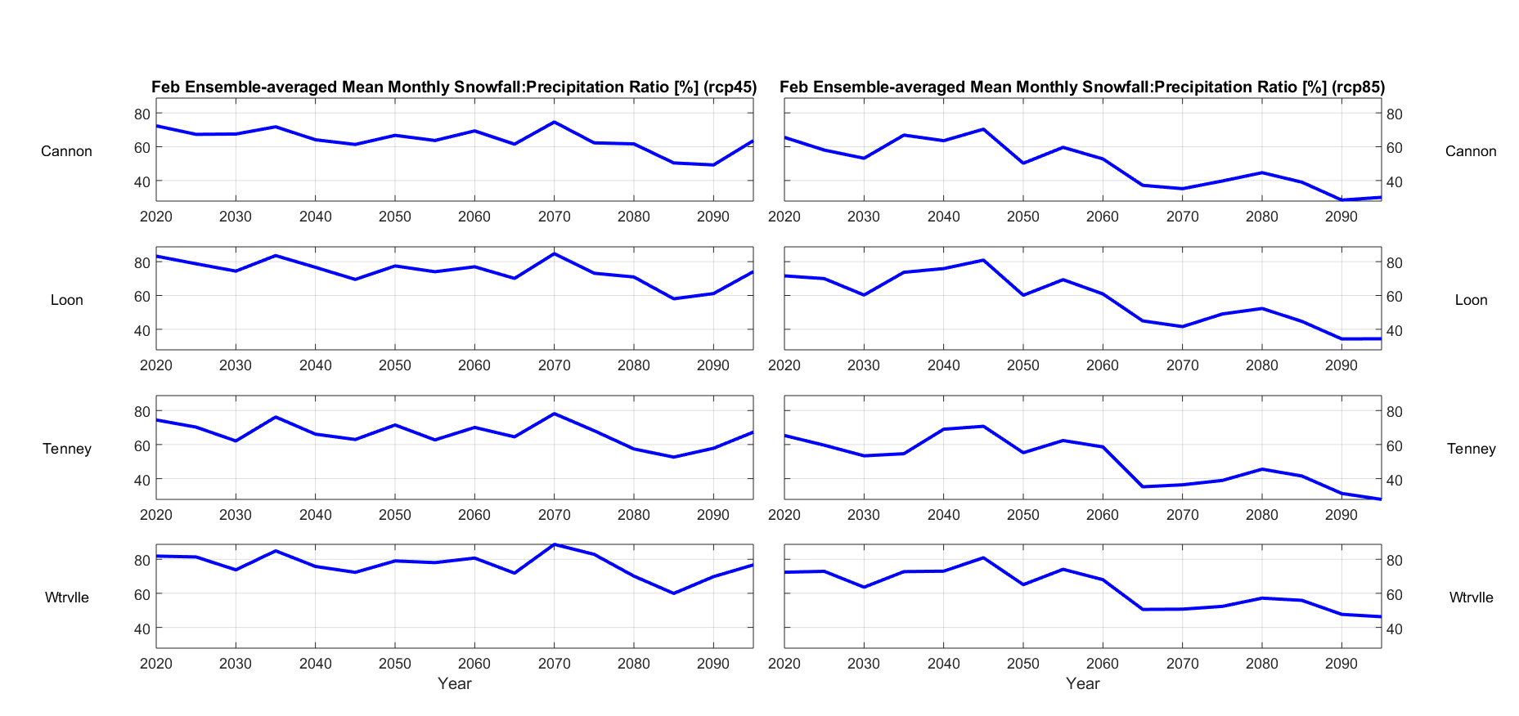
Fig. 2.4.2.: February ensemble-averaged snowfall-to-total precipitation ratio, 2020 – 2095.

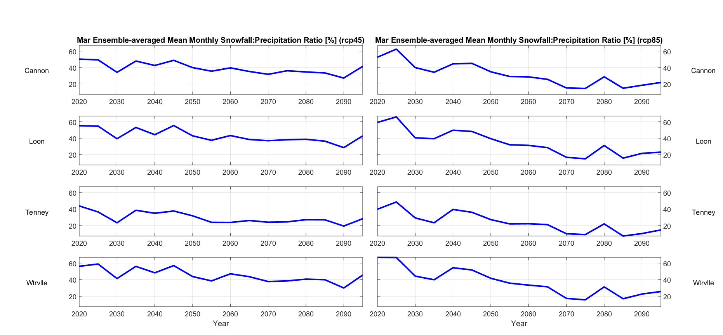
Fig. 2.4.3.: March ensemble-averaged snowfall-to-total precipitation ratio, 2020 – 2095.

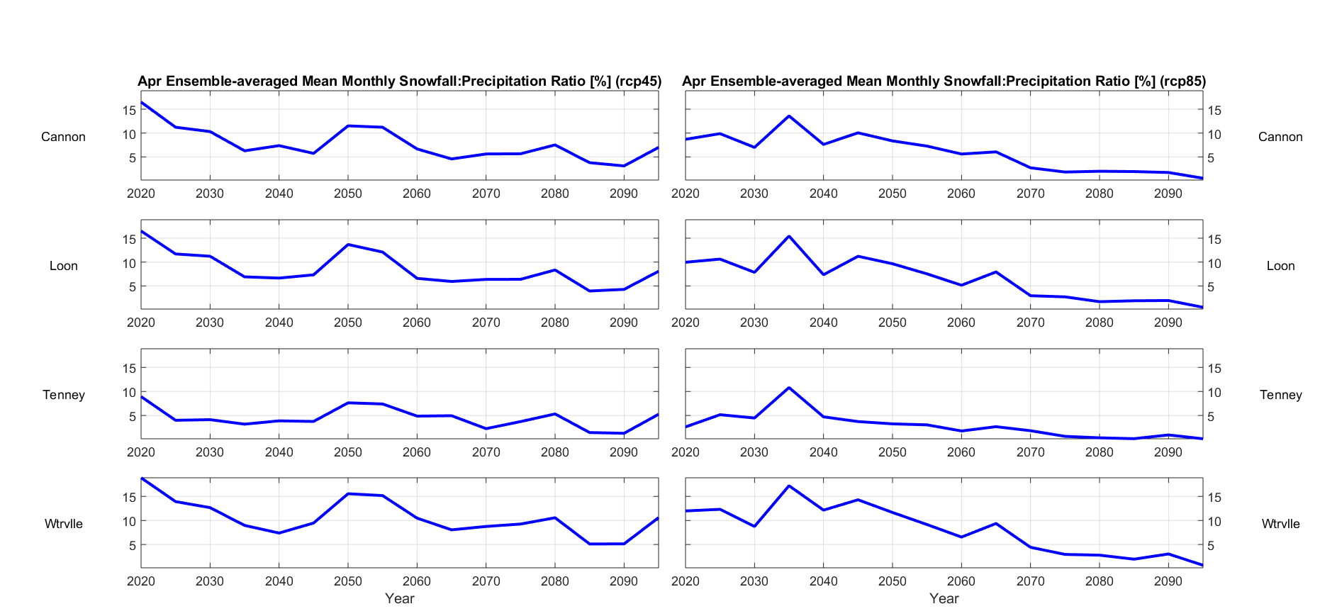
Fig. 2.4.4.: April ensemble-averaged snowfall-to-total precipitation ratio, 2020 – 2095.

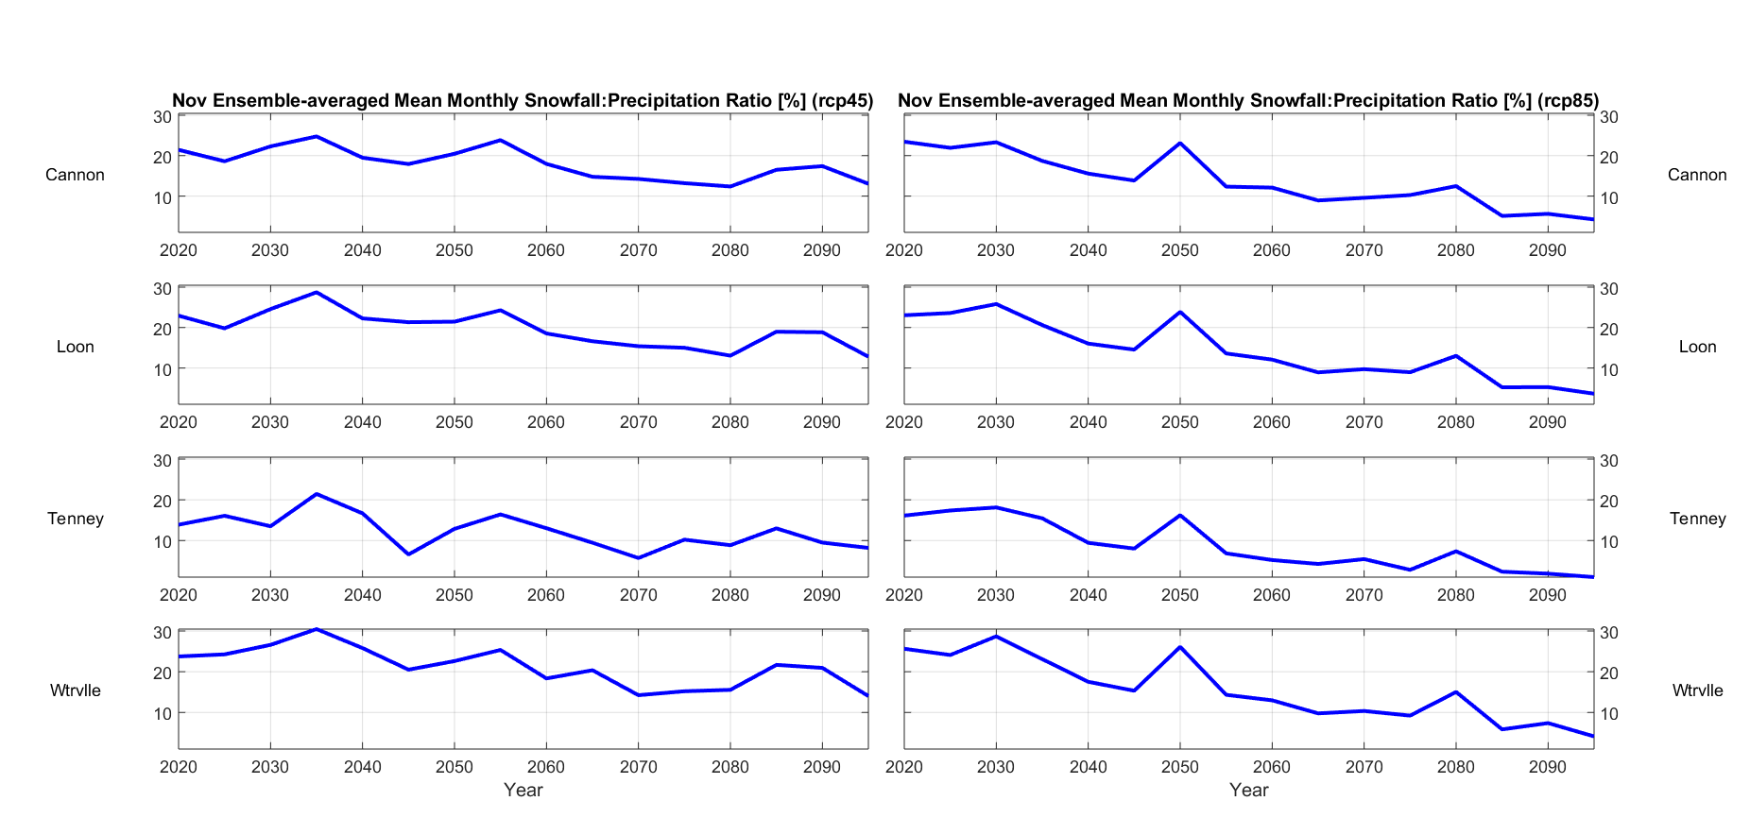
Fig. 2.4.5.: November ensemble-averaged snowfall-to-total precipitation ratio, 2020 – 2095.

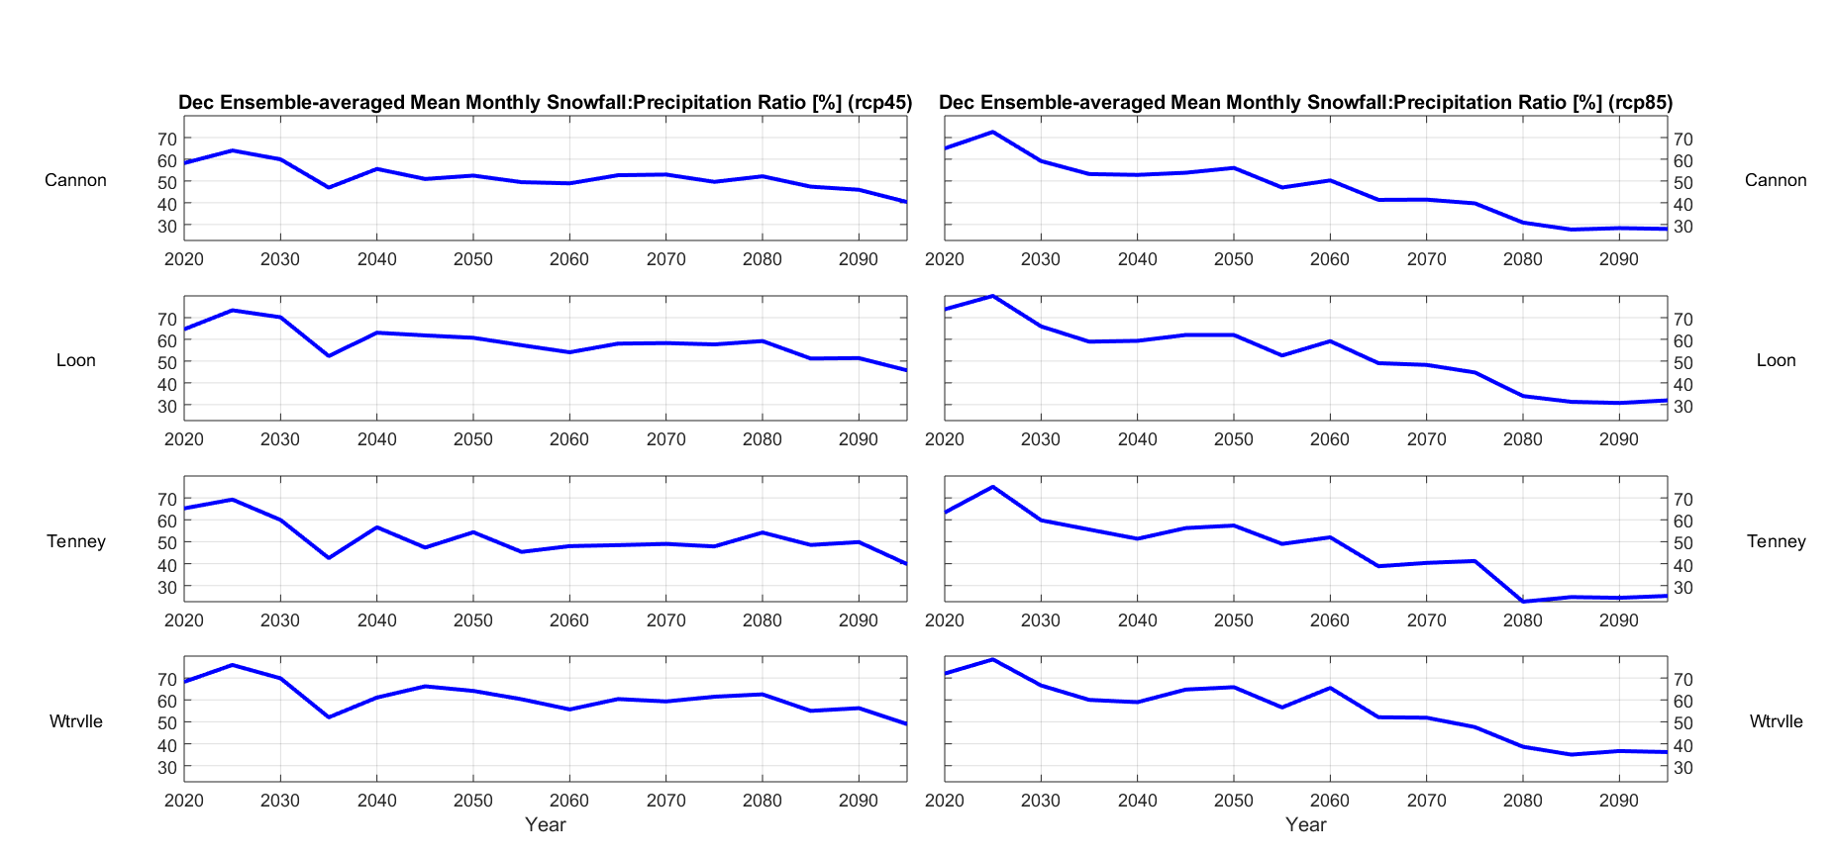
Fig. 2.4.6.: December ensemble-averaged snowfall-to-total precipitation ratio, 2020 – 2095.

- Average natural snowpack:
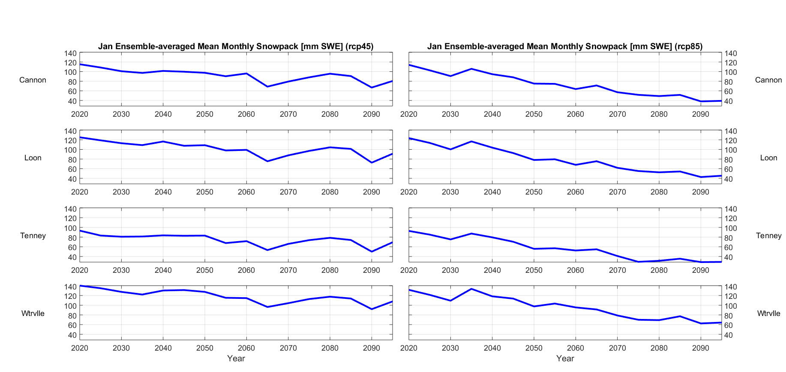
Fig. 2.5.1.: January ensemble-averaged mean monthly natural snowpack, 2020 – 2095.

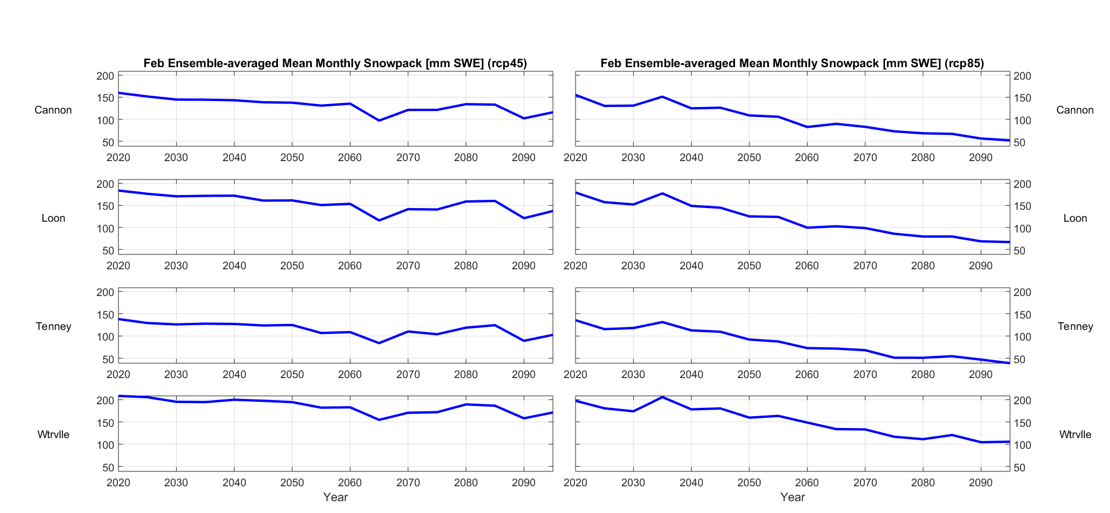
Fig. 2.5.2.: February ensemble-averaged mean monthly natural snowpack, 2020 – 2095.

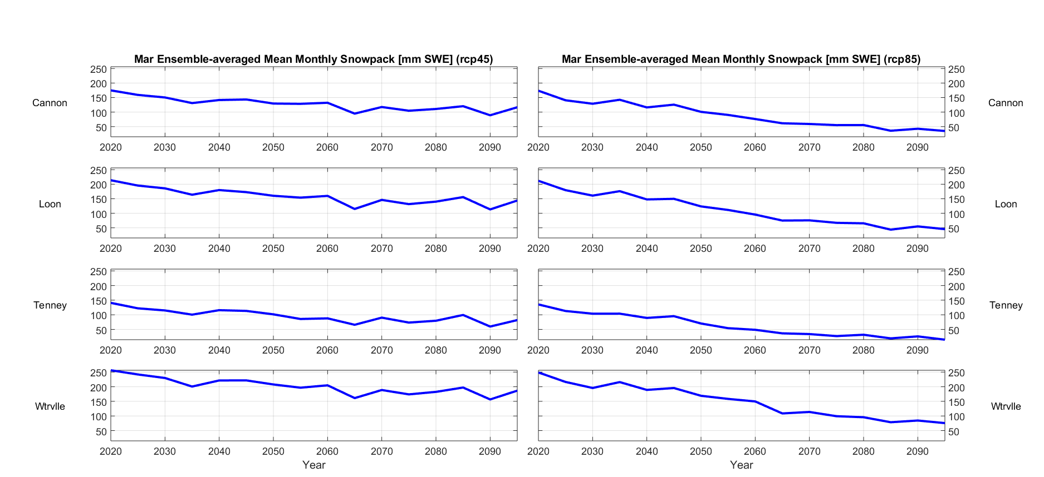
Fig. 2.5.3.: March ensemble-averaged mean monthly natural snowpack, 2020 – 2095.

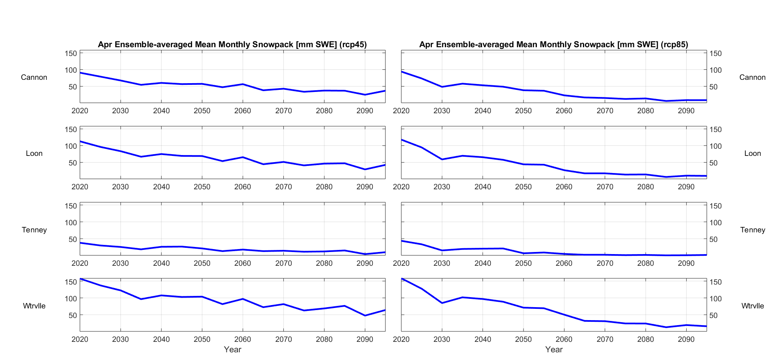
Fig. 2.5.4.: April ensemble-averaged mean monthly natural snowpack, 2020 – 2095.

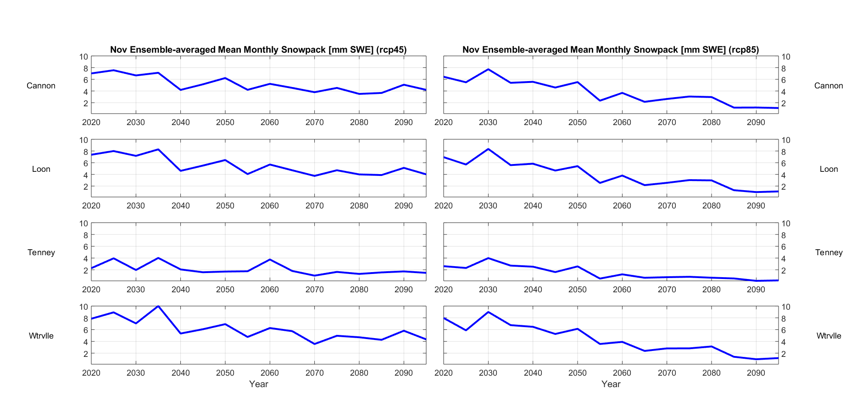
Fig. 2.5.5.: November ensemble-averaged mean monthly natural snowpack, 2020 – 2095.

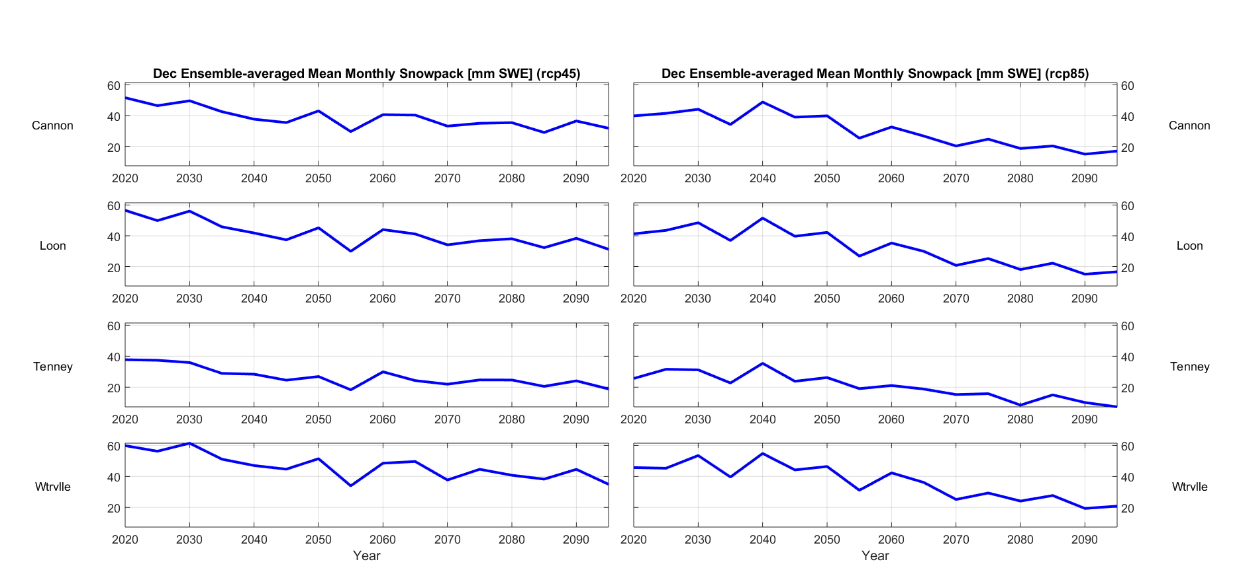
Fig. 2.5.6.: December ensemble-averaged mean monthly natural snowpack, 2020 – 2095.

Warm-Season Results. As with the warm-season results, two separate sets of results are shown, corresponding to the RCP4.5 and RCP8.5 emissions scenarios. These are presented here graphically. Interpretation is in Summary and Conclusions (below).

- Number of days with maximum temperature >= 90 °F (32.2 °C):

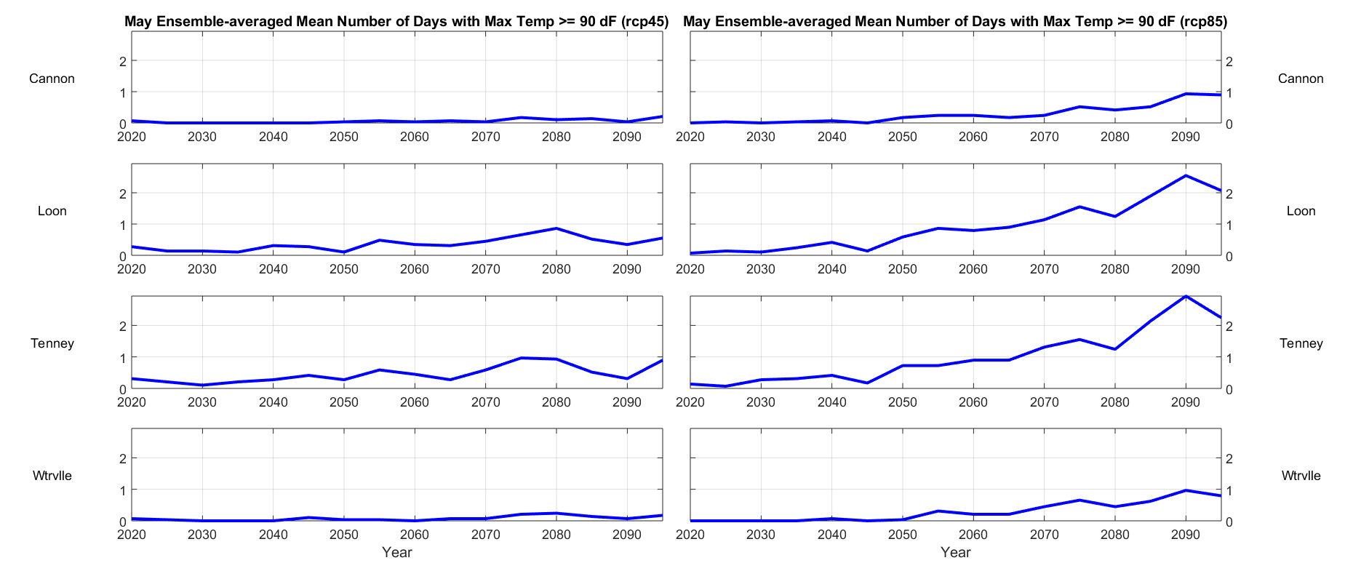
Fig. 3.1.1.: May ensemble-averaged number of days with maximum temperature ≥ 90 °F, 2020 – 2095.

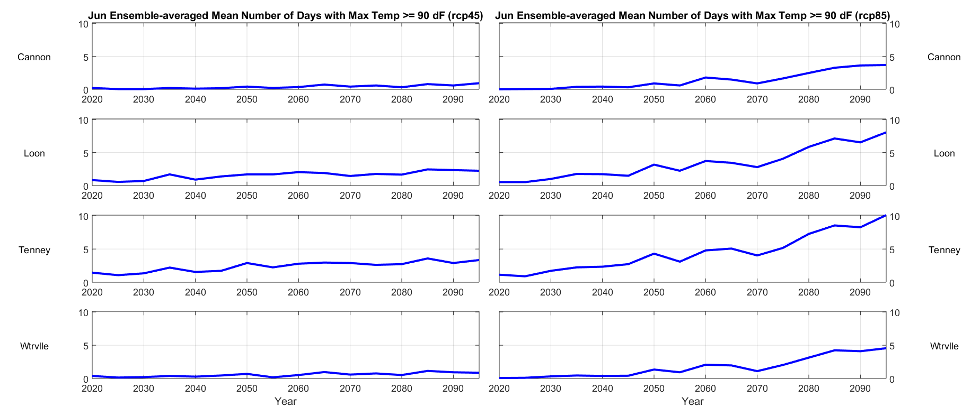
Fig. 3.1.2.: June ensemble-averaged number of days with maximum temperature ≥ 90 °F, 2020 – 2095.

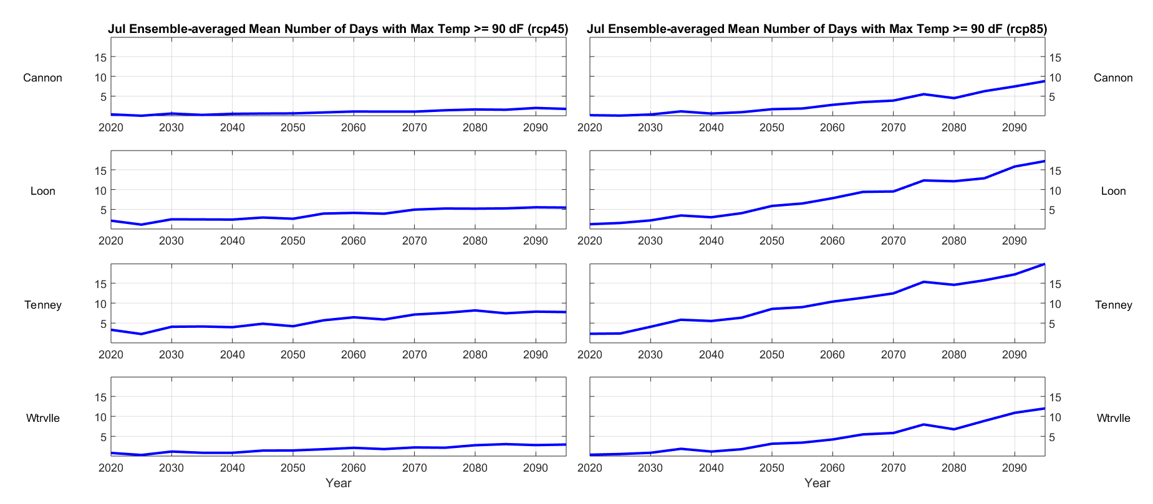
Fig. 3.1.3.: July ensemble-averaged number of days with maximum temperature ≥ 90 °F, 2020 – 2095.

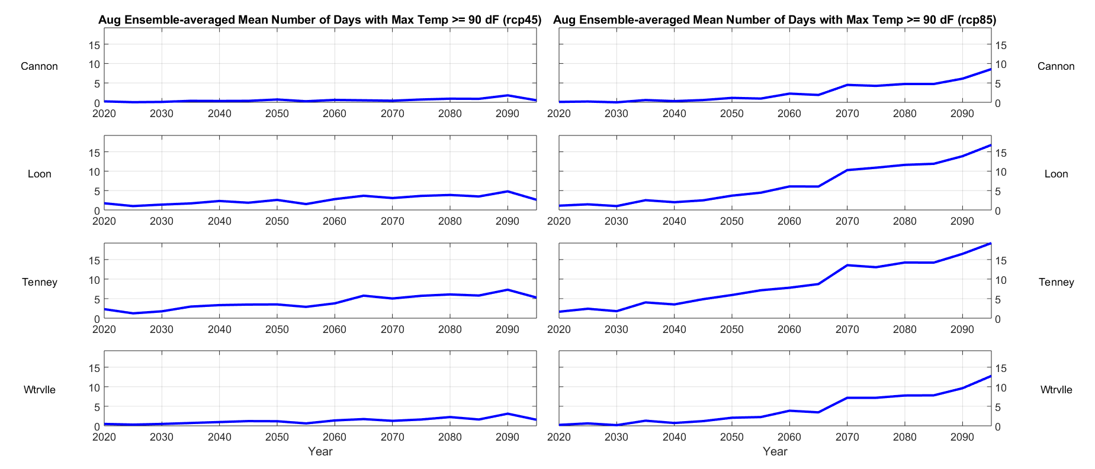
Fig. 3.1.4.: August ensemble-averaged number of days with maximum temperature ≥ 90 °F, 2020 – 2095.

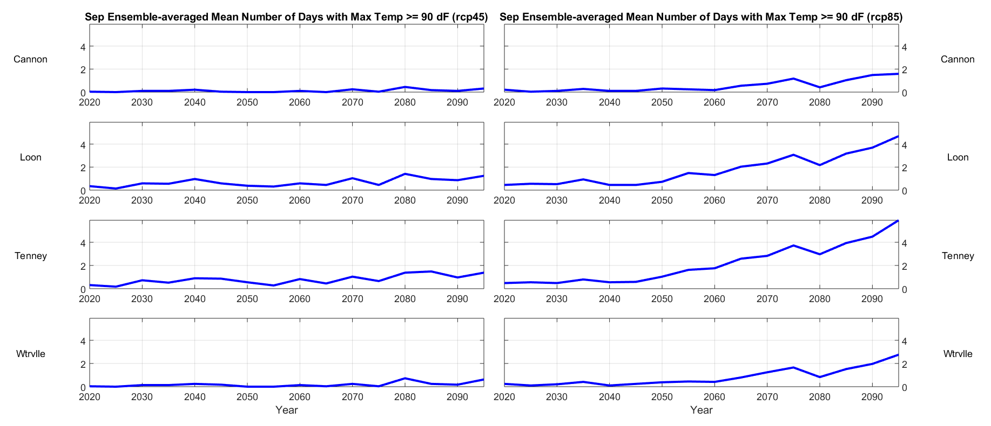
Fig. 3.1.5.: September ensemble-averaged number of days with maximum temperature ≥ 90 °F, 2020 – 2095.

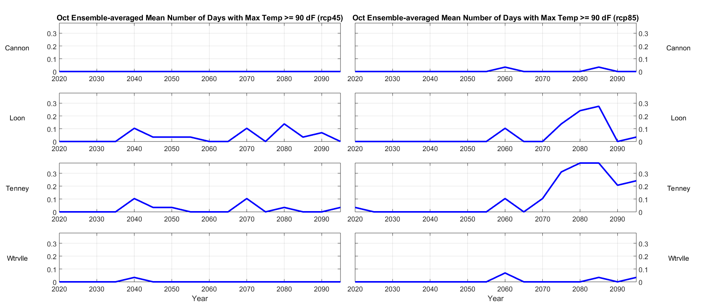
Fig. 3.1.6.: October ensemble-averaged number of days with maximum temperature ≥ 90 °F, 2020 – 2095.

- Ensemble-average warm season precipitation; total by month:

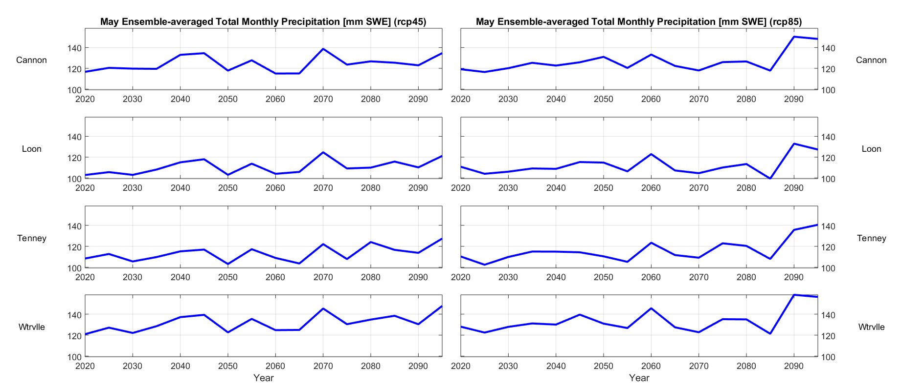
Fig. 3.2.1.: May ensemble-averaged total monthly precipitation, 2020 – 2095.

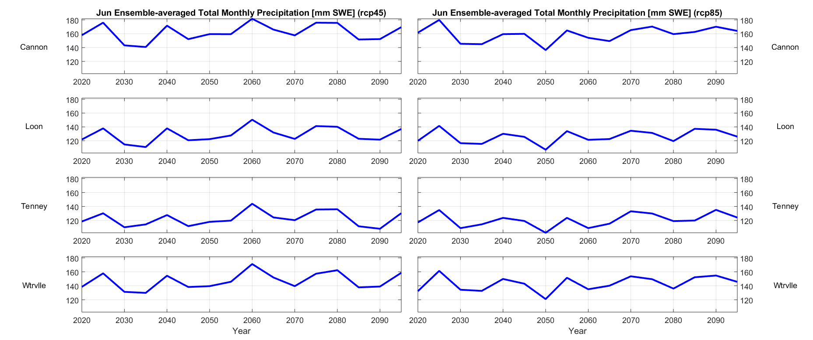
Fig. 3.2.2.: June ensemble-averaged total monthly precipitation, 2020 – 2095.

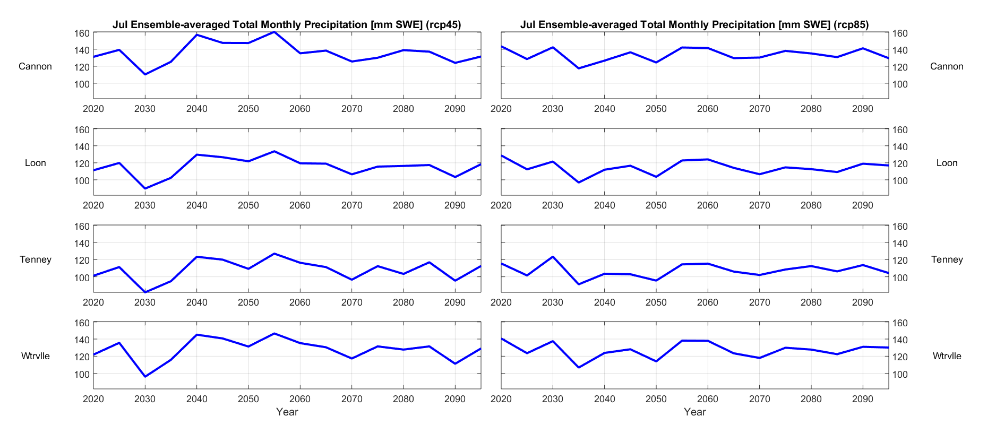
Fig. 3.2.3.: July ensemble-averaged total monthly precipitation, 2020 – 2095.

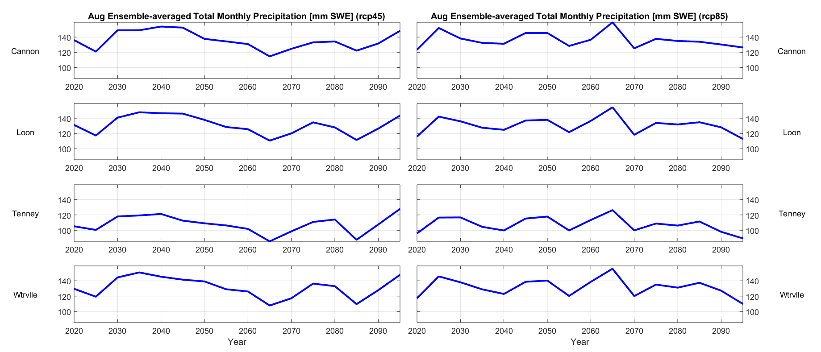
Fig. 3.2.4.: August ensemble-averaged total monthly precipitation, 2020 – 2095.

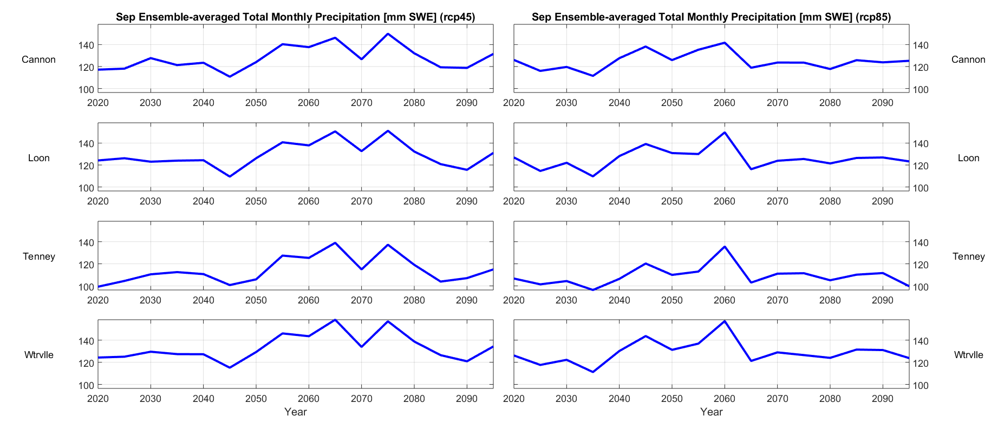
Fig. 3.2.5.: September ensemble-averaged total monthly precipitation, 2020 – 2095.

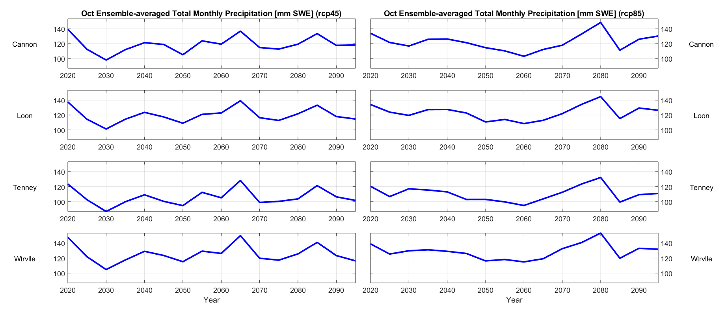
Fig. 3.2.6.: October ensemble-averaged total monthly precipitation, 2020 – 2095.

- Ensemble-average number of warm-season zero-precipitation events, by number of days:

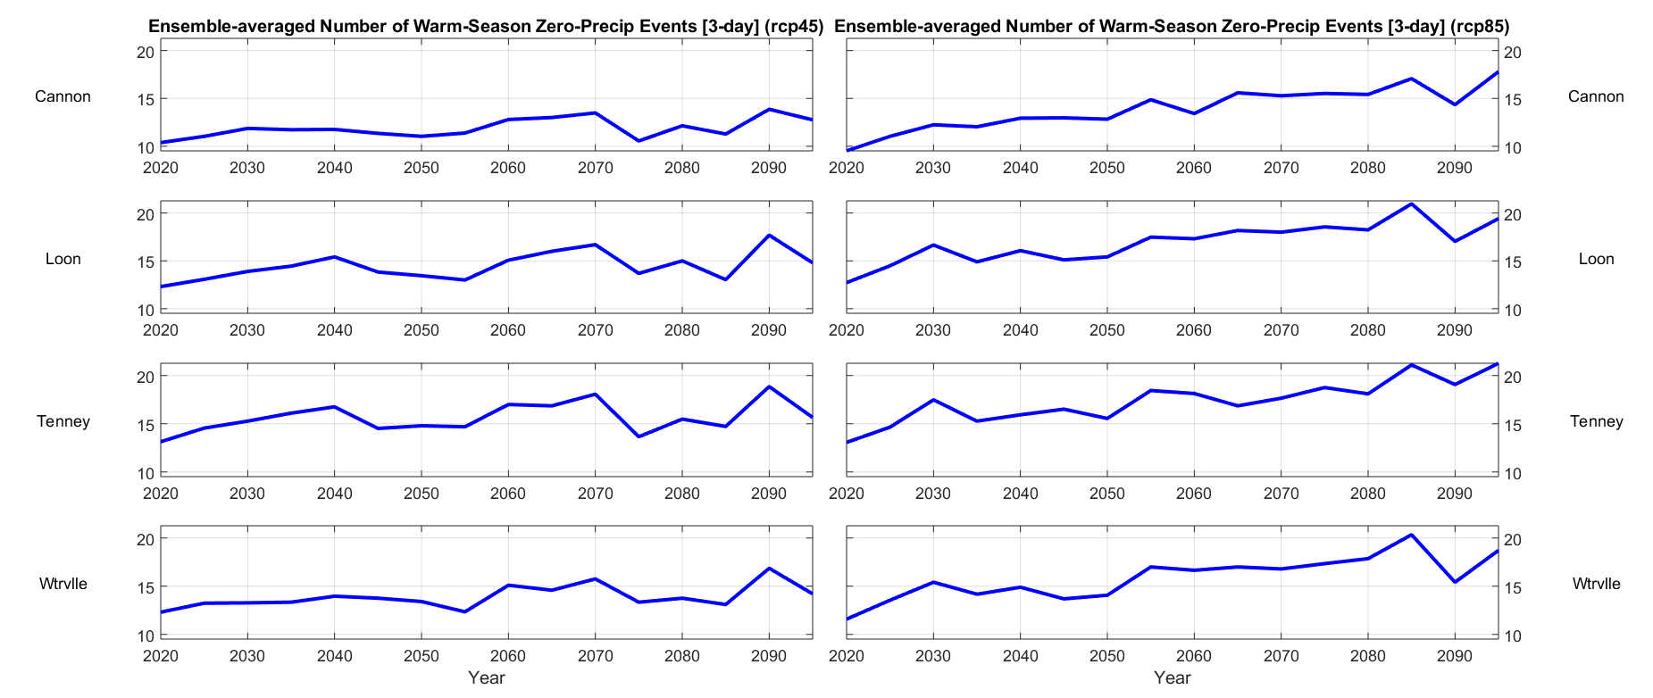
Fig. 3.3.1.: Ensemble-averaged number of warm-season 3-day zero-precipitation events, 2020 - 2095.

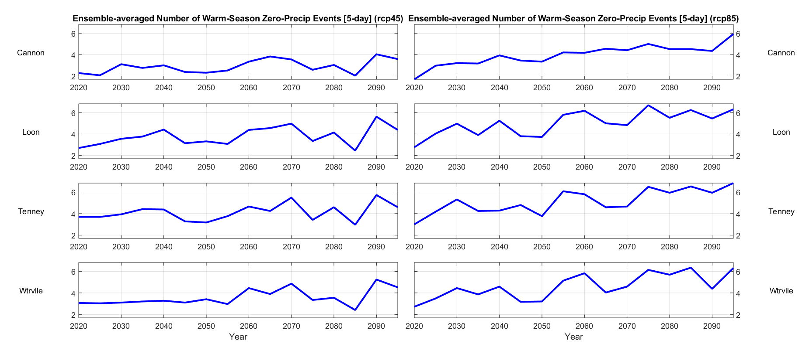
Fig. 3.3.2.: Ensemble-averaged number of warm-season 5-day zero-precipitation events, 2020 - 2095.

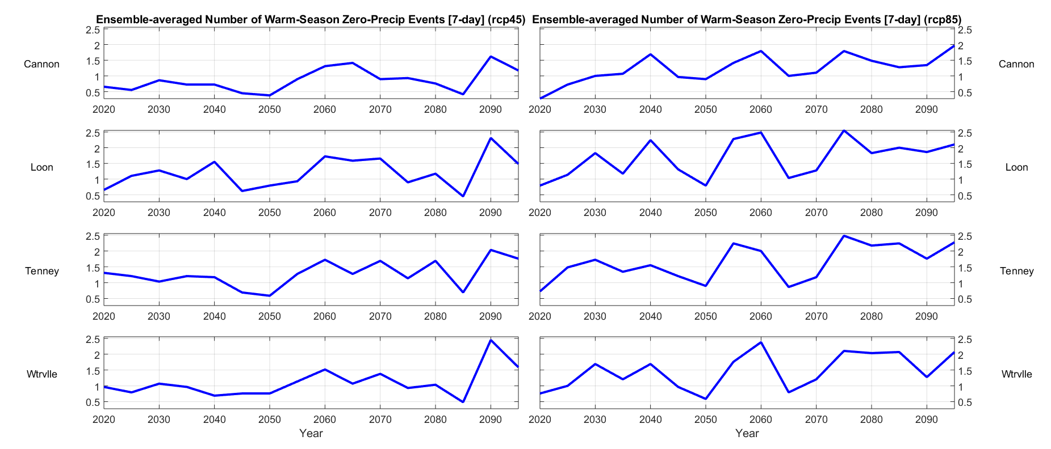
Fig. 3.3.3.: Ensemble-averaged number of warm-season 7-day zero-precipitation events, 2020 - 2095.

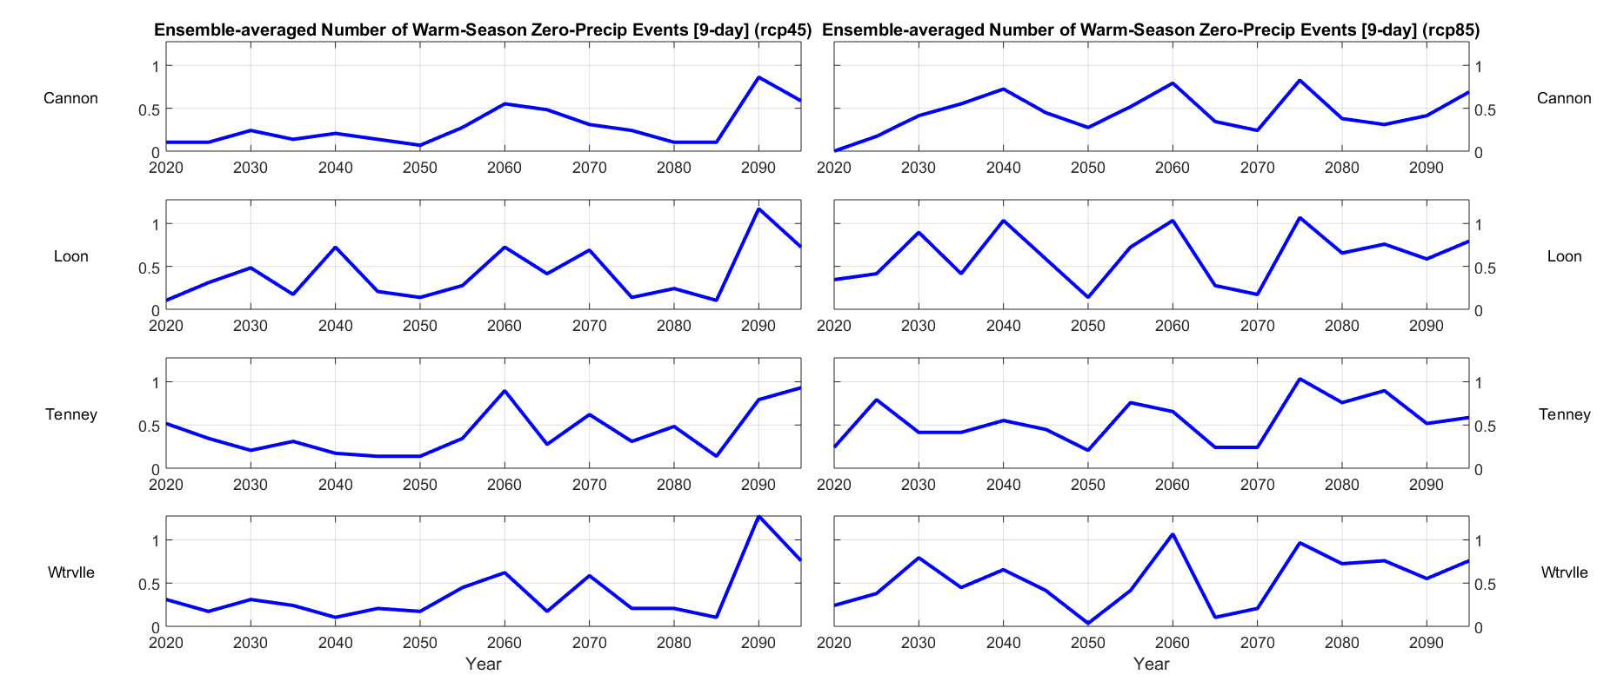
Fig. 3.3.4.: Ensemble-averaged number of warm-season 9-day zero-precipitation events, 2020 - 2095.

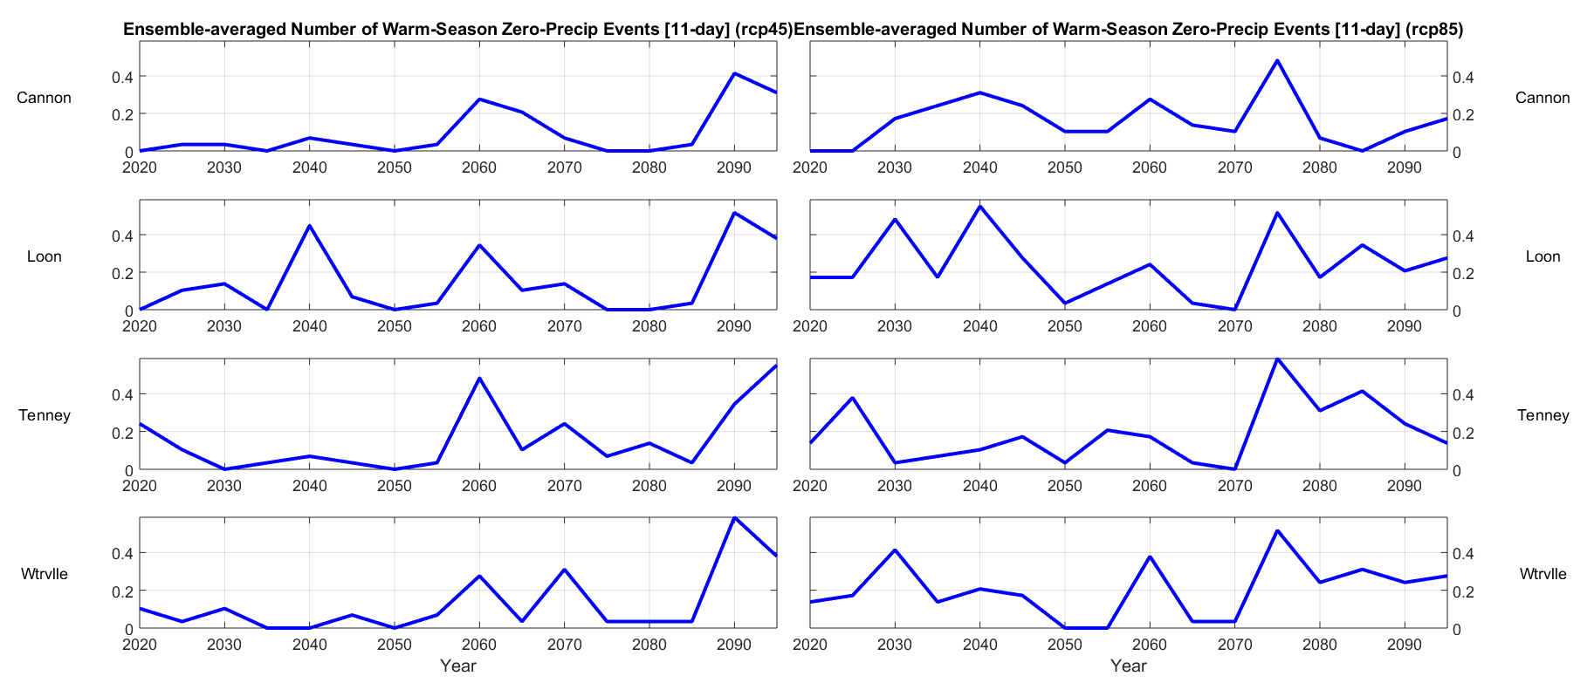
Fig. 3.3.5.: Ensemble-averaged number of warm-season 11-day zero-precipitation events, 2020 - 2095.

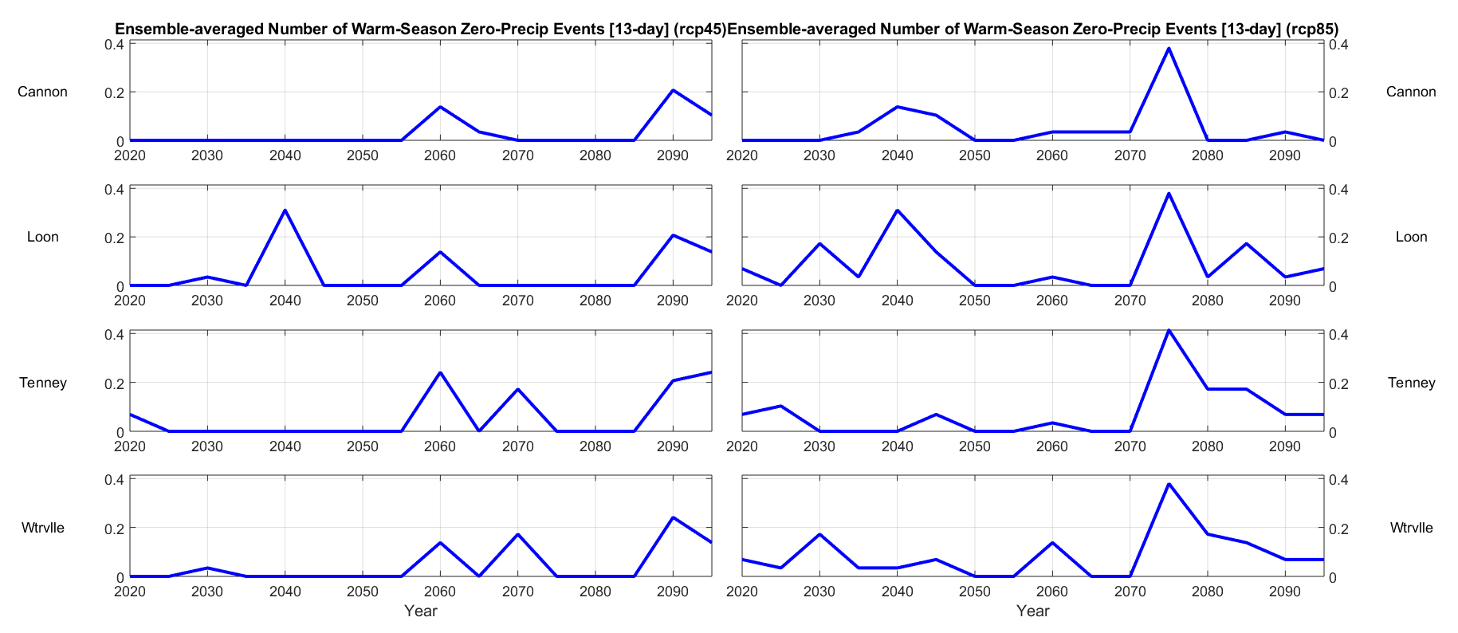
Fig. 3.3.6.: Ensemble-averaged number of warm-season 13-day zero-precipitation events, 2020 - 2095.

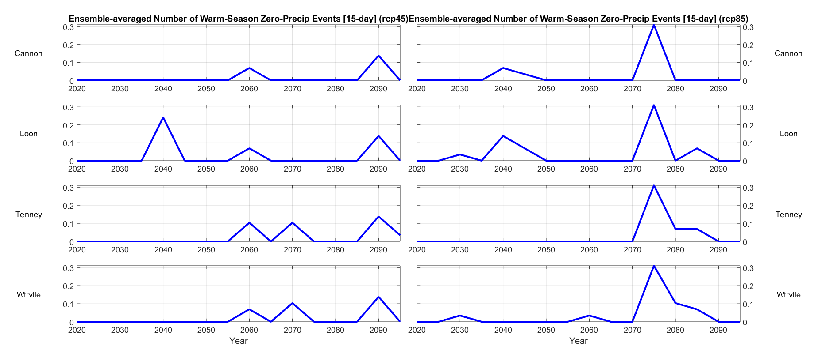
Fig. 3.3.7.: Ensemble-averaged number of warm-season 15-day zero-precipitation events, 2020 - 2095.

- Ensemble average number of warm-season daily precipitation events in category:

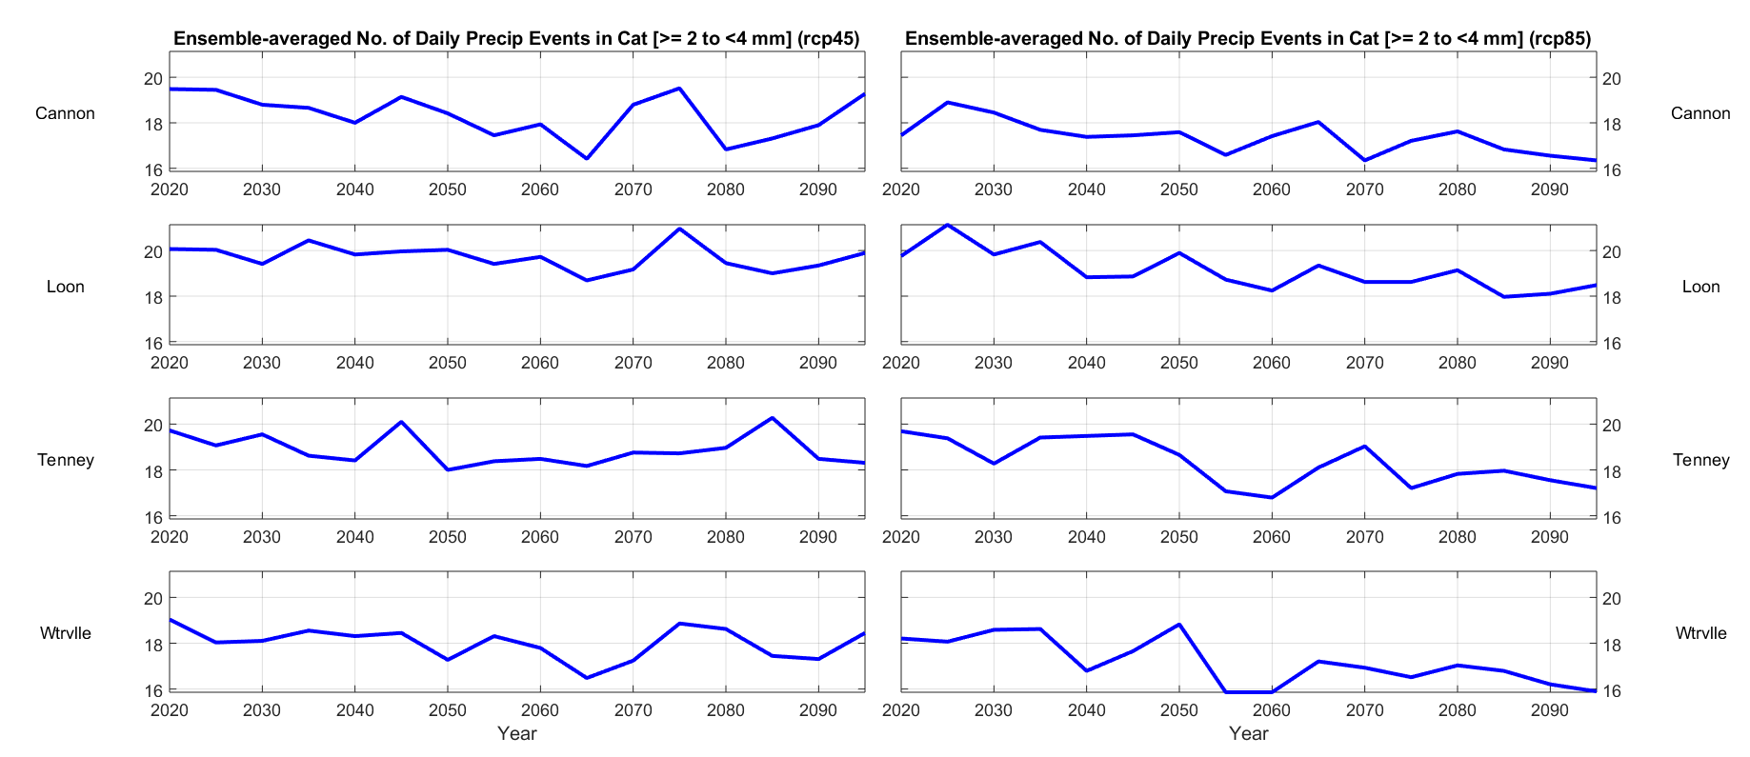
Fig. 3.4.1.: Ensemble-averaged number of warm-season precipitation events ≥ 2 to < 4 mm, 2020 - 2095.

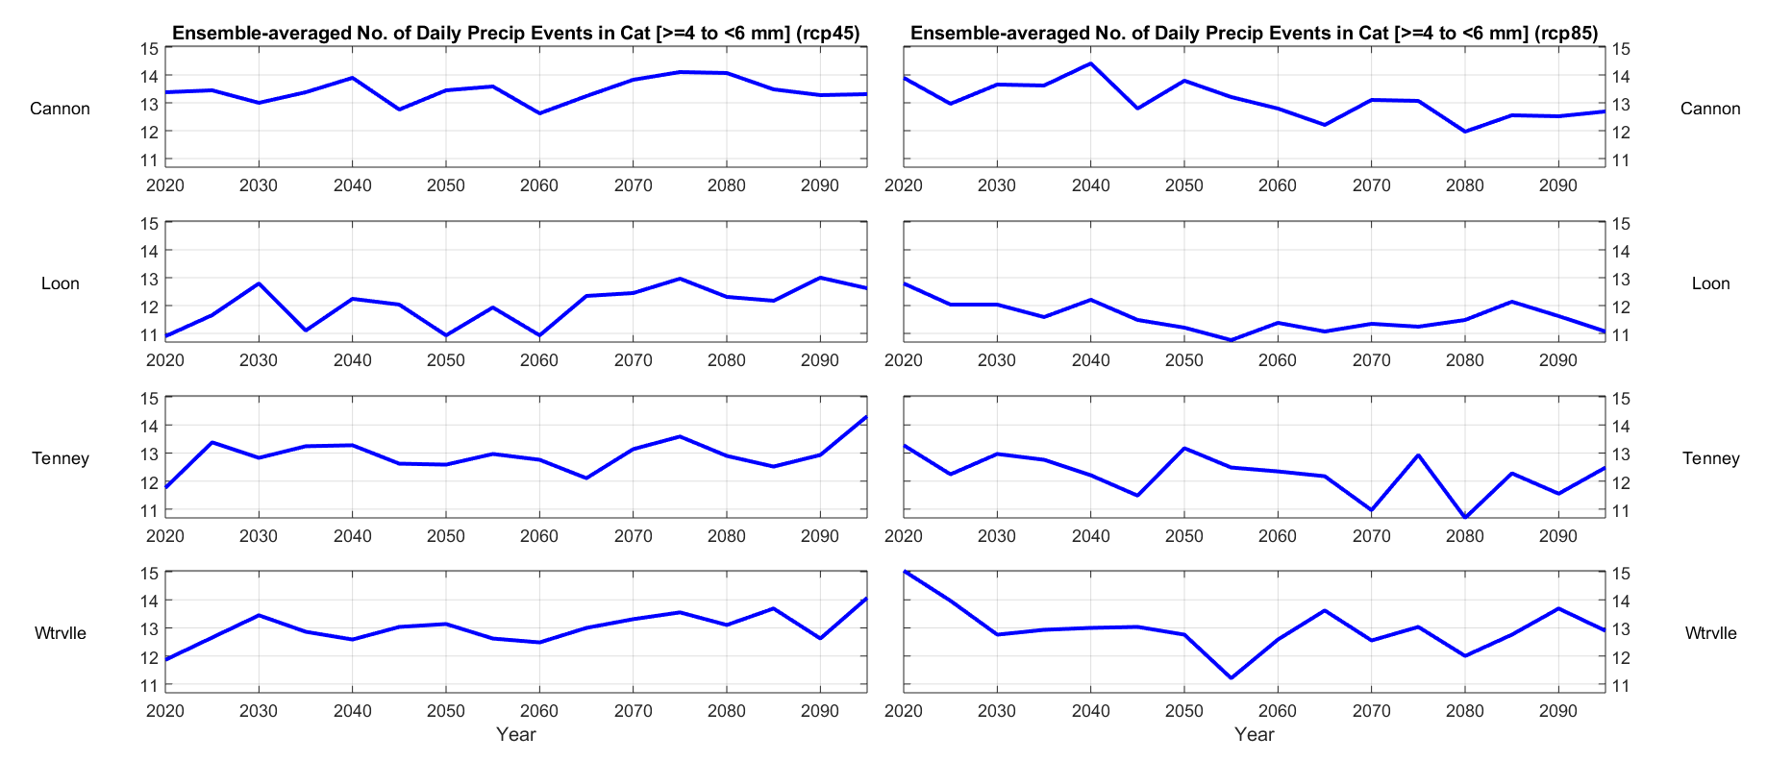
Fig. 3.4.2.: Ensemble-averaged number of warm-season precipitation events ≥ 4 to < 6 mm, 2020 - 2095.

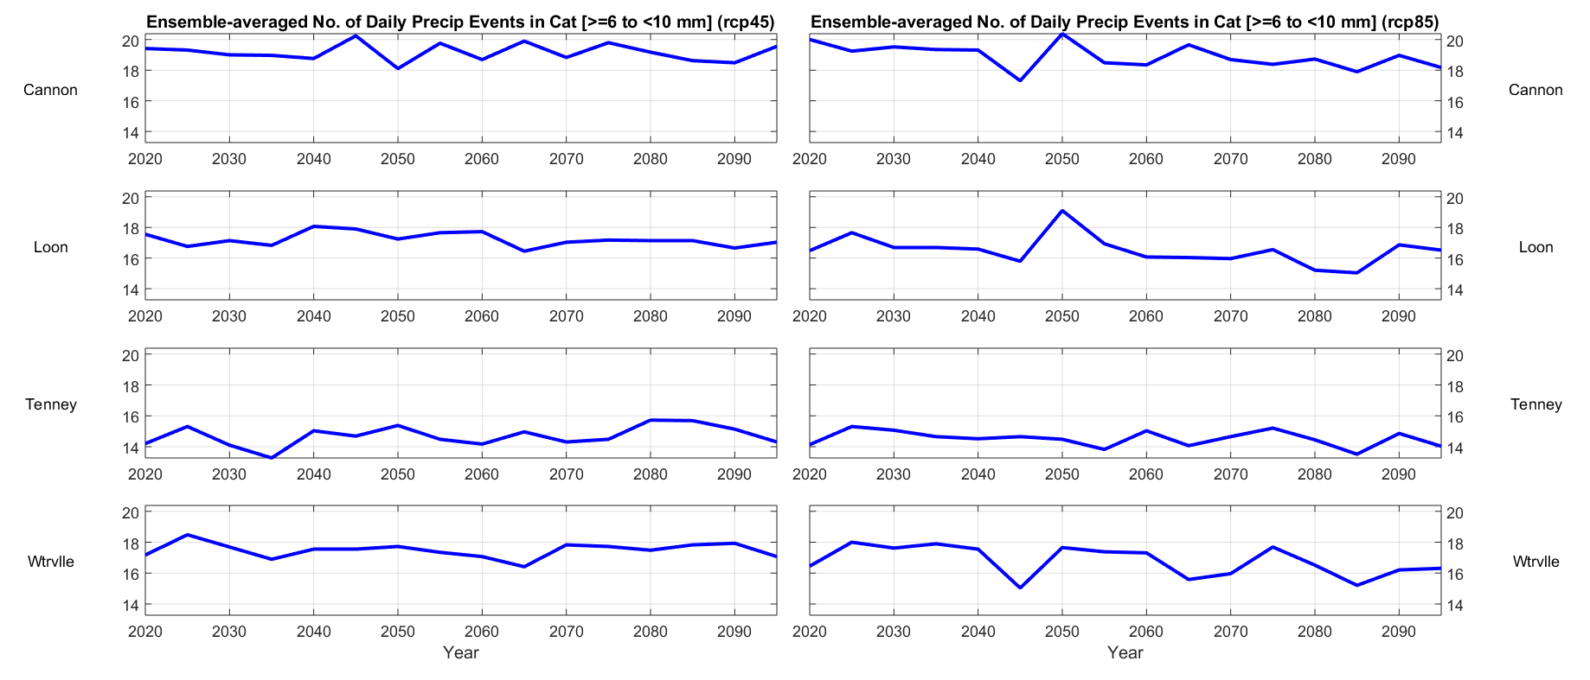
Fig. 3.4.3.: Ensemble-averaged number of warm-season precipitation events ≥ 6 to < 10 mm, 2020 - 2095.

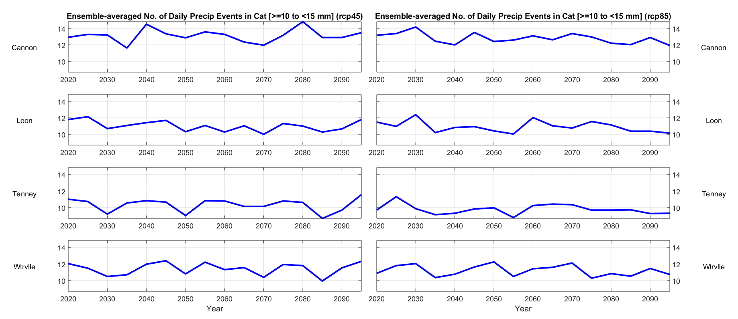
Fig. 3.4.4.: Ensemble-averaged number of warm-season precipitation events ≥ 10 to < 15 mm, 2020 - 2095.

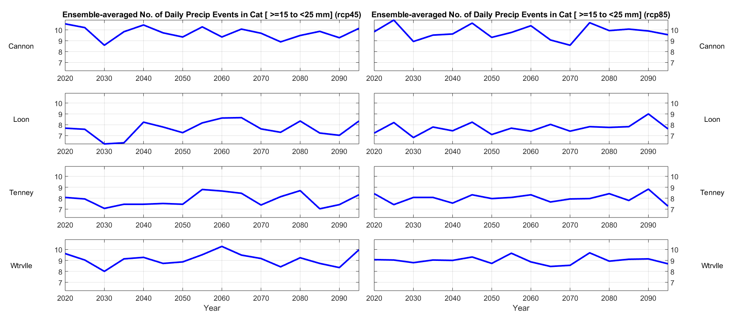
Fig. 3.4.5.: Ensemble-averaged number of warm-season precipitation events ≥ 15 to < 25 mm, 2020 - 2095.

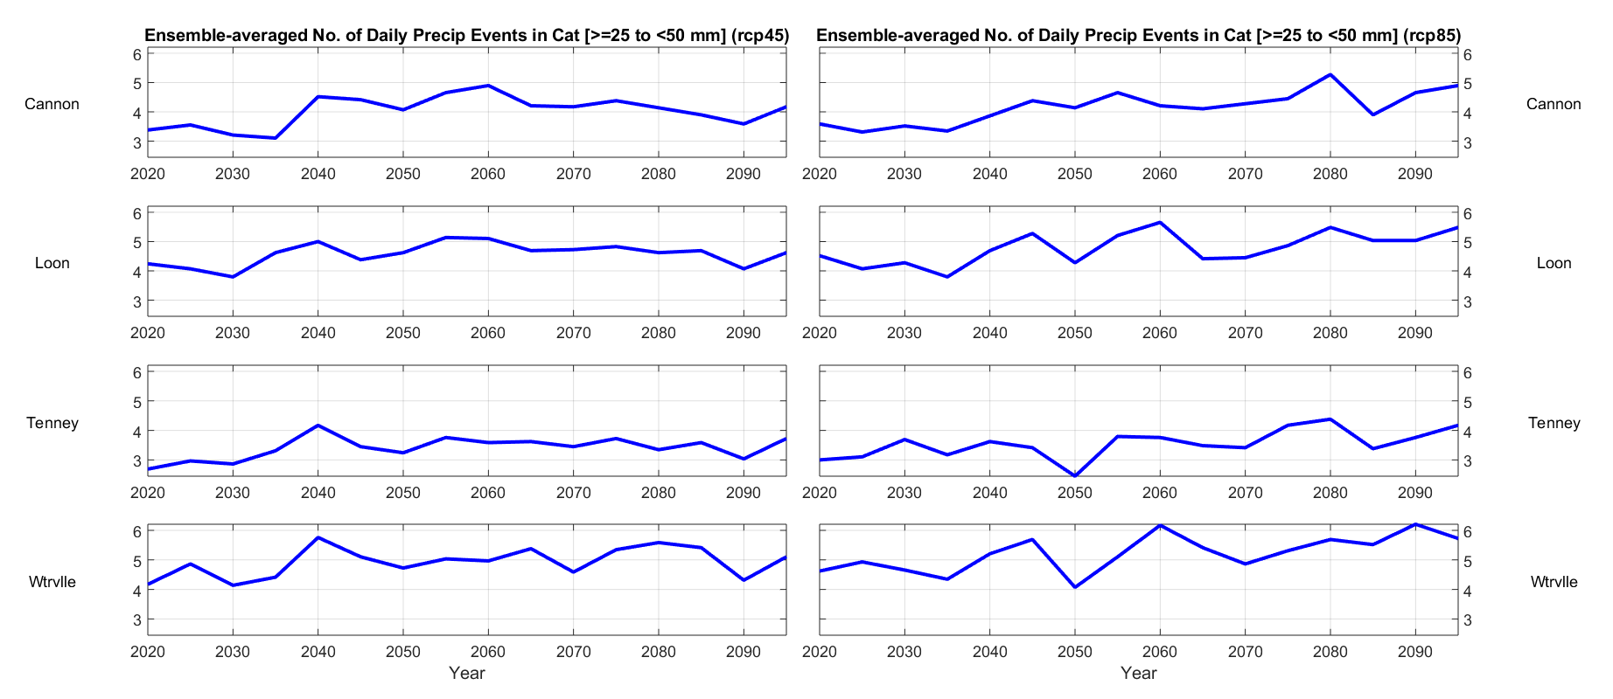
Fig. 3.4.6.: Ensemble-averaged number of warm-season precipitation events ≥ 25 to < 50 mm, 2020 - 2095.

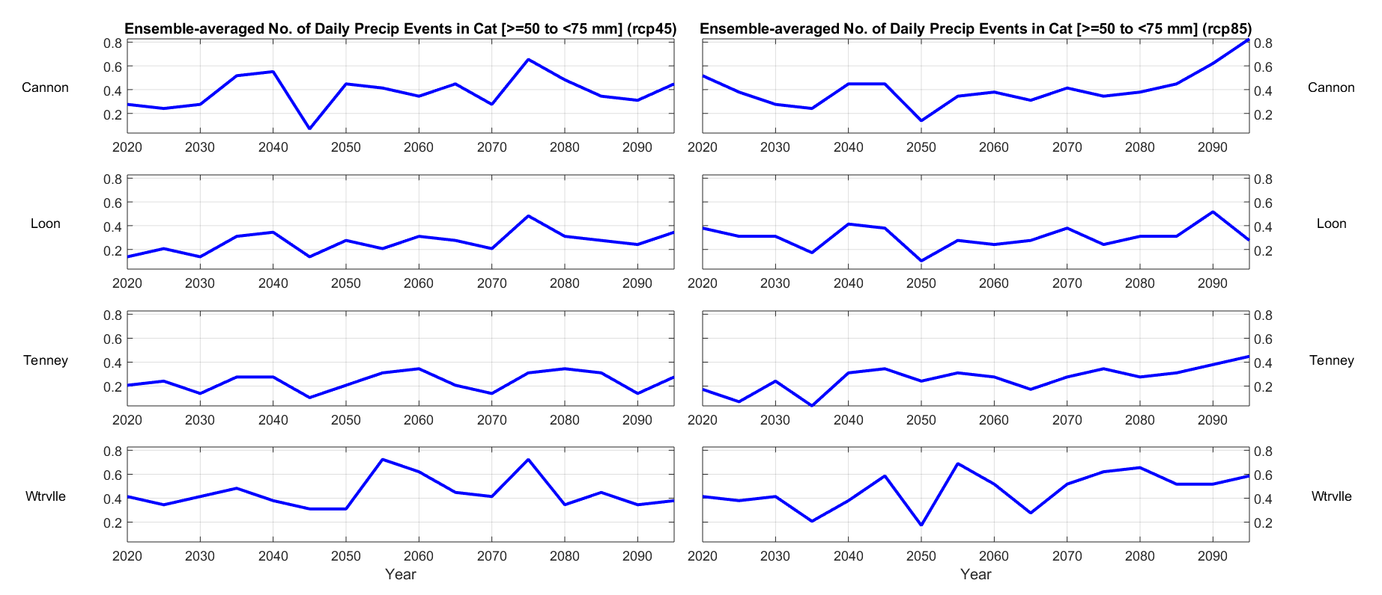
Fig. 3.4.7.: Ensemble-averaged number of warm-season precipitation events ≥ 50 to < 75 mm, 2020 - 2095.

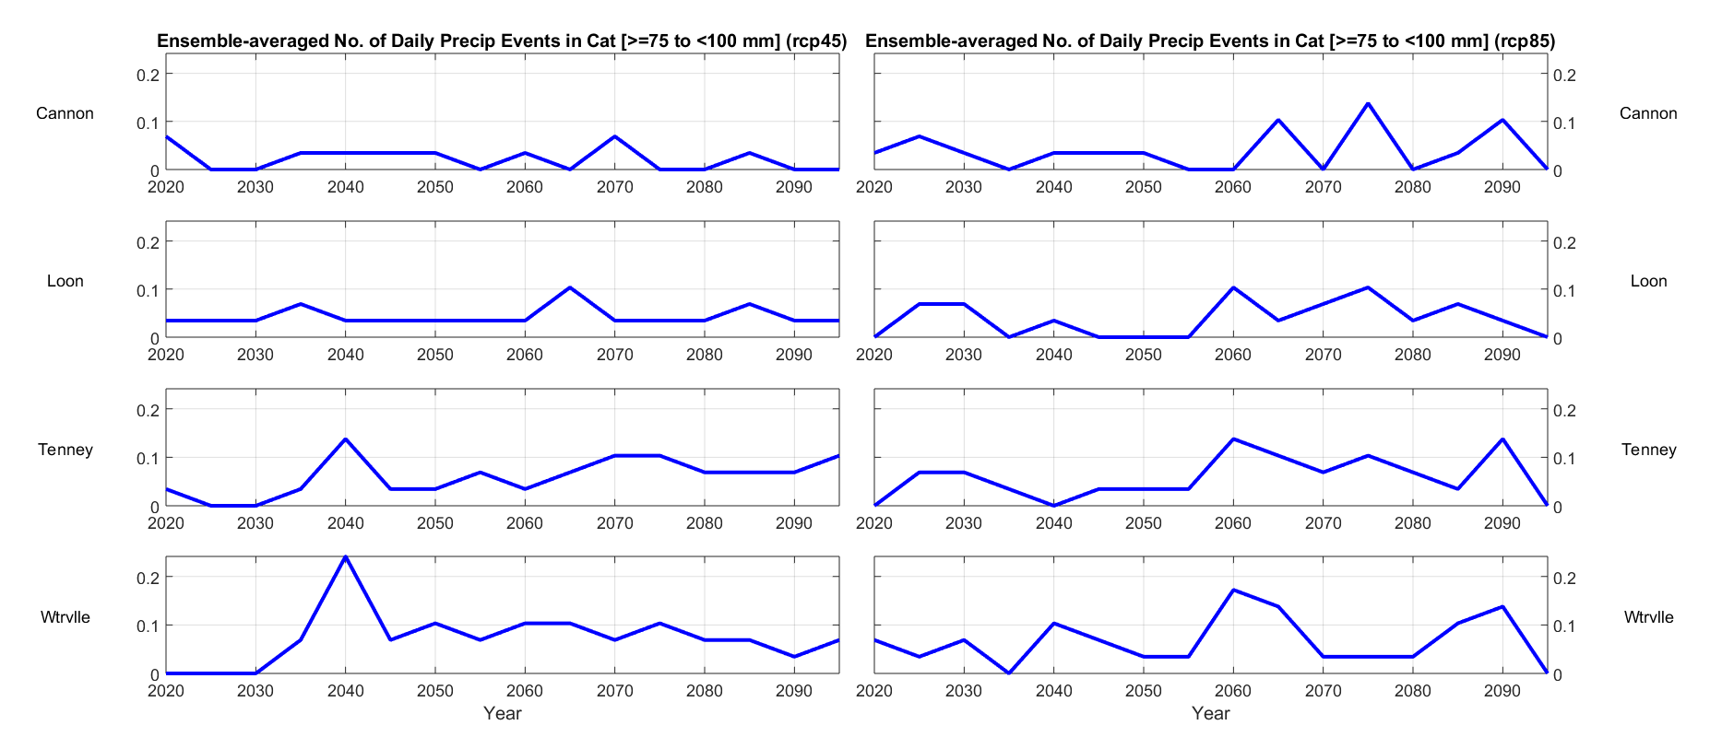
Fig. 3.4.8.: Ensemble-averaged number of warm-season precipitation events ≥ 75 to < 100 mm, 2020 - 2095.

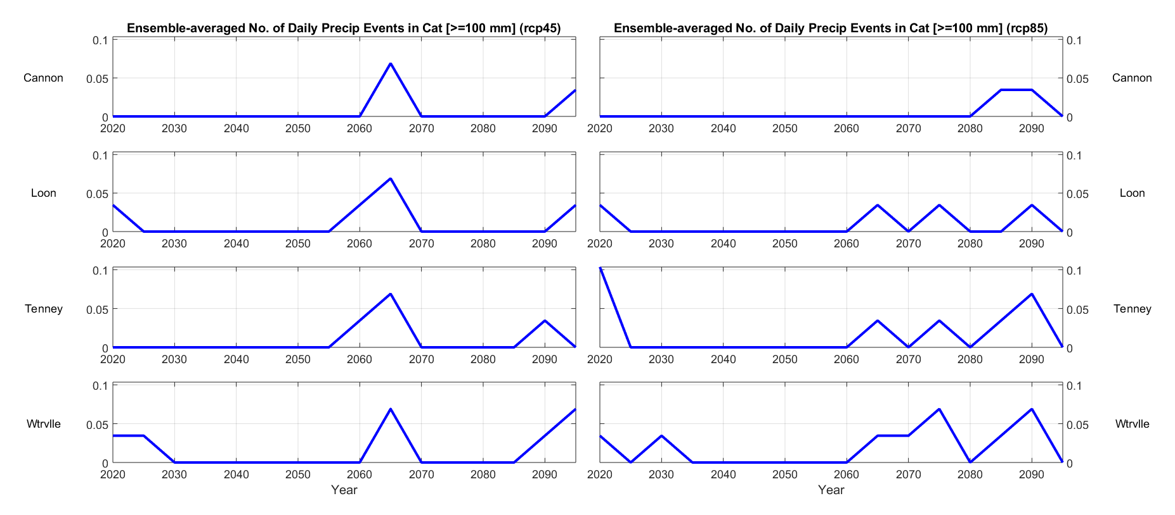
Fig. 3.4.9.: Ensemble-averaged number of warm-season precipitation events ≥ 100 mm, 2020 - 2095.

- Ensemble average number of warm-season daily precipitation events in category, with improved mid-range resolution:

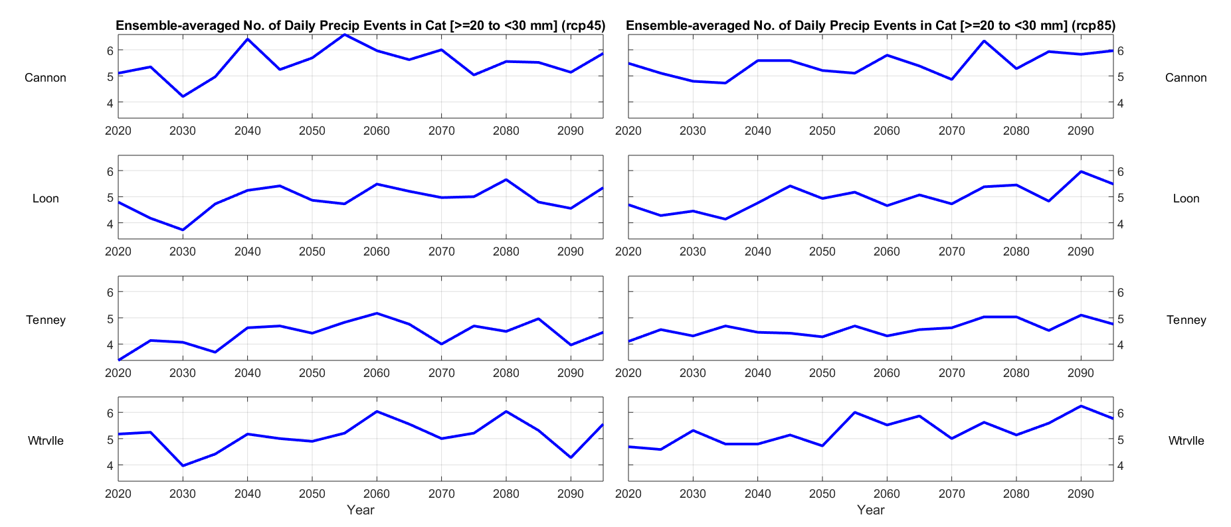
Fig. 3.5.1.: Ensemble-averaged number of warm-season precipitation events ≥ 20 to < 30 mm, 2020 - 2095.

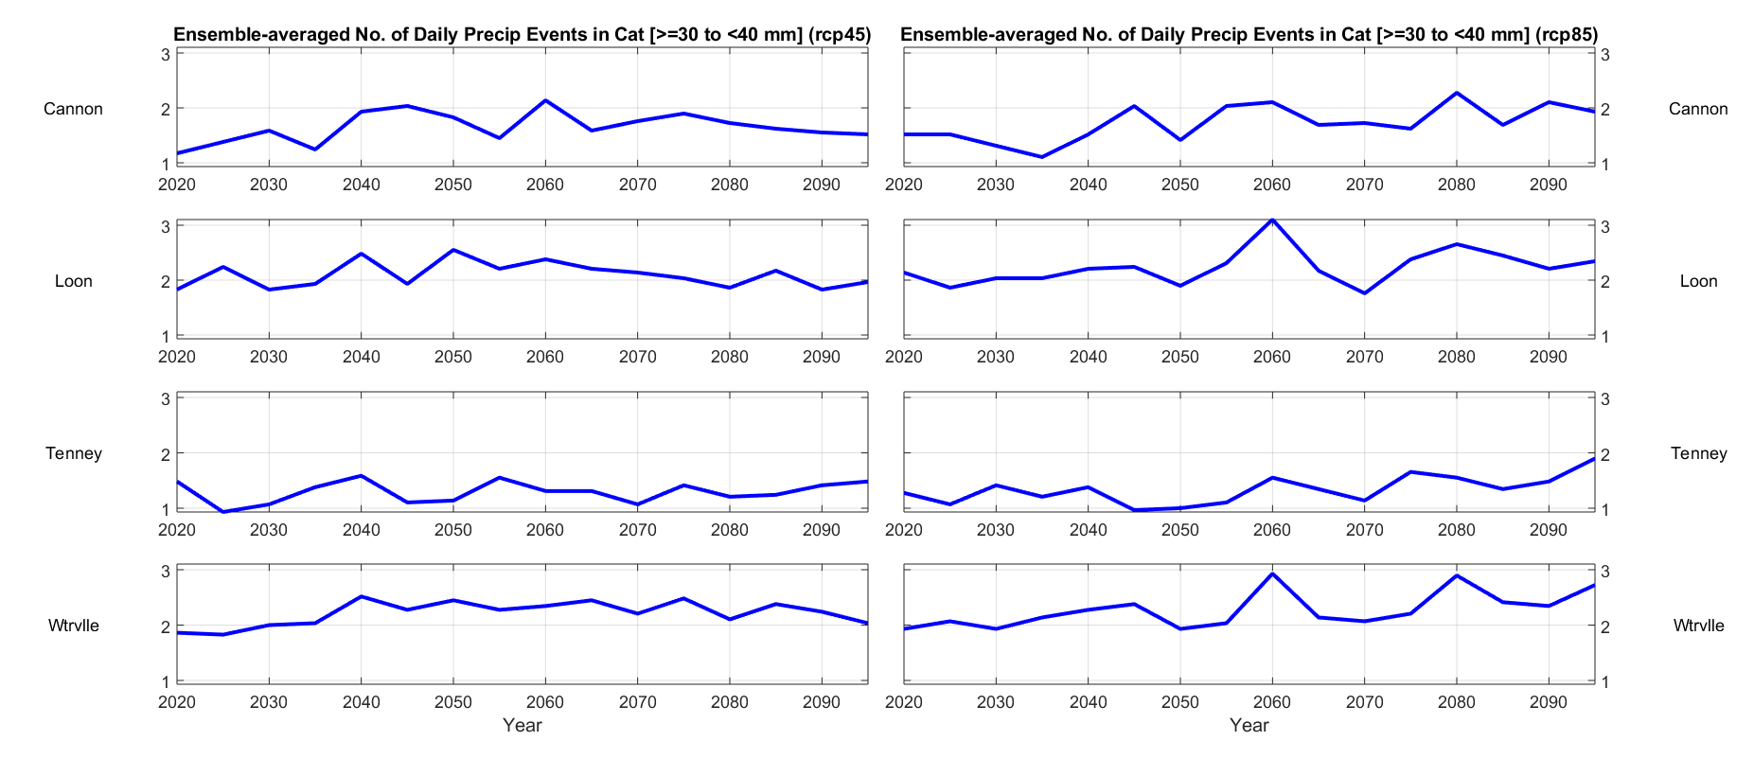
Fig. 3.5.2.: Ensemble-averaged number of warm-season precipitation events ≥ 30 to < 40 mm, 2020 - 2095.

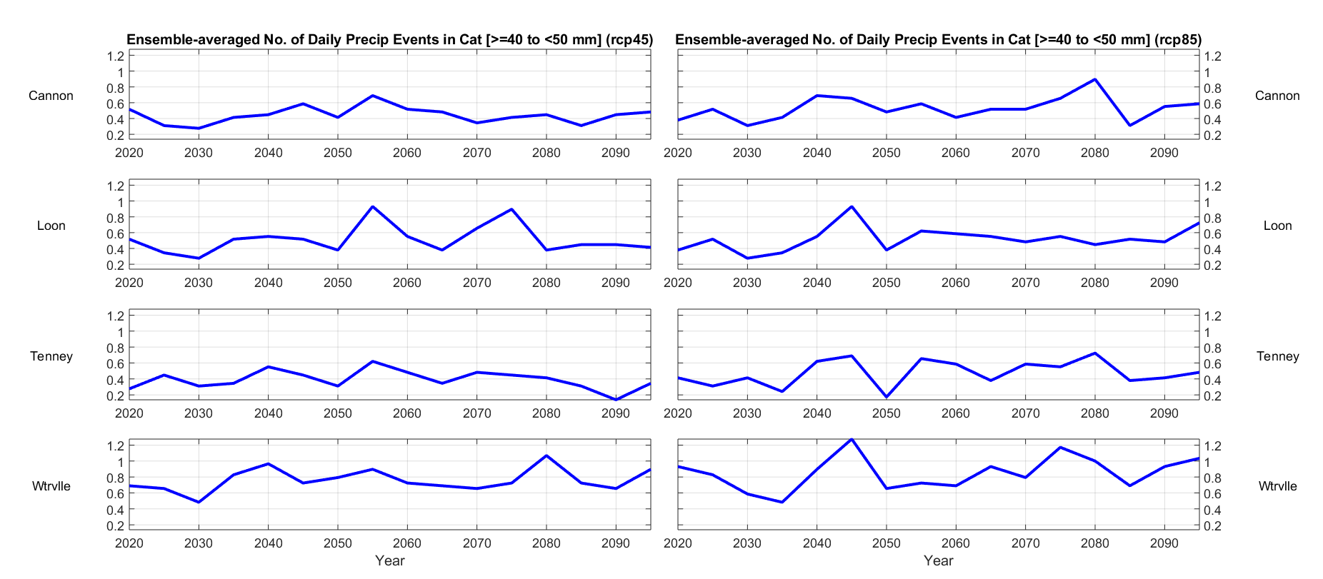
Fig. 3.5.3.: Ensemble-averaged number of warm-season precipitation events ≥ 40 to < 50 mm, 2020 - 2095.

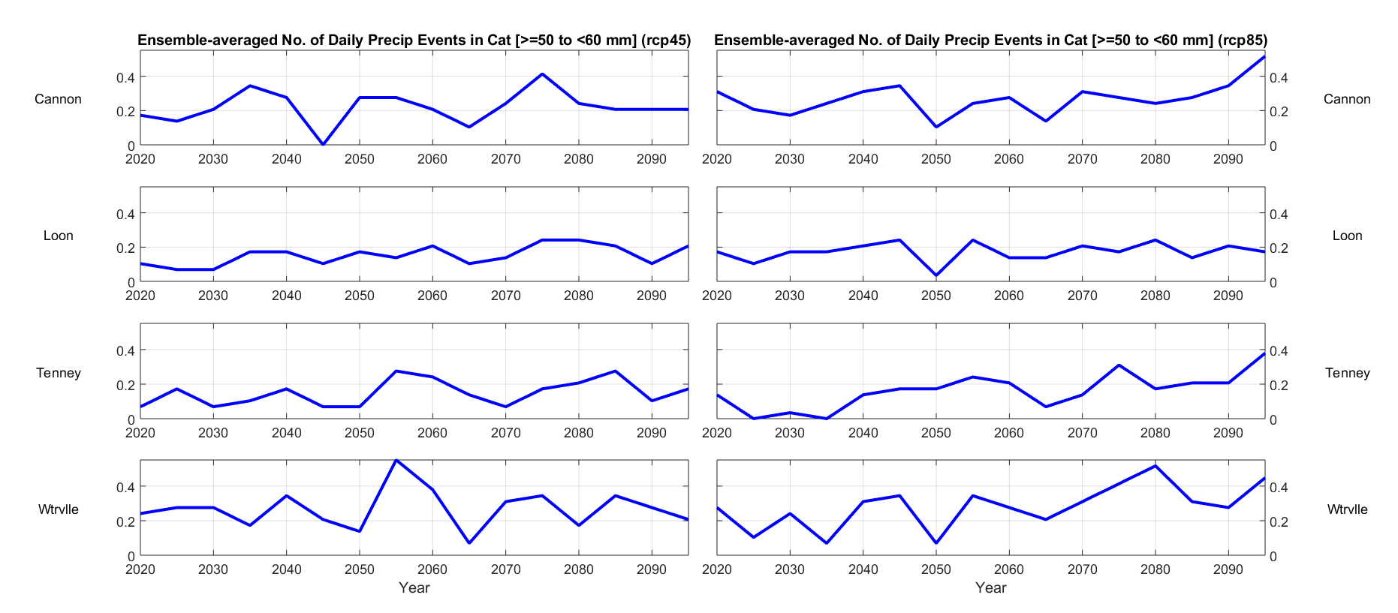
Fig. 3.5.4.: Ensemble-averaged number of warm-season precipitation events ≥ 50 to < 60 mm, 2020 - 2095.

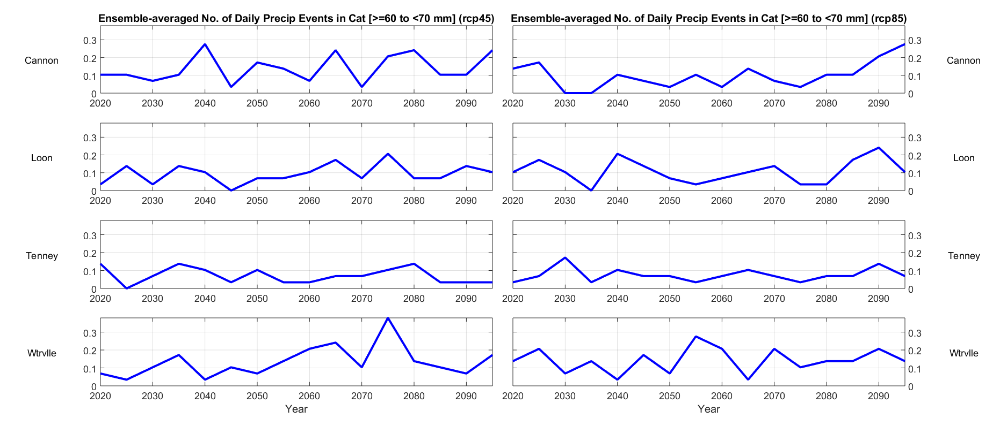
Fig. 3.5.5.: Ensemble-averaged number of warm-season precipitation events ≥ 60 to < 70 mm, 2020 - 2095.

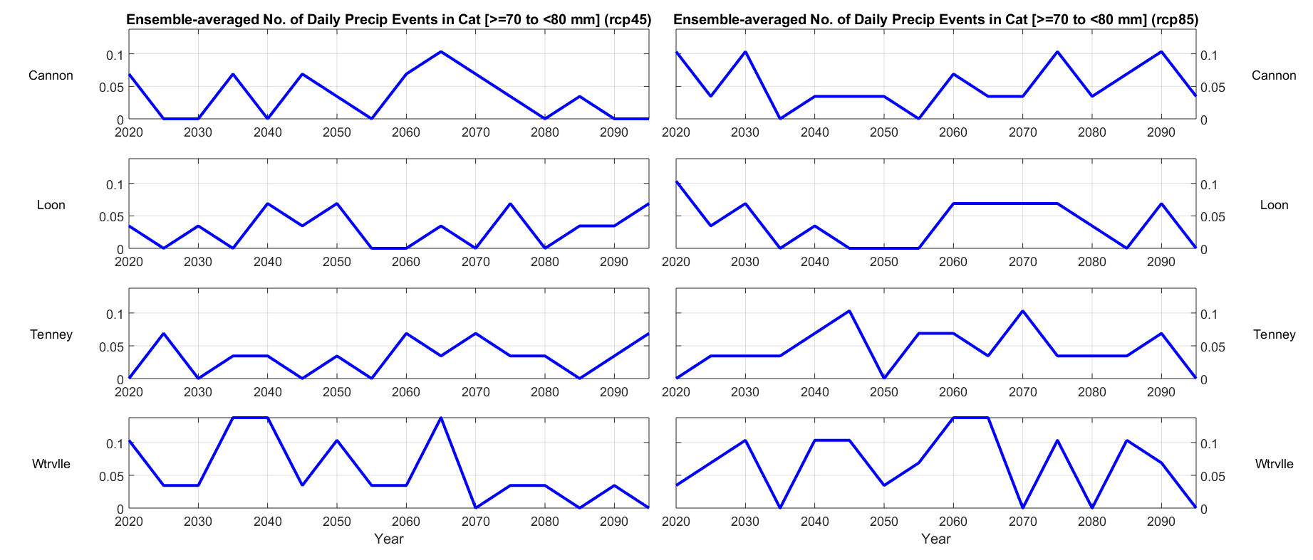
Fig. 3.5.6.: Ensemble-averaged number of warm-season precipitation events ≥ 70 to < 80 mm, 2020 - 2095.

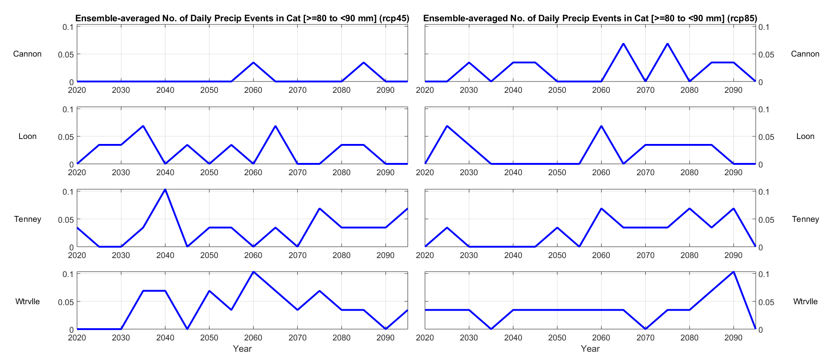
Fig. 3.5.7.: Ensemble-averaged number of warm-season precipitation events ≥ 80 to < 90 mm, 2020 - 2095.

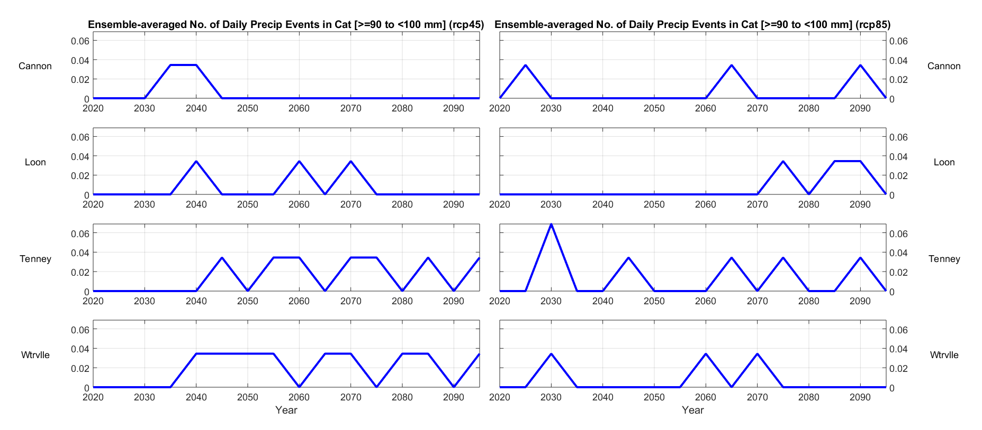
Fig. 3.5.8.: Ensemble-averaged number of warm-season precipitation events ≥ 90 to < 100 mm, 2020 - 2095.

Interpretation of Results.

- Cold-season.

  - Minimum daily temperatures. As stated in Part 1 of the Physical Sciences Report, changes in minimum daily temperature during the period 2020 – 2040 are relatively insensitive to which RCP is assumed. In both cases, and across all six months of the cold season, the ensemble indicates increases in mean monthly minimum temperature (MMMT) at all locations on the order of 1 – 2 °C. However the RCP-dependent differences become evident by about mid-century, and quite significant by 2095.

- In January (Fig. 2.1.1), RCP4.5 is associated with an increase in MMMT of about 3 °C, while RCP8.5 indicates increase of 6 – 7 °C by the end of the century.

- In February and March (Figs. 2.1.2 and 2.1.3), RCP4.5 is associated with an increase of 2 °C, while RCP8.5 is associated with an increase of about 6 °C.

- In April (Fig. 2.1.4), both RCPs result in MMMT exceeding the freezing point of water at Cannon and Loon by 2050, at Tenney Mountain by 2060, and at Waterville Valley by about 2070.

- In November (Fig. 2.1.5), MMMT increases by 2 - 3 °C by 2095 with RCP4.5, and by about 5 °C with RCP8.5. With RCP8.5, MMMT exceeds the freezing point of water at three of the four locations by about 2080.

- December (Fig. 2.1.6) MMMTs increases by 2 – 3 °C with RCP4.5 by 2095, and 4 – 5 °C with RCP8.5, although, in both cases, they remain below the freezing point of water.

  - Number of days when snowmaking is possible. During the period 2020 – 2040, there is relatively little difference between RCP4.5 and RCP8.5. More dramatic changes emerge at three of the four locations by mid-century.

- In January (Fig. 2.2.1), RCP4.5 is associated with a decrease in the number of days ranging from zero (at Waterville Valley) to about three (at Cannon). RCP8.5 shows larger decreases, ranging from two fewer days (at Waterville Valley) to four fewer days (at Loon). There is a similar distribution of results for February (Fig. 2.2.2).

- March (Fig. 2.2.3) shows larger decreases with both RCPs. With RCP4.5, there is a range from one fewer day (at Cannon) to two fewer days (at Loon and Tenney Mountain). With RCP8.5, decreases range from 6 – 7 fewer days, depending on location.

- April’s (Fig. 2.2.4) pattern is stronger than March’s. RCP4.5 shows a decrease of about 3 – 4 days by 2040, and 5 – 6 days by 2095. RCP8.5 shows similar reductions by 2040, but by 2095 the reduction increases to 8 – 15 days, depending on location.

- In November (Fig. 2.2.5), RCP4.5 is associated with a loss of about three days by 2040, and 5 – 6 days 2095. RCP8.5 is associated with a loss of about 11 – 13 days, depending on location.

- In December (Fig. 2.2.6), RCP4.5 is associated with a loss of 1 – 2 days by 2040, and 2 – 4 days by 2095. RCP8.5 is associated with no loss of snowmaking days by 2040, but reductions of 3 – 6 days by 2095.

  - Total monthly snowfall. Here, location-dependent differences emerge between the two RCPs.

- In January (Fig. 2.3.1), RCP4.5 is associated with fluctuating snowfall amounts during the 21st Century, but there are no important changes between the present 2020 and 2095. RCP8.5 is not associated with any important changes between 2020 and 2040, but shows reductions in total snowfall of between zero (at Waterville Valley) and about 20 mm (at Tenney Mountain).

- February’s (Fig. 2.3.2) results are similar to January’s, except that reductions in total snowfall of between 20 and 30 mm appear at all four locations with RCP8.5.

- March (Fig. 2.3.3) shows reductions at all four locations with both RCPs by 2040. By 2095, RCP4.5 is associated with a reduction of 10 – 20 mm at all locations, while RCP8.5 is associated with reductions of 30 – 50 mm.

- April (Fig. 2.3.4) is similar to March, with both RCPs showing reductions of 5 – 15 mm by 2040. RCP4.5 is associated with a mid-century increase back to levels near those of 2020, but this is not evident with RCP8.5. By the end of the century, RCP4.5 is associated with a reduction of 5 – 15 mm, while RCP8.5. is associated with reductions of 5 – 12 mm. Further, with RCP8.5., total monthly snowfall is essentially zero by 2095.

- In November (Fig. 2.3.5), RCP4.5 is associated with either zero or very small reductions in snowfall by 2040, and reductions of 10 – 15 mm by 2095. RCP8.5 is associated with reductions of 8 – 10 mm by 2040, and 10 – 35 mm by 2095. One location (Tenney Mountain) shows zero natural snowfall by 2095, and the remainder are all below 10 mm.

- In December (Fig. 2.3.6), both RCPs are associated with a reduction of about 30 mm at all four locations by 2040. By 2095, RCP4.5 is associated with a decrease of about 40 mm, while RCP8.5 is associated with a decreases of 30 – 50 mm, depending on location.

  - Snowfall-to-precipitation ratio. This parameter is relatively insensitive to RCP between 2020 and 2040, but important differences emerge by the end of the 21st Century.

- In January (Fig. 2.4.1), RCP4.5 and RCP8.5 are both associated with relatively small changes in this ratio. With RCP4.5, there is a reduction of about 10 percent at all locations. With RCP8.5., there is reduction of about 30 percent at all locations by 2095, with three (Cannon, Loon, and Tenney Mountain) all indicating that less than half of the total monthly precipitation will fall as snow, while Waterville Valley falls to just less than 60 percent.

- In February (Fig. 2.4.2), RCP4.5 and RCP8.5 both indicate little change by 2040. With RCP4.5, there is a reduction on the order of about 10 percent at all locations by 2095. With RCP8.5., there is a reduction of 20 – 40 percent by 2095, with three locations (Cannon, Loon, and Tenney Mountain) all indicating a ratio of less than 40 percent, and Waterville Valley indicating a ratio of slightly less than 50 percent.

- In March (Fig. 2.4.3), RCP4.5 is associated with little reduction in this ratio by 2040, while RCP8.5 is associated with a reduction of roughly 10 percent. By 2095, RCP4.5 indicates a reduction of about 10 percent at all locations, while RCP8.5 indicates a reduction of 20 – 40 percent. RCP8.5 is associated with ratios of only about 20 percent by the end of the century.

- April (Fig. 2.4.4), which at present is the end of the ski season in New Hampshire, shows similar reductions, except they show up earlier, especially with RCP4.5. By 2040, RCP4.5 is associated with a reduction on the order of 10 percent, while RCP8.5 shows zero change to a slight increase, depending on location. By 2095, RCP4.5 shows the ratio dropping to between 5 and 10 percent, while RCP8.5 shows the ratio dropping to near zero. This result indicates that April will no longer be a skiing month in the Campton area by the end of the century, as almost all precipitation will fall in some form other than snow.

- In November (Fig. 2.4.5), RCP4.5 is not associated with any important changes to the ratio by 2040, while RCP8.5 is associated with decreases of about 10 percent at all locations. By 2095, RCP4.5 is associated with reductions of about 5 percent, while RCP8.5 is associated with reductions of about 20 percent at all locations. One location (Tenney Mountain) indicates that the ratio will be near zero by the end of the century, while the other three are all below 10 percent by that time. This result indicates that, like April, November will no longer be a skiing month by the end of the century.

- In December (Fig. 2.4.6), RCP4.5 is associated with reductions in this ratio of about 10 percent by 2040, while RCP8.5 is associated with reductions of 15 – 20 percent by the same time. By 2095, RCP4.5 indicates a reduction of 20 – 25 percent, while RCP indicates a reduction of 30 – 40 percent. In particular, the RCP8.5 scenario indicates that, by 2095, only about 30 – 35 percent of all precipitation in December will fall in the form of snow, with the rest falling as snow pellets (sleet), freezing rain, or ordinary rain. This can be compared to the present, when 60 – 70 percent of total December precipitation falls as snow.

  - Natural snowpack. As with several of the previous parameters, this one is relatively insensitive to RCP between 2020 and 2040, but important differences emerge by the end of the century.

- In January (Fig. 2.5.1), both RCPs indicate a rection of about 10 mm SWE at all locations by 2040. With RCP4.5, this falls to about 80 mm SWE at three locations (Cannon, Loon, and Tenney Mountain), and about 110 mm SWE at Waterville Valley. With RCP8.5, Tenney Mountain falls to less than 40 mm SWE by 2095, Cannon to about 40 mm SWE, Loon to about 45 mm SWE, and Waterville Valley to about 60 mm SWE.

- In February (Fig. 2.5.2), RCP4.5 is associated with a reduction of about 10 mm SWE by 2040, and RCP8.5 is associated with a reduction of between zero (at Waterville Valley) and 20 – 30 mm SWE at the other locations by 2040. By 2095, RCP4.5 produces reductions of about 40 mm SWE at all locations, while RCP8.5 produces reductions of about 100 mm SWE at all locations. By 2095, Tenney Mountain indicates less than 50 mm SWE, Cannon slightly more than 50 mm SWE, Loon about 75 mm SWE, and Waterville Valley about 100 mm SWE. At all four locations, February snowpacks are reduced by about half with RCP8.5 by 2095.

- In March (Fig. 2.5.3), both scenarios are associated with reductions in snowpack by 2040. RCP4.5 shows reductions of 20 – 40 mm SWE, and RCP8.5 shows reductions of about 55 mm SWE at all locations. By 2095, RCP4.5 shows reductions of about 50 mm SWE, while RCP8.5 is associated with reductions of about 150 mm SWE. By 2095, March snowpack with RCP8.5 is as low as about 25 mm SWE (at Tenney Mountain) and as high as about 75 mm SWE (at Waterville Valley). These are significant reductions from 2020 values of between 150 and 250 mm SWE.

- April (Fig. 2.5.4) is similar to March. Both scenarios show reductions at all locations by 2040. By 2095, RCP4.5 is associated with reductions of 50 – 90 mm SSW, with Waterville showing the largest decrease. With RCP8.5, all four locations indicate that natural snowpack will be reduced to near zero, meaning that April will no longer be part of the ski season by the end of the century.

- In November (Fig. 2.5.5), RCP4.5 is associated with reductions of snowpack by about half at three locations (Cannon, Loon, and Waterville Valley), while Tenney Mountain remains at a relatively low value of 2 mm SWE until then. By 2095, RCP4.5 shows modest reductions in snowpack at the same three locations, while Tenney Mountain remains steady at only 2 mm SWE. Under RCP8.5, all locations drop to less than 2 mm SWE by 2095, indicating that, like April, November will no longer be part of the ski season in the region.

- December (Fig. 2.5.6) shows small reductions under RCP4.5 by 2040, while remaining relatively constant under RCP8.5. In the former case, snowpack is reduced by 15 – 20 mm SWE at all locations, while remaining steady to slightly increasing during the same period under RCP8.5. By 2095, both RCP4.5 and RCP8.5 are associated with reductions of about 20 mm SWE at all four locations. RCP4.5 values by 2095 range from 20 mm SWE (at Tenney Mountain) to about 35 mm SWE (at the other three locations). RCP8.5 values by 2095 are all at or below 20 mm SWE at all locations.

- Warm-season. Results are shown in Figures 3.x.x., above.

References.

Burakowski, E., 2020: Personal communication. Dr. Burakowski is a Research Assistant Professor at the Earth Systems Research Center, in the Institute for the Study of Earth, Oceans, and Space, University of New Hampshire.

ClimateNexus, n.d.: RCP8.5: Business-as-usual or a worst-case scenario, accessed July, 2020. [Available on-line at climatenexus.org/climate-change-news/rcp-8-5-business-as-usual-or-a-worst-case-scenario/]

Grogan, D., E. Burakoswki, and A. Contosta, 2020: Snowmelt control on spring hydrology declines as the vernal window lengthens, Environmental Research Letters, in review.

Hausfather, Z., 2018: Explainer: How ‘Shared Socioeconomic Pathways’ explore future climate change, accessed July, 2020. [Available on-line at www.carbonbrief.org/explainer-how-shared-socioeconomic-pathways-explore-future-climate-change]

IPCC Data Distribution Center, 2019: Representative Concentration Pathways (RCPs), accessed July, 2020. [Available on-line at sedac.ciesin.columbia.edu/ddc/ar5_scenario_process/RCPs.html]

Miller, S., 2020: AirSea Matlab-based data analysis suite. For more, see http://vortex.plymouth.edu/~stmiller, and follow the link for Matlab:airsea.

NOAA(a), n.d., Climate Model: Temperature Change (RCP 4.5 – 2006 - 2010), accessed July, 2020. [Available on-line at sos.noaa.gov/datasets/climate-model-temperature-change-rcp-45-2006-2100]

NOAA(b), n.d., Climate Model: Temperature Change (RCP 8.5 – 2006 - 2010), accessed July, 2020. [Available on-line at sos.noaa.gov/datasets/climate-model-temperature-change-rcp-85-2006-2100]

Pierce, D., D. Cayan, and B. Thrasher, 2014: Statistical downscaling
Using Localized Constructed Analogs (LOCA), Journal of Hydrometeorology, 15, 2558 – 2585.

RCP Database, 2009: RCP Database Version 2.0.5, accessed on-line July, 2020. [Available on-line at www.iiasa.ac.at/web-apps/tnt/RcpDb]

Wilson, G., M. Green, and K. Mack, 2018: Historical climate warming in the White Mountains of New Hampshire (USA): Implications for snowmaking water needs at ski areas, Mountain Research and Development, 38 (2), 164 - 171, http://dx.doi.org/10.1659/MRD-JOURNAL-D-17-00117

Appendix D: Technical notes about graphs in main report

Figures 2.1, 2.2, 3.3, 3.4 and 3.5 in the main report were derived from data obtained from the Earth Systems Research Center at UNH (ESRC) as discussed in Appendices A-C above. This section provides some details about how the graphs were generated. The other graphs in the main report were copied from various publications as listed in the footnotes of the report, with annotations sometimes added to emphasize points relevant to the discussion.

Figure 2.1 Date of First Thaw in Campton area
The chart is based on the "Cumulative thawing index", which is a running total of the daily thawing indices starting from a value of 0 during the winter freeze. It is increased each day by the amount the average temperature for that day exceeds the freezing point (32⁰F) or decreased if the average is below freezing. The daily average was calculated by averaging the maximum and minimum temperatures for the site. The thaw date is the first day where the CTI exceeds 25, which is the standard used for this calculation.

This calculation was run on all 29 models in the ESRC database for Tenney Mountain and for all years in the intervals shown in the graph, such as 2020-2029. We calculated the number of times that the first thaw occurred on each date and divided that by the total number of samples for that interval. The raw values were then processed through a rolling average filter with an interval of 20. The filtered percentages are shown in the Y axis of the graph, while the X axis are the dates. For example, a Y value 2.0 for the date March 12 indicates a 2% chance that the first thaw will occur on that date. Different traces show the probability distributions over different decades. The results were consistent with other studies, such as a 2017 study for the National Science Foundation that used samples from nearby Ellsworth.

Figure 2.3 Number of Days over 90⁰ in Campton
This simple bar graph was made by counting the number of days with daily high temperatures over 90⁰F each year for each of the 29 models in the ESRC database for Tenney Mountain. The annual values were then averaged.

Figure 3.3. Waterville Valley average snowpack in mm of SWE
This graph used the snowpack dataset provided by ESRC for Waterville Valley. The daily values were averaged across the 29 models and for each year in the decade and emission scenario. A 20 sample rolling average filter was then applied to the data to clean up the graph.

Figure 3.4. Number of days when overnight temperatures allow snowmaking
Separate graphs were generated for each of the three main ski resorts near Campton. For each year in each data set , the total number of days when the minimum temperature was below -2⁰C, as required for snowmaking. The values were then averaged across the 29 different models and for each year in the decades shown in the graph.

Figure 3.5: Percentage of winter precipitation falling as rain at Loon Mountain
This chart uses two data sets provided by ESRC: the daily snowfall and the daily precipitation, which would include both the snowfall and rain. These two values were accumulated across 29 models and for each year in the decade covered by each trace in the graph, and then the percentage of rain calculated as (TotalPrecipitation-TotalSnowfall)/TotalPrecipitation. These values were then run through a rolling average filter to clean up the graph.

Their results are valid for the period beyond which the emission scenario is irrelevant (Bryan et al. 2015). They assume the A2 emissions scenario, which, according to NARCCAP, “is at the higher end of the SRES emissions scenarios (but not the highest)” (UCAR 2000). For more about the Special Report on Emissions Scenarios (SRES), see Nakicenovic et al. (2000).
ICAO = International Civil Aviation Organization
AWOS = Automated Weather Observation System
The Plymouth State Weather Center obtains its base data via a NOAAPort satellite downlink from the National Oceanic and Atmospheric Administration.
Meteorological winter, defined as December, January, and February (DJF).
Meteorological summer, defined as June, July, and August (JJA).
An often used ratio is 10:1, meaning that every inch of snow contains a tenth of an inch of liquid. This is a very general rule and is not reliable. The real relationship is more complex, and heavily dependent on temperature. Snow falling in warmer temperatures may approximate a ratio of 10:1, but snowfall in very cold temperatures may correspond to a ratio as high as 100:1. The National Center for Environmental Information (NCEI), formerly known as the National Climatic Data Center (NCDC), has published a temperature-dependent conversion table, available here: https://www.ncdc.noaa.gov/sites/default/files/attachments/Estimating_the_Water_Equivalent_of_Snow.pdf
SWE = Snow Water Equivalent; the amount of liquid water obtained if the frozen sample is melted.
Campton coordinates (43° 50’ 59” N, 71° 38’ 54” W) correspond to Town Hall, near Exit 28 on I-93.
Data in the base files were provided for each year. The decision to compute results at 5-yr intervals was made to reduce processor time.
"Process for Seasonal Load Limit Starting and Ending Dates", Minnesota Dept of Transportation, Oct 7, 2014. https://www.dot.state.mn.us/materials/pvmtdesign/sll/doc/TM1410MAT02-1520679-v1.PDF
Jo Sias Daniela, et. al, "Climate change: potential impacts on frost–thaw conditions and seasonal load restriction timing for low-volume roadways", Tandfonline, August 2017, https://par.nsf.gov/servlets/purl/10039935

